Rectortown United Methodist Church
May 17th, 2026 10:00 a.m.
245th Homecoming
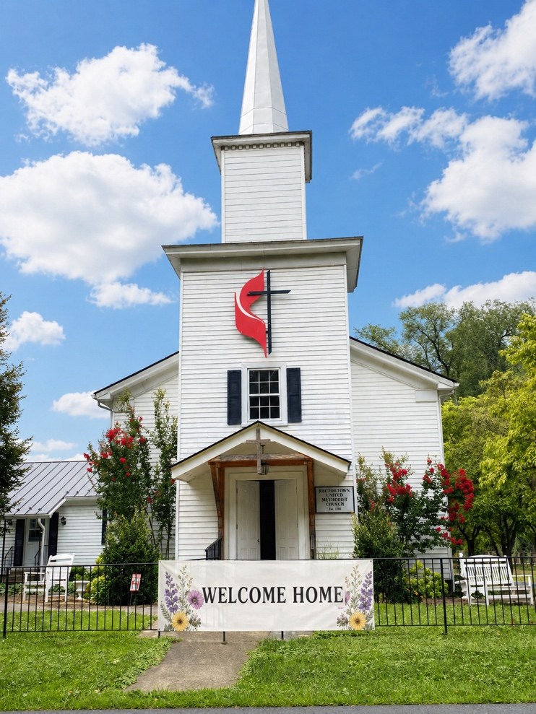

Pastor: Eduardo Carrillo
3049 Rectortown Road, Marshall, VA 20115
Pastor’s Cell Phone: (703) 967-4361
Pastor’s E-mail: eduardocarrillo@vaumc.org
Music Director: Karen Chase
Ministers: every member of the congregation
Welcome to Rectortown UMC!

“This is the day that the Lord has made;
let us rejoice and be glad in it.” Psalm 118:24 NRSV

* Please Stand As You Are Able and Comfortable
PRELUDE - let us quiet our minds and hearts.

WELCOME Larry Scheuble

Welcome travelers & wonderers of faith.
Welcome home

GATHERING
*CALL to WORSHIP
Leader: We come today from many places, some from just down the road, and others from years and miles away.
People: We come to remember where we have been and the Grace that carried us through.
Leader: We gather in this present moment, in this sacred space, to stand together as one family.
People: We are here to celebrate where we are, grounded in Faith and held by Love.
Leader: But our journey does not end at these doors. God is speaking a new word; the Spirit is breathing a new life into this season.
People: We look forward with hope to where God is calling us to go.

Leader: Whether this is your first time in these pews or your fifty-second year, welcome home. Not just to a building, but to the heart of the Father who has been waiting for your arrival.
All: Let us worship the God of our past, our present, and our future. Let us worship the God who brings us home!
*OPENING PRAYER
Gracious and Eternal God, We come before You today, acknowledging the journeys we have taken. We thank You for where we have been, for the strength You gave us in the valleys and the light You provided when the path was dim. We thank You for where we are, for this moment, this breath, and this family gathered in Your Name. We confess that we have sometimes wandered in spirit, yet we rejoice in the homecoming You offer us daily. Thank You for welcoming us back into Your presence with open arms. As we look toward where You are calling us, grant us the courage to step into this new season. Help us to be a people of vision, a people of grace, and a people who always find our true home in You. Amen.

CELEBRATION
* CONGREGATIONAL SINGING
“Victory in Jesus” UMH 370

HISTORY OF RUMC Larry Scheuble

*HYMN “Hymn of Promise” UMH 707

CONNECTION
GUEST RECOGNITION Larry Scheuble

PASSING OF THE PEACE/ MEET & GREET

COMMUNION

PROCLAMATION
SCRIPTURE READING John 15: 1 – 11

HOMECOMING MESSAGE
“Deep Roots Makes For Great Fruit”

SENDING FORTH
*CLOSING HYMN
“Blest Be the Tie that Binds” UMH 557

* BENEDICTION & MEAL BLESSING
* Please stand as you are able and comfortable.
This worship service has ended, and now your service begins.
As you leave church today, you are entering the mission field.

PRAYERS FOR THE CHURCH AND FOR THE WORLD:
For Family and Friends:
Russ & Ethel Muter  Gillian Payne  Ernestine Hall  Hall Family  David Nalls | Kathleen Rhodes  Rick Willis  Austin  Ronald Scheuble
For the Family of those who grieve for:
Georgie Ann Grimes
Katherine
For the Church and For the World:

For those in need of healing, and their caretakers.
For first responders, the military, and their families.
For God’s People, The Church, and the World.
Prayers for national, state, and local leaders; and for our Nation.
If you know someone you would like to add to our prayer list, please forward your request to the church office by email at: secretary@rectortownumc.org or by calling (540) 364-1066.

RUMC CELEBRATIONS
Birthdays
Gary Garrett – 19th
Kenneth Nalls – 21st

Anniversaries
Amy & Joe Riggio – 19th

UPCOMING MEETINGS AND EVENTS

Fifth Sunday Surprise
May 31st, Bring a friend!

Rectortown United Methodist Church
  - Location: 3049 Rectortown Road, Rectortown, VA
Mailing Address: PO Box 301, Rectortown, VA 20140
Email: secretary@rectortownumc.org
Phone: (540)364.1066

