Rectortown United Methodist Church

March 30th, 2025 10:00 a.m.

*4th Sunday in Lent*

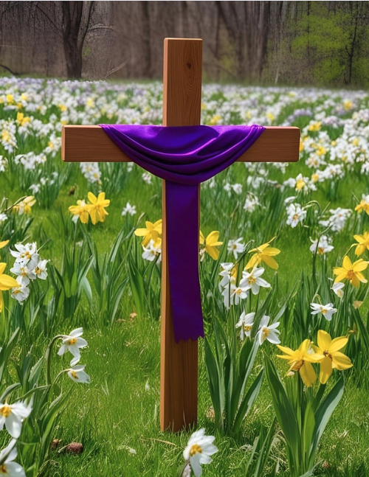

***Pastor****: TaeWon Kang*

*3049 Rectortown Road, Marshall, VA* 20115

*Pastor’s Cell Phone:* (470) 728 - 9060  
*Pastor’s E-mail:* pastortaewonkang@gmail.com

***Music Director****:* Karen Chase

***Ministers****: every member of the congregation*

Welcome to Rectortown UMC!

*“You are looking for Jesus the Nazarene, who was crucified. He has risen!”*

Mark 16:6 NIV

**\*** *Please Stand As You Are Able and Comfortable*

**PRELUDE** - *let us quiet our minds and hearts.*

**WELCOME, ANNOUNCEMENTS and CELEBRATIONS**

**\*BRINGING IN THE LIGHT OF CHRIST**

**\*CALL to WORSHIP**

Leader: How blessed we are that God forgives us

and loves us!  
**People: For all those times when we have**

**fallen short of what God would have us**

**be, we have been forgiven.**Leader: God makes us new in God’s Spirit!  
**People: Now is the time to joyfully accept the**

**newness of life which God offers to us.**Leader: Come, let us worship and be thankful.  
**People: Let us open our hearts to the peace**

**and joy of God. AMEN.**

**\*OPENING PRAYER**

**How incredible is your love, O God! We have been made new in your love and reconciled to you and to each other in peace and joy. Be with us this day as we hear your words of comfort and hope. Guide our lives that we may serve you more fully all of our days. AMEN.**

**\* HYMN**

“Alas! And Did My Savior Bleed” UMH 359 (v.1,2,&5)

**YOUNG DISCIPLES’ MESSAGE**

**\*PRAYER for ILLUMINATION** UMH 393

**Spirit of the living God, fall afresh on me.**

**Spirit of the living God, fall afresh on me.**

**Melt me, mold me, fill me, use me.**

**Spirit of the living God, fall afresh on me.**

**EPISTLE READING**

2 Corinthians 5: 16 - 21

This is the word of God for the people of God.

**Thanks be to God.**

**RESPONSIVE READING** Psalm 32 UMH 766

**\*GOSPEL READING** Luke 15: 1 – 3, 11b - 32

**\*** Gloria Patri –“Glory Be to the Father” UMH 70

**SERMON** “Jesus’ Love Accepting Us”

**\*RESPONDING HYMN**

“Amazing Grace” UMH 378

**AFFIRMATION OF FAITH**

Apostles’ Creed (Traditional Version) UMH 881

**SHARING OUR JOYS and CONCERNS**

**PASTORAL PRAYER & LORD’S PRAYER**

**GIVING OUR GIFTS and TITHES**

Offertory:

Doxology UMH 94  
 “Praise God from Whom All Blessings Flow”

Offertory Prayer

**\*CLOSING HYMN**

“O Happy day that fixed my choice” UMH 391 (v.1,2,&5)

**\*BENEDICTION**

**\* POSTLUDE**

* *Please stand as you are able and comfortable.*

|  |
| --- |
| ***This worship service has ended, and now your service begins.***  ***As you leave church today, you are entering the mission field.*** |

***PRAYERS FOR THE CHURCH AND FOR THE WORLD:***

|  |  |
| --- | --- |
| **For Family and Friends:** | |
| Linda Brown  Jim Caylen  Towny Lunsford  Christine Felts & Mother  Vickie Duff  The Reed Family | Shirley Embrey  Russ & Ethel Muter  Aiden Leake  Joann Garrett  Ann Woodward  Jean Fontana |
| **For the Family of those who grieve for:**  Laura Skirka  Judy Bailey  Colonel Jim Dismukes  LeAnn Scheuble | |
|  |  |

**For the Church and For the World:**

For those in need of healing, and their caretakers.

For first responders, the military, and their families.

For God’s People, The Church, and the World.

Prayers for national, state, and local leaders; and for our Nation.

**If you know someone you would like to add to our prayer list, please forward your request to the church office by email at: secretaryrumc@gmail.com, or by calling (540) 364-1066.**

**RUMC CELEBRATIONS**

|  |  |
| --- | --- |
| **Birthdays** | |
| Ward Ponn – 31st | William Deitrich – April 5th |
| **Anniversaries** | |
| Julie & James Massaro – April 2nd | |

**UPCOMING MEETINGS AND EVENTS**

**In Person Bible Study**

Every Tuesday at 10:30am in the fellowship hall

**Admin Council**

Thursday, April 3rd at 7pm. In person and zoom.

**Good Friday**

April 18th – MUMC service at Noon, RUMC service at 5:30pm

**Rectortown United Methodist Church**

Location: 3049 Rectortown Road, Rectortown, VA

Mailing Address: PO Box 301, Rectortown, VA 20140

Email: secretary@rectortownumc.org

Phone: (540)364.1066