Rectortown United Methodist Church
November 2nd, 2025 10:00 a.m.
21st Sunday after Pentecost/ All Saints

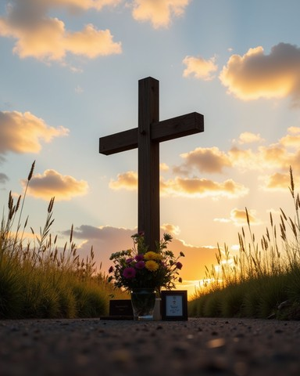

Pastor: Eduardo Carrillo
3049 Rectortown Road, Marshall, VA 20115
Pastor’s Cell Phone: (703) 967-4361
Pastor’s E-mail: pastor@rectortownumc.org
Music Director: Karen Chase
Ministers: every member of the congregation
Welcome to Rectortown UMC!

“This is the day that the Lord has made;
let us rejoice and be glad in it.” Psalm 118:24 NRSV

* Please Stand As You Are Able and Comfortable
PRELUDE - let us quiet our minds and hearts.
WELCOME, ANNOUNCEMENTS and CELEBRATIONS

GATHERING
*BRINGING IN THE LIGHT OF CHRIST

*CALL to WORSHIP
Leader: We remember the saints who have gone
before us.
People: Their faith still echoes in our hearts.
Leader: We gather with gratitude for lives well-
lived.
People: And with hope for the glory still to
come.
Leader: God’s power is at work in every
generation.
People: Let us worship the One who gives
life and light.

*OPENING PRAYER
Eternal God, you have knit together your people across time and space, calling each by name and holding all in your light. As we remember the saints today, those we’ve known and those we’ve never met, remind us of our place in your story. Strengthen us to live as your beloved and faithful people. Amen.
* HYMN
“For All the Saints” UMH 711

PROCLAMATION
YOUNG DISCIPLES’ MESSAGE

*PRAYER for ILLUMINATION UMH 393
Spirit of the living God, fall afresh on me.
Spirit of the living God, fall afresh on me.
Melt me, mold me, fill me, use me.
Spirit of the living God, fall afresh on me.

OLD TESTAMENT READING
Daniel 7: 1 – 3 , 15 – 18

*NEW TESTAMENT READING
Ephesians 1: 11 – 23
This is the word of God for the people of God.
Thanks be to God.

SERMON “Inheriting the Light”

RESPONSE
*RESPONDING HYMN
“We Are God’s People” TFWS 2220

INVITATION, CONFESSION, AND PARDON
INVITATION (UMH 12)
Christ our Lord invites to his table all who
love him,
Who earnestly repent of their sin
And seek to live in peace with one another.
Therefore, let us confess our sin before God
and one another.

CONFESSION (UMH 12)
Merciful God,
We confess that we have not loved you
with our whole heart.
We have failed to be an obedient church.
We have not done your will,
We have broken your law,
We have rebelled against your love,
We have not loved our neighbors,
And we have not heard the cry of the
needy.
Forgive us, we pray.
Free us for joyful obedience,
Through Jesus Christ our Lord. Amen.

PARDON (UMH 12)
Hear the good news:
Christ died for us while we were yet sinners;
That proves God’s love toward us.
In the name of Jesus Christ, you are forgiven!

PASSING OF THE PEACE

SHARING OUR JOYS and CONCERNS

PASTORAL PRAYER

GIVING OUR GIFTS and TITHES
Offertory:
Doxology UMH 94
“Praise God from Whom All Blessings Flow”
Offertory Prayer

GREAT THANKSGIVING UMH 13

LORD’S PRAYER, BREAKING THE BREAD, AND GIVING THE BREAD AND CUP UMH 14

*PRAYER AFTER COMMUNION UMH 11
Eternal God, we give you thanks for this holy mystery in which you have given yourself to us. Grant that we may go into the world in the strength of your Spirit, to give ourselves for others, in the name of Jesus Christ our Lord, Amen.

*CLOSING HYMN
“Faith of Our Fathers” UMH 710

SENDING FORTH
*BENEDICTION

* POSTLUDE
* Please stand as you are able and comfortable.
This worship service has ended, and now your service begins.
As you leave church today, you are entering the mission field.

PRAYERS FOR THE CHURCH AND FOR THE WORLD:
For Family and Friends:
Russ & Ethel Muter  Patsy Williams  Joan Newsome  Gillian Payne  Ernestine Hall  Sandra  Hall Family | John McGuinn & Sydney  Sandy Thomas  David Nalls  Kathleen Rhodes  Matt  Rick Willis
For the Family of those who grieve for:
Gaylen Ellison
Estelle Beach
Dottie Newman

For the Church and For the World:

For those in need of healing, and their caretakers.
For first responders, the military, and their families.
For God’s People, The Church, and the World.
Prayers for national, state, and local leaders; and for our Nation.

If you know someone you would like to add to our prayer list, please forward your request to the church office by email at: secretaryrumc@gmail.com, or by calling (540) 364-1066.

RUMC CELEBRATIONS

Birthdays
Tyler Willis – November 6th
Anniversaries
None

UPCOMING MEETINGS AND EVENTS

Admin Council
Thursday, November 6th at 7pm. In person and zoom.

Trustees Meeting
Tuesday, November 11th at 6pm. In person and zoom.

Fig Leaf
November 21st at 10 am, in person and zoom.

Charge Conference Date Change
November 19th at Woodstock UMC
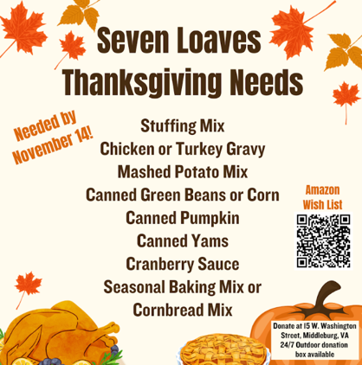
Election Day
November 4th

Rectortown United Methodist Church
  - Location: 3049 Rectortown Road, Rectortown, VA
Mailing Address: PO Box 301, Rectortown, VA 20140
Email: secretary@rectortownumc.org
Phone: (540)364.1066

