**Rectortown United Methodist Church**

July 6th, 2025 10:00 a.m.

*4th Sunday after Pentecost*

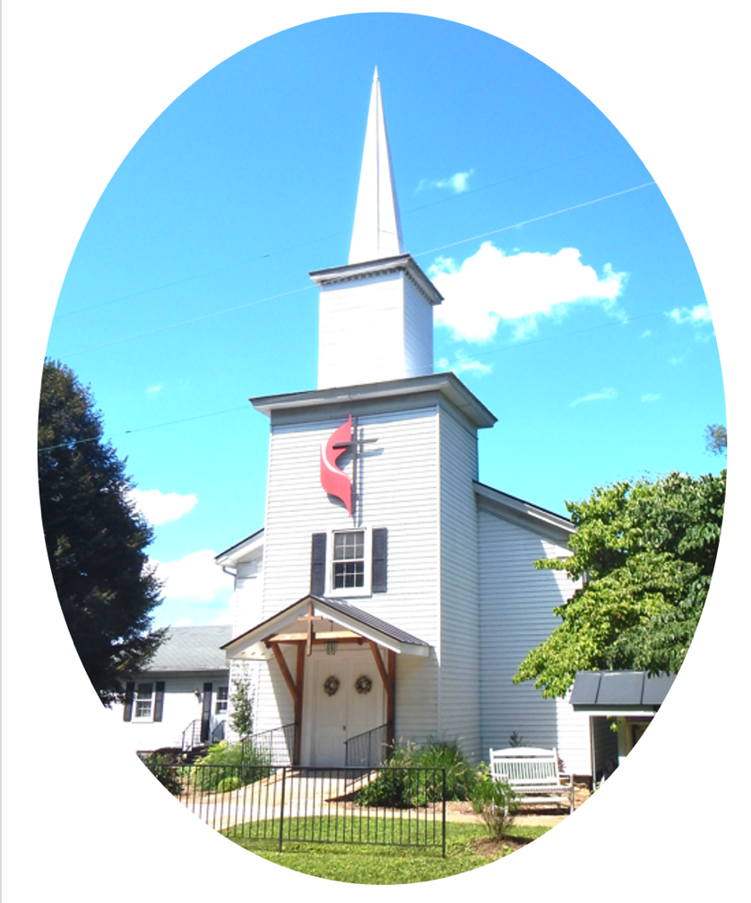

***Pastor****: Eduardo Carrillo*

*3049 Rectortown Road, Marshall, VA* 20115

*Pastor’s Cell Phone:* (703) 967-4361  
*Pastor’s E-mail:* pastor@rectortownumc.org

***Music Director****:* Karen Chase

***Ministers****: every member of the congregation*

Welcome to Rectortown UMC!

*“You are looking for Jesus the Nazarene, who was crucified. He has risen!”*

Mark 16:6 NIV

**\*** *Please Stand As You Are Able and Comfortable*

**PRELUDE** - *let us quiet our minds and hearts.*

**WELCOME, ANNOUNCEMENTS and CELEBRATIONS**

**\*BRINGING IN THE LIGHT OF CHRIST**

**\*CALL to WORSHIP**

Leader: Come, all who have known the depths of

sorrow and the heights of joy.

**People:** **We come to praise the One who**

**turns mourning into dancing.**

Leader: Come, all who are weary from carrying

burdens and walking the path of grace.

**People:** **We come to bear one another’s**

**burdens and walk by the Spirit**.

Leader: Lift up your hearts, for God’s anger is

brief, but His favor lasts a lifetime.

**People:** **We rejoice in the Lord, whose mercy**

**restores, whose love endures.**

**All:** **Let us worship God with grateful hearts,**

**giving glory to the One who makes all**

**things new!**

**\*OPENING PRAYER**

**Gracious God, You are the lifter of our heads, the healer of our wounds, and the restorer of our souls. We thank You for your mercy that meets us in the valley and raises us to new life. As we gather, quiet our distractions, forgive our failings, and fill us with your grace. Teach us to sow seeds of the Spirit, to bear one another’s burdens, and to rejoice in the grace that carries us through every season. In the name of Jesus Christ our Lord, Amen.**

**\* HYMN**

“What A Friend We Have In Jesus” UMH 526

**YOUNG DISCIPLES’ MESSAGE**

**\*PRAYER for ILLUMINATION** UMH 393

**Spirit of the living God, fall afresh on me.**

**Spirit of the living God, fall afresh on me.**

**Melt me, mold me, fill me, use me.**

**Spirit of the living God, fall afresh on me.**

**RESPONSIVE READING** Psalm 30 UMH 762

**\*NEW TESTAMENT READING**

Galatians 6: 1 – 16

This is the word of God for the people of God.

**Thanks be to God.**

**SERMON**

“New Chapter, Same Grace”

**\*RESPONDING HYMN**

“Come Thou Fount of Every Blessing” UMH 400

**INVITATION, CONFESSION, AND PARDON**

**INVITATION (UMH 12)**

Christ our Lord invites to his table all who

love him,

Who earnestly repent of their sin

And seek to live in peace with one another.

Therefore, let us confess our sin before God

and one another.

**CONFESSION (UMH 12)**

**Merciful God,**

**We confess that we have not loved you**

**with our whole heart.**

**We have failed to be an obedient church.**

**We have not done your will,**

**We have broken your law,**

**We have rebelled against your love,**

**We have not loved our neighbors,**

**And we have not heard the cry of the**

**needy.**

**Forgive us, we pray.**

**Free us for joyful obedience,**

**Through Jesus Christ our Lord. Amen.**

**PARDON (UMH 12)**

Hear the good news:

Christ died for us while we were yet sinners;

That proves God’s love toward us.

In the name of Jesus Christ, you are forgiven!

**PASSING OF THE PEACE**

**SHARING OUR JOYS and CONCERNS**

**PASTORAL PRAYER**

**GIVING OUR GIFTS and TITHES**

Offertory:

Doxology UMH 94  
 “Praise God from Whom All Blessings Flow”

Offertory Prayer

**GREAT THANKSGIVING** UMH 13

**LORD’S PRAYER, BREAKING THE BREAD, AND GIVING THE BREAD AND CUP** UMH 14

**\*PRAYER AFTER COMMUNION** UMH 11

***Eternal God, we give you thanks for this holy mystery in which you have given yourself to us. Grant that we may go into the world in the strength of your Spirit, to give ourselves for others, in the name of Jesus Christ our Lord, Amen.***

**\*CLOSING HYMN**

“Love Divine, All Loves Excelling” UMH 384

**\*BENEDICTION**

**\* POSTLUDE**

* *Please stand as you are able and comfortable.*

|  |
| --- |
| ***This worship service has ended, and now your service begins.***  ***As you leave church today, you are entering the mission field.*** |

***PRAYERS FOR THE CHURCH AND FOR THE WORLD:***

|  |  |
| --- | --- |
| **For Family and Friends:** | |
| Russ & Ethel Muter | |
| **For the Family of those who grieve for:**  Winnie | |
|  |  |

**For the Church and For the World:**

For those in need of healing, and their caretakers.

For first responders, the military, and their families.

For God’s People, The Church, and the World.

Prayers for national, state, and local leaders; and for our Nation.

**If you know someone you would like to add to our prayer list, please forward your request to the church office by email at: secretaryrumc@gmail.com, or by calling (540) 364-1066.**

**RUMC CELEBRATIONS**

|  |  |
| --- | --- |
| **Birthdays** | |
| Cindy Stolte -July 6th | Hazel Sisk – July 6th |
| Hunter Brown – July 7th | |
| **Anniversaries** | |
| Sue & Jess Lowry – July 10th | |

**UPCOMING MEETINGS AND EVENTS**

**Admin Council**

Thursday, **August 7th at 7pm**. In person and zoom.

**Trustees Meeting**

Tuesday, **July 8th** at 6pm. In person and zoom.

**Worship Meeting**

Cancelled

**Fig Leaf**

Tuesday, **July 15th** at 10am. Zoom and in person.

**Rectortown United Methodist Church**

Location: 3049 Rectortown Road, Rectortown, VA

Mailing Address: PO Box 301, Rectortown, VA 20140

Email: secretary@rectortownumc.org

Phone: (540)364.1066