Rectortown United Methodist Church
October 11th, 2026 9:30 a.m.
Twentieth Sunday after Pentecost


Pastor: Eduardo Carrillo
3049 Rectortown Road, Marshall, VA 20115
Pastor’s Cell Phone: (703) 967-4361
Pastor’s E-mail: eduardocarrillo@vaumc.org
Music Accompanist: Cheryl Kowalczyk
Ministers: every member of the congregation
Welcome to Rectortown UMC!

“This is the day that the Lord has made;
let us rejoice and be glad in it.” Psalm 118:24 NRSV

* Please Stand As You Are Able and Comfortable
PRELUDE - let us quiet our minds and hearts.
WELCOME, ANNOUNCEMENTS and CELEBRATIONS
GATHERING
*BRINGING IN THE LIGHT OF CHRIST

*CALL to WORSHIP
Leader: God invites us to a lavish banquet, a feast of joy and abundance.
People: Yet we fashion golden calves in the wilderness, seeking gods we can control.
Leader: The Lord’s anger burns against our spiritual adultery, yet His mercy turns aside destruction.
People: He remembers His covenant and calls us back from our self-made altars.
Leader: Come to the feast, but come clothed in the righteousness of Christ.
People: We lay down our idols to put on the garments of salvation.

*OPENING PRAYER
Gracious Father, we are quick to wander and eager to replace Your living presence with cheap, manageable substitutes. We confess that like Israel, we make gods out of gold, and like the ungrateful guests, we make light of Your gracious invitation.
Lord, turn away Your wrath and forgive our fickleness. Robe us in the righteous wedding garments of Christ, that we may stand before Your holy presence without fear. Break our addiction to lesser things and fill us with the holy joy of Your kingdom. Amen.

* HYMN
“Come Thou Fount of Every Blessing” UMH 400
PROCLAMATION
*PRAYER for ILLUMINATION UMH 393
Spirit of the living God, fall afresh on me.
Spirit of the living God, fall afresh on me.
Melt me, mold me, fill me, use me.
Spirit of the living God, fall afresh on me.

FIRST READING
Exodus 32: 1 – 14
*SECOND READING
Matthew 22: 1 – 14
This is the word of God for the people of God.
Thanks be to God.

SERMON
“Golden Calves and Wedding Garments”

RESPONSE
*RESPONDING HYMN UMH 348
“Softly and Tenderly, Jesus is Calling”

*AFFIRMATION OF FAITH UMH 881
Apostles’ Creed (Traditional Version)

GIVING OUR GIFTS and TITHES
Offertory:
Doxology UMH 94
“Praise God from Whom All Blessings Flow”
Offertory Prayer

SENDING FORTH
SHARING OUR JOYS & CONCERNS
PASTORAL PRAYER & LORD’S PRAYER
*BENEDICTION & POSTLUDE

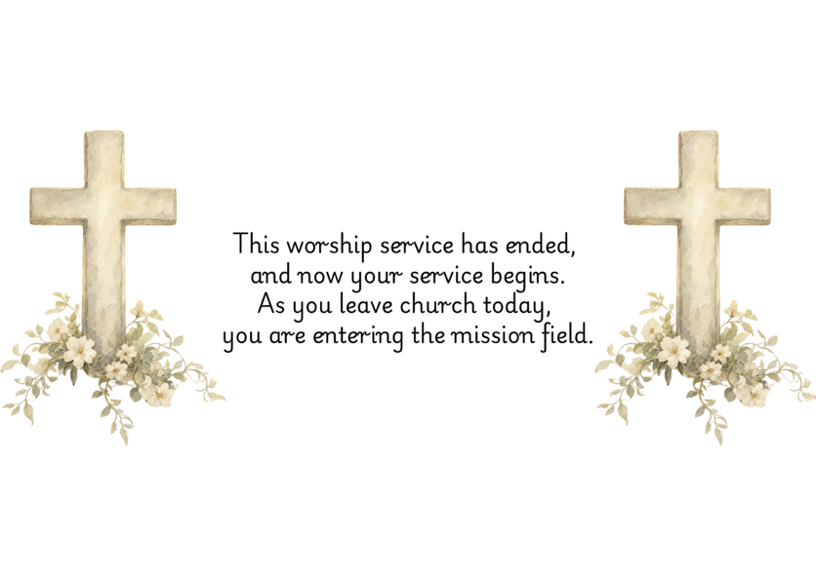

PRAYERS FOR THE CHURCH AND FOR THE WORLD:
For Family and Friends:
Russ & Ethel Muter  Gillian Payne  Billy Wines  Gloria Shelton  Joan Newsome  Keith Kuck  Don Williams | Kathleen Rhodes  Rick Willis  Austin  Shirley Embrey  Marline & Warren  Billy Wines  Tammy Frazier
For the Family of those who grieve for:
Teddy Saunders
For the Church and For the World:

For those in need of healing, and their caretakers.
For first responders, the military, and their families.
For God’s People, The Church, and the World.
Prayers for national, state, and local leaders; and for our Nation.
If you know someone you would like to add to our prayer list, please forward your request to the church office by email at: secretary@rectortownumc.org or by calling (540) 364-1066.

RUMC CELEBRATIONS
Birthdays
Erica Cooper – 11th

Anniversaries
None

UPCOMING MEETINGS AND EVENTS
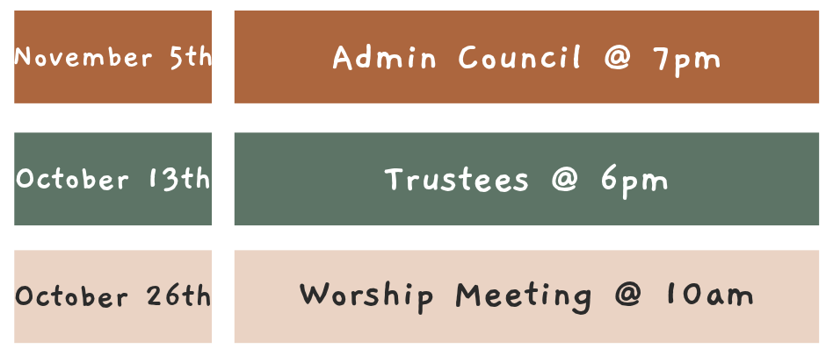

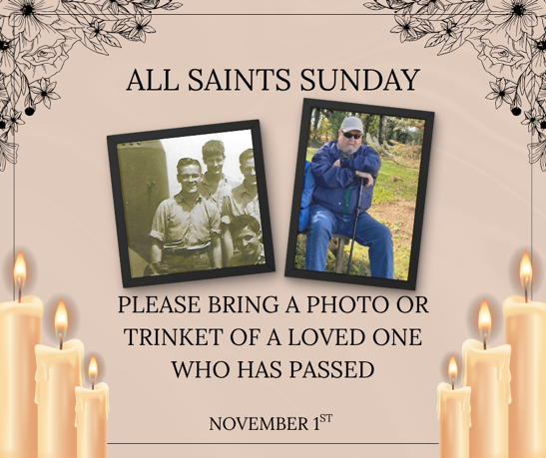

Rectortown United Methodist Church
  - Location: 3049 Rectortown Road, Rectortown, VA
Mailing Address: PO Box 301, Rectortown, VA 20140
Email: secretary@rectortownumc.org
Phone: (540)364.1066

