Rectortown United Methodist Church
December 21st, 2025 10:00 a.m.
4th Sunday of Advent



Pastor: Eduardo Carrillo
3049 Rectortown Road, Marshall, VA 20115
Pastor’s Cell Phone: (703) 967-4361
Pastor’s E-mail: pastor@rectortownumc.org
Music Director: Karen Chase
Ministers: every member of the congregation
Welcome to Rectortown UMC!

“This is the day that the Lord has made;
let us rejoice and be glad in it.” Psalm 118:24 NRSV

* Please Stand As You Are Able and Comfortable
PRELUDE - let us quiet our minds and hearts.
WELCOME, ANNOUNCEMENTS and CELEBRATIONS

GATHERING
*BRINGING IN THE LIGHT OF CHRIST

*CALL to WORSHIP
Leader: Come, people of God, for joy is drawing
near.
People: We come to make room for joy that
is deeper than circumstance.
Leader: When fear or uncertainty clouds our
hearts, God whispers, “Do not be afraid.”
People: We come to trust the promise of
Emmanuel – God with us.
Leader: Today, we light the candle of JOY. Like
Joseph, we open our hearts to the
surprising ways God works.
All: Christ comes as Joy – quiet, steady, and
true, filling the spaces where fear once
lived.

*OPENING PRAYER
God of abiding joy, you enter our lives in unexpected ways, turning confusion into confidence and fear into faith. When we are hesitant to believe, remind us that your presence is our assurance. Make room in our hearts for the joy that comes from trusting your promises. Let that joy take root and grow until it overflows into the world around us. In the name of Jesus, our Joy and our Emmanuel, we pray. Amen.

* HYMN
“Once in Royal David’s City” UMH 250

PROCLAMATION
YOUNG DISCIPLES’ MESSAGE

*PRAYER for ILLUMINATION UMH 393
Spirit of the living God, fall afresh on me.
Spirit of the living God, fall afresh on me.
Melt me, mold me, fill me, use me.
Spirit of the living God, fall afresh on me.

OLD TESTAMENT READING
Isaiah 7: 10 – 16

*NEW TESTAMENT READING
Matthew 1:18 – 25
This is the word of God for the people of God.
Thanks be to God.

SERMON “Room for Joy”

RESPONSE
*RESPONDING HYMN
“What Child is This?” UMH 219

*AFFIRMATION OF FAITH UMH 881
Apostles’ Creed (Traditional Version)

SHARING OUR JOYS and CONCERNS

PASTORAL PRAYER & LORD’S PRAYER

GIVING OUR GIFTS and TITHES
Offertory:
Doxology UMH 94
“Praise God from Whom All Blessings Flow”
Offertory Prayer

*CLOSING HYMN
“Hark! The Herald Angels Sing” UMH 240

SENDING FORTH
*BENEDICTION

* POSTLUDE
* Please stand as you are able and comfortable.
This worship service has ended, and now your service begins.
As you leave church today, you are entering the mission field.

PRAYERS FOR THE CHURCH AND FOR THE WORLD:
For Family and Friends:
Russ & Ethel Muter  Gillian Payne  Ernestine Hall  Sandra  Hall Family  Donna Olson | John McGuinn & Sydney  Kathleen Rhodes  Rick Willis  Don  Austin  Dennis
For the Family of those who grieve for:

For the Church and For the World:

For those in need of healing, and their caretakers.
For first responders, the military, and their families.
For God’s People, The Church, and the World.
Prayers for national, state, and local leaders; and for our Nation.

If you know someone you would like to add to our prayer list, please forward your request to the church office by email at: secretaryrumc@gmail.com, or by calling (540) 364-1066.

RUMC CELEBRATIONS

Birthdays
None
Anniversaries
None

UPCOMING MEETINGS AND EVENTS

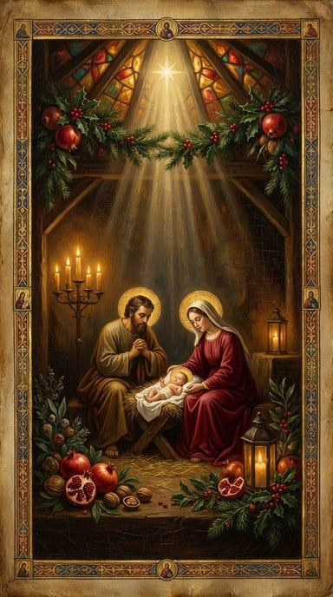
Christmas Eve Service – December 24th at 5 pm

Rectortown United Methodist Church
  - Location: 3049 Rectortown Road, Rectortown, VA
Mailing Address: PO Box 301, Rectortown, VA 20140
Email: secretary@rectortownumc.org
Phone: (540)364.1066

