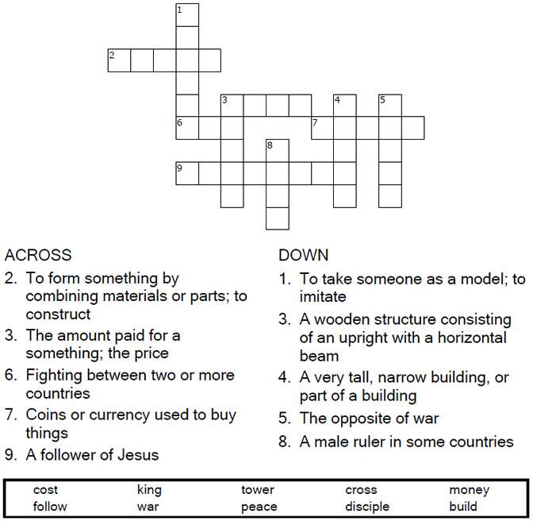


Copyright © Sermons4Kids, Inc.
May be reproduced for Ministry Use

Children’s Worship Bulletin

Counting the Cost

Luke 14:25-33

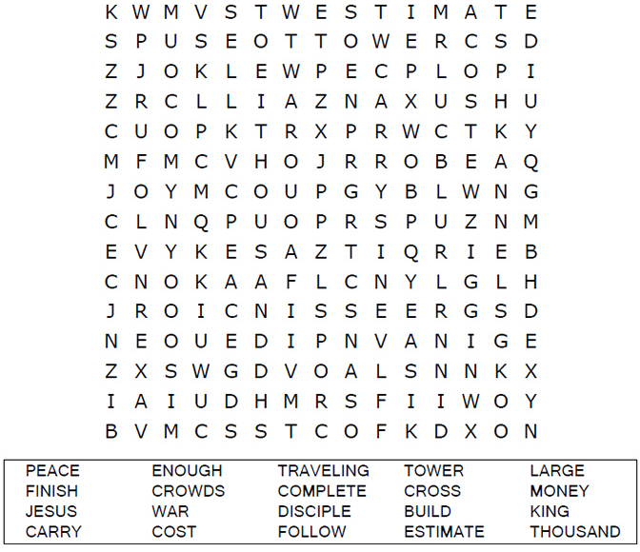

Your Church Name
City, Address

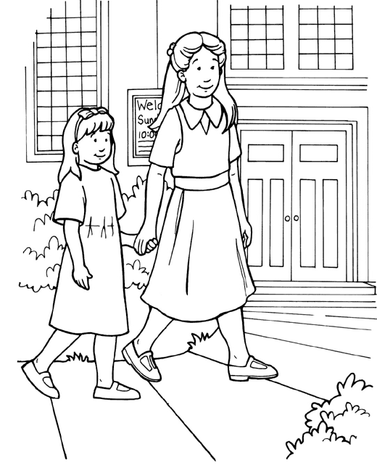
I will follow Jesus, God’s Son

From Thru-the-Bible Coloring Pages for Ages 4-8. © Standard Publishing.
Used by permission. Reproducible Coloring Books may be purchased from
Standard Publishing, www.standardpub.com, 1-800-543-1301.

Enter the correct words in the boxes based on the shape of the letters.

