Rectortown United Methodist Church
January 18th, 2026 10:00 a.m.
Second Sunday after Epiphany
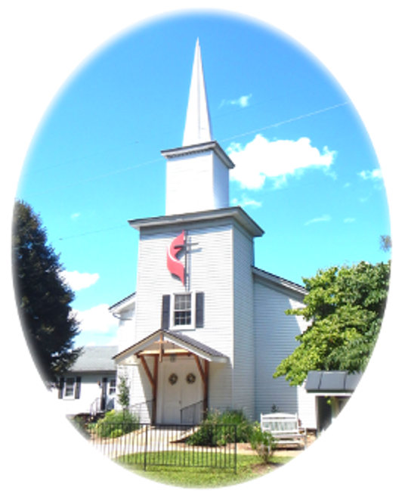

Pastor: Eduardo Carrillo
3049 Rectortown Road, Marshall, VA 20115
Pastor’s Cell Phone: (703) 967-4361
Pastor’s E-mail: pastor@rectortownumc.org
Guest Music Director: Cheryl Kowalczyk
Ministers: every member of the congregation
Welcome to Rectortown UMC!

“This is the day that the Lord has made;
let us rejoice and be glad in it.” Psalm 118:24 NRSV

* Please Stand As You Are Able and Comfortable
PRELUDE - let us quiet our minds and hearts.
WELCOME, ANNOUNCEMENTS and CELEBRATIONS

GATHERING
*BRINGING IN THE LIGHT OF CHRIST

*CALL to WORSHIP
Leader: It all begins with God’s grace
People: a gift of God’s love.
Leader: Grace cannot be put in a box.
People: We receive God’s grace even before
we know it’s there.
Leader: God shows us grace, not because of what
we do,
People: But because we are beloved,
cherished, and forgiven!

*OPENING PRAYER
Loving God, you surround us in your grace so fully that sometimes we don’t even know it’s there. It goes before us, with us and behind us, our very breath and life. Thank you for this unending gift that calls us into life and love, makes our relationship with you right, and transforms us to become more and more like Jesus. In this time of worship, help us to know and treasure your grace more deeply. Warm our hearts by its fire. In Jesus’ name we pray. Amen.

* HYMN
“Amazing Grace” UMH 378

PROCLAMATION
YOUNG DISCIPLES’ MESSAGE

*PRAYER for ILLUMINATION UMH 393
Spirit of the living God, fall afresh on me.
Spirit of the living God, fall afresh on me.
Melt me, mold me, fill me, use me.
Spirit of the living God, fall afresh on me.

OLD TESTAMENT READING
Exodus 34: 1 – 9

*NEW TESTAMENT READING
Ephesians 2: 4 – 10

This is the word of God for the people of God.
Thanks be to God.

SERMON “Grace”

RESPONSE
*RESPONDING HYMN
“I Love to Tell the Story” UMH 156

*AFFIRMATION OF FAITH UMH 881
Apostles’ Creed (Traditional Version)

SHARING OUR JOYS and CONCERNS

PASTORAL PRAYER & LORD’S PRAYER

GIVING OUR GIFTS and TITHES
Offertory:
Doxology UMH 94
“Praise God from Whom All Blessings Flow”
Offertory Prayer

*CLOSING HYMN
“The Summons” TFWS 2130

SENDING FORTH
*BENEDICTION

* POSTLUDE
* Please stand as you are able and comfortable.
This worship service has ended, and now your service begins.
As you leave church today, you are entering the mission field.

PRAYERS FOR THE CHURCH AND FOR THE WORLD:
For Family and Friends:
Russ & Ethel Muter  Gillian Payne  Ernestine Hall  Sandra  Hall Family  Donna Olson  Joan Newsome | John McGuinn & Sydney  Kathleen Rhodes  Rick Willis  Don Williams  Austin  Dennis
For the Family of those who grieve for:
Larry Underwood
For the Church and For the World:

For those in need of healing, and their caretakers.
For first responders, the military, and their families.
For God’s People, The Church, and the World.
Prayers for national, state, and local leaders; and for our Nation.

If you know someone you would like to add to our prayer list, please forward your request to the church office by email at: secretaryrumc@gmail.com, or by calling (540) 364-1066.

RUMC CELEBRATIONS

Birthdays
None
Anniversaries
None

UPCOMING MEETINGS AND EVENTS

Martin Luther King, Jr. Day
Offices Closed, January 19th

Pastor and Secretary Out of office
January 21st, joint breakfast meeting

Rectortown United Methodist Church
  - Location: 3049 Rectortown Road, Rectortown, VA
Mailing Address: PO Box 301, Rectortown, VA 20140
Email: secretary@rectortownumc.org
Phone: (540)364.1066

