Rectortown United Methodist Church
December 24th, 2025 5:00 pm
Christmas Eve Service

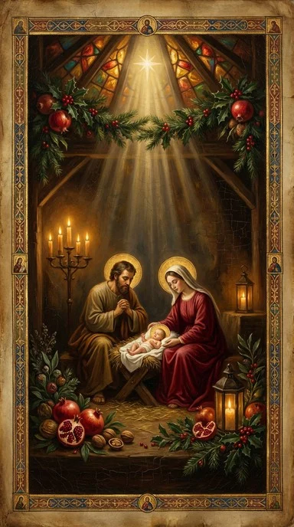

Pastor: Eduardo Carrillo
3049 Rectortown Road, Marshall, VA 20115
Pastor’s Cell Phone: (703) 967-4361
Pastor’s E-mail: pastor@rectortownumc.org
Music Director: Karen Chase
Ministers: every member of the congregation
Welcome to Rectortown UMC!

“This is the day that the Lord has made;
let us rejoice and be glad in it.” Psalm 118:24 NRSV

* Please Stand As You Are Able and Comfortable
PRELUDE - let us quiet our minds and hearts.
WELCOME, ANNOUNCEMENTS and CELEBRATIONS

GATHERING
*BRINGING IN THE LIGHT OF CHRIST

*CALL to WORSHIP
Leader: Tonight, heaven breaks into earth with
good news.
People: Glory to God in the highest!
Leader: Tonight, light shines in the darkness.
People: Joy fills the air, and peace is
proclaimed.
Leader: Tonight, we light the candle where there
is room for all, for hope, for peace, for love
and for joy. Let us keep the light alive in us
and in the world.
All: Come, Emmanuel, God with us!

*OPENING PRAYER
Holy God, on this night we gather with wonder and gratitude. You come to us not in power or splendor, but in humility and love. In the ordinary places of our lives, you make room for your extraordinary presence. Shine your light in us and through us. Fill us with peace, surround us with joy, and send us out with your love to share the good news: Christ is born! It is in the name of the One who is the Light of the World that we pray. Amen.

* HYMN
“Angels We Have Heard on High” UMH 238

PROCLAMATION
YOUNG DISCIPLES’ MESSAGE

*PRAYER for ILLUMINATION UMH 393
Spirit of the living God, fall afresh on me.
Spirit of the living God, fall afresh on me.
Melt me, mold me, fill me, use me.
Spirit of the living God, fall afresh on me.

SCRIPTURE READING
Luke 2: 1 – 20
This is the word of God for the people of God.
Thanks be to God.

SERMON “Making Room”

RESPONSE
*RESPONDING HYMN
“O Little Town of Bethlehem” UMH 230

*AFFIRMATION OF FAITH UMH 881
Apostles’ Creed (Traditional Version)

SHARING OUR JOYS and CONCERNS

PASTORAL PRAYER & LORD’S PRAYER

GIVING OUR GIFTS and TITHES
Offertory:
Doxology UMH 94
“Praise God from Whom All Blessings Flow”
Offertory Prayer

*CLOSING HYMN
“Silent Night” UMH 239

SENDING FORTH
*BENEDICTION

* POSTLUDE
* Please stand as you are able and comfortable.
This worship service has ended, and now your service begins.
As you leave church today, you are entering the mission field.

PRAYERS FOR THE CHURCH AND FOR THE WORLD:
For Family and Friends:
Russ & Ethel Muter  Gillian Payne  Ernestine Hall  Sandra  Hall Family  Donna Olson | John McGuinn & Sydney  Kathleen Rhodes  Rick Willis  Don Williams  Austin  Dennis
For the Family of those who grieve for:

For the Church and For the World:

For those in need of healing, and their caretakers.
For first responders, the military, and their families.
For God’s People, The Church, and the World.
Prayers for national, state, and local leaders; and for our Nation.

If you know someone you would like to add to our prayer list, please forward your request to the church office by email at: secretaryrumc@gmail.com, or by calling (540) 364-1066.

RUMC CELEBRATIONS

Birthdays
None

Anniversaries
None



Rectortown United Methodist Church
  - Location: 3049 Rectortown Road, Rectortown, VA
Mailing Address: PO Box 301, Rectortown, VA 20140
Email: secretary@rectortownumc.org
Phone: (540)364.1066

