Crossword Puzzle

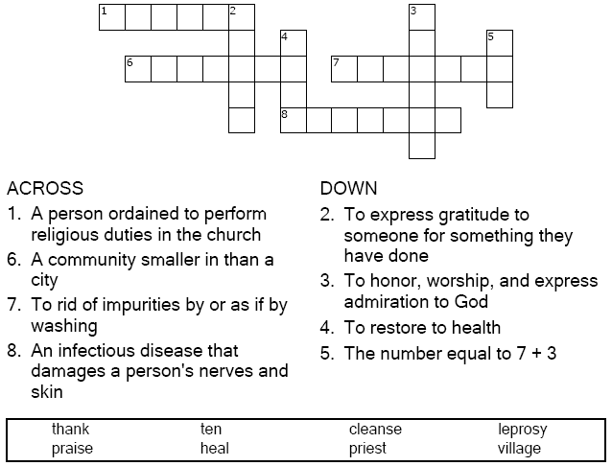

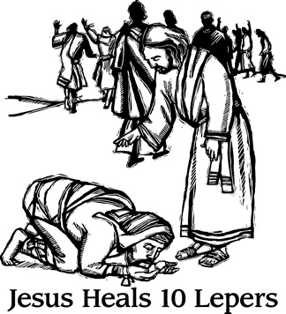

Copyright © Sermons4Kids, Inc.

May be reproduced for Ministry Use

**Children’s Worship Bulletin**



Luke 17:11-19

Word Search Puzzle

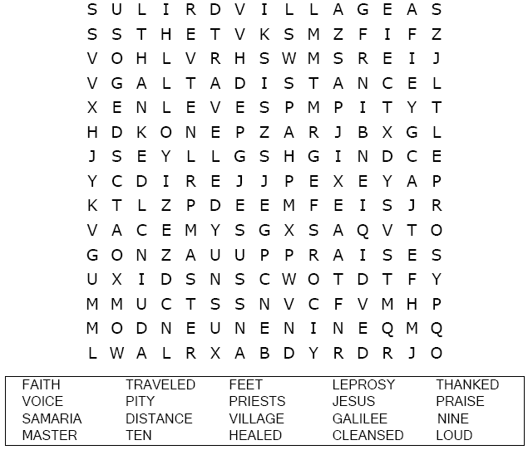

Coloring Page

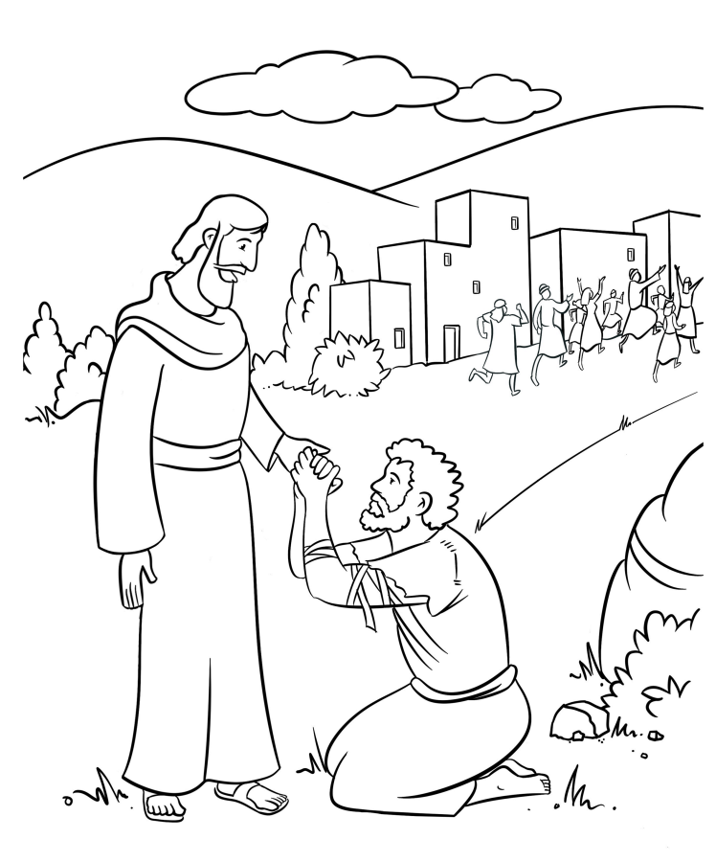

**The Ten Lepers  
Luke 17:11-19**

Decoder Puzzle

Each number represents a letter of the alphabet. Substitute  
the correct letter for the numbers to reveal the coded words.

