Rectortown United Methodist Church
February 8th, 2026 10:00 a.m.
Fifth Sunday After Epiphany
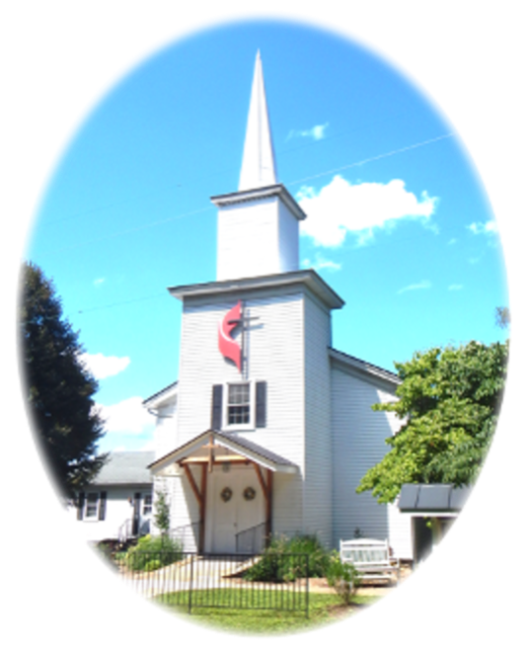

Pastor: Eduardo Carrillo
3049 Rectortown Road, Marshall, VA 20115
Pastor’s Cell Phone: (703) 967-4361
Pastor’s E-mail: pastor@rectortownumc.org
Music Director: Karen Chase
Ministers: every member of the congregation
Welcome to Rectortown UMC!

“This is the day that the Lord has made;
let us rejoice and be glad in it.” Psalm 118:24 NRSV

* Please Stand As You Are Able and Comfortable
PRELUDE - let us quiet our minds and hearts.
WELCOME, ANNOUNCEMENTS and CELEBRATIONS
GATHERING
*BRINGING IN THE LIGHT OF CHRIST
*CALL to WORSHIP
Leader: We don’t always get it right.
People: So, we learn from one another.
Leader: Sometimes our conversations cause pain
People: but we are called to speak with love.
Leader: Forgiveness is key to working together,
People: just as God forgives us.
Leader: We are called to do everything out of
love,
People: because God loved us first!

*OPENING PRAYER
God of us all, thank you that we do not have to do this life of faith alone. Thank you for the community both near and far that walks alongside us. When we experience division in your beloved family, help us to remember our common bond in Jesus Christ. Give us your Spirit of compassion, kindness, humility, patience, and love in our relationships with one another. May our life together show the world what is possible with you. All this we pray in Jesus’ name. Amen.
* HYMN
“Guide Me, O Though Great Jehovah” UMH 127

PROCLAMATION
YOUNG DISCIPLES’ MESSAGE

*PRAYER for ILLUMINATION UMH 393
Spirit of the living God, fall afresh on me.
Spirit of the living God, fall afresh on me.
Melt me, mold me, fill me, use me.
Spirit of the living God, fall afresh on me.

OLD TESTAMENT READING
Malachi 3: 16 – 18

*NEW TESTAMENT READING
Colossians 3: 12 – 17
This is the word of God for the people of God.
Thanks be to God.

SERMON “Holy Conferencing”

RESPONSE
*RESPONDING HYMN
“Together We Serve” TFWS 2175

INVITATION, CONFESSION, AND PARDON
INVITATION (UMH 12)
Christ our Lord invites to his table all who
love him,
Who earnestly repent of their sin
And seek to live in peace with one another.
Therefore, let us confess our sin before God
and one another.

CONFESSION (UMH 12)
Merciful God,
We confess that we have not loved you
with our whole heart.
We have failed to be an obedient church.
We have not done your will,
We have broken your law,
We have rebelled against your love,
We have not loved our neighbors,
And we have not heard the cry of the
needy.
Forgive us, we pray.
Free us for joyful obedience,
Through Jesus Christ our Lord. Amen.
PARDON (UMH 12)
Hear the good news:
Christ died for us while we were yet sinners;
That proves God’s love toward us.
In the name of Jesus Christ, you are forgiven!

PASSING OF THE PEACE

SHARING OUR JOYS and CONCERNS
PASTORAL PRAYER

GIVING OUR GIFTS and TITHES
Offertory:
Doxology UMH 94
“Praise God from Whom All Blessings Flow”
Offertory Prayer
GREAT THANKSGIVING UMH 13
LORD’S PRAYER, BREAKING THE BREAD, AND GIVING THE BREAD AND CUP UMH 14

*PRAYER AFTER COMMUNION UMH 11
Eternal God, we give you thanks for this holy mystery in which you have given yourself to us. Grant that we may go into the world in the strength of your Spirit, to give ourselves for others, in the name of Jesus Christ our Lord, Amen.

*CLOSING HYMN
“Pass It On” UMH 572

SENDING FORTH
*BENEDICTION
* POSTLUDE
* Please stand as you are able and comfortable.
This worship service has ended, and now your service begins.
As you leave church today, you are entering the mission field.

PRAYERS FOR THE CHURCH AND FOR THE WORLD:
For Family and Friends:
Russ & Ethel Muter  Gillian Payne  Ernestine Hall  Sandra  Hall Family  Donna Olson  Joan Newsome | John McGuinn & Sydney  Kathleen Rhodes  Rick Willis  Don Williams  Austin  Dennis
For the Family of those who grieve for:
Larry Underwood
For the Church and For the World:

For those in need of healing, and their caretakers.
For first responders, the military, and their families.
For God’s People, The Church, and the World.
Prayers for national, state, and local leaders; and for our Nation.

If you know someone you would like to add to our prayer list, please forward your request to the church office by email at: secretaryrumc@gmail.com, or by calling (540) 364-1066.

RUMC CELEBRATIONS

Birthdays
None
Anniversaries
None

UPCOMING MEETINGS AND EVENTS

Trustees Meeting
Tuesday, February 10th at 6 pm.
Zoom & In Person

Fig Leaf
Friday, February 20th at 10 am. Zoom & In Person

Worship Meeting
Wednesday, February 25th at 10 am. Zoom & In Person

Pastor & Joint Secretary Meeting
Friday, February 13th at 11am. Tentative

Rectortown United Methodist Church
  - Location: 3049 Rectortown Road, Rectortown, VA
Mailing Address: PO Box 301, Rectortown, VA 20140
Email: secretary@rectortownumc.org
Phone: (540)364.1066

