Rectortown United Methodist Church
June 22nd, 2025 10:00 a.m.
Second Sunday after Pentecost
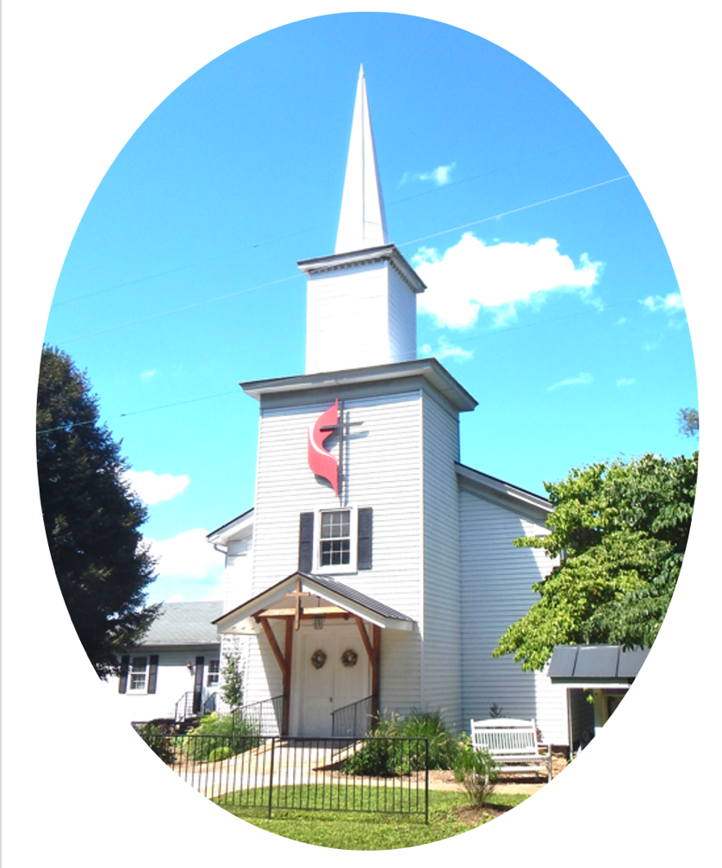

Guest Speaker: Cheryl Kowalczyk
3049 Rectortown Road, Marshall, VA 20115
Pastor’s Cell Phone:
Pastor’s E-mail:
Music Director: Karen Chase
Ministers: every member of the congregation
Welcome to Rectortown UMC!

“You are looking for Jesus the Nazarene, who was crucified. He has risen!”
Mark 16:6 NIV

* Please Stand As You Are Able and Comfortable
PRELUDE - let us quiet our minds and hearts.

WELCOME, ANNOUNCEMENTS and CELEBRATIONS

*BRINGING IN THE LIGHT OF CHRIST

*CALL to WORSHIP
Leader: As we have been baptized into Christ,
People: We are clothed with Christ.
Leader: And if we belong to Christ,
People: Then we are Abraham’s offspring
Leader: And heirs according to the promise.
People: Thanks be to God.

*OPENING PRAYER
Holy God, there is much that tries to separate us from one another. Creed and color, gender and nation, class and culture call for our fragmentation, but you call us to live together in your grace. You call us your children. You call us beloved. Today, let the refrain: “There is no longer Jew or Greek; there is no longer slave or free; there is no longer male and female, for all of you are one in Christ Jesus” (Gal. 3:29) guide us with every step. We pray this in Jesus’ name. Amen.
* HYMN
“Be Thou My Vision” UMH 451

YOUNG DISCIPLES’ MESSAGE

*PRAYER for ILLUMINATION UMH 393
Spirit of the living God, fall afresh on me.
Spirit of the living God, fall afresh on me.
Melt me, mold me, fill me, use me.
Spirit of the living God, fall afresh on me.

NEW TESTAMENT READING
Galatians 3: 23 - 29
This is the word of God for the people of God.
Thanks be to God.

RESPONSIVE READING Psalm 130 UMH 824
* Gloria Patri –“Glory Be to the Father” UMH 70

SERMON
“Waiting in Expectant Hope”

*NICENE CREED UMH 880

SHARING OUR JOYS and CONCERNS

PASTORAL PRAYER & LORD’S PRAYER

GIVING OUR GIFTS and TITHES
Offertory:
Doxology UMH 94
“Praise God from Whom All Blessings Flow”
Offertory Prayer

*CLOSING HYMN
“God of Love and God of Power” UMH 578

*BENEDICTION

* POSTLUDE
* Please stand as you are able and comfortable.
This worship service has ended, and now your service begins.
As you leave church today, you are entering the mission field.

PRAYERS FOR THE CHURCH AND FOR THE WORLD:
For Family and Friends:
Christine Felts & Mother | Russ & Ethel Muter
For the Family of those who grieve for:
Winnie
For the Church and For the World:

For those in need of healing, and their caretakers.
For first responders, the military, and their families.
For God’s People, The Church, and the World.
Prayers for national, state, and local leaders; and for our Nation.
If you know someone you would like to add to our prayer list, please forward your request to the church office by email at: secretaryrumc@gmail.com, or by calling (540) 364-1066.

RUMC CELEBRATIONS

Birthdays
Ethan Brown – June 25th
Anniversaries
None

UPCOMING MEETINGS AND EVENTS

Admin Council
Thursday, July 3rd at 7pm. In person and zoom.

Trustees Meeting
Tuesday, July 8th at 6pm. In person and zoom.

Fig Leaf
Tuesday, July 15th at 10am. Zoom and in person.

Pastor Move In Day
June 25th

Office Closed
July 4th, 2025

Rectortown United Methodist Church
  - Location: 3049 Rectortown Road, Rectortown, VA
Mailing Address: PO Box 301, Rectortown, VA 20140
Email: secretary@rectortownumc.org
Phone: (540)364.1066

