Rectortown United Methodist Church
November 9th, 2025 10:00 a.m.
22nd Sunday after Pentecost/ Veteran’s Day/ Organ & Tissue Donor Sunday


Pastor: Eduardo Carrillo
3049 Rectortown Road, Marshall, VA 20115
Pastor’s Cell Phone: (703) 967-4361
Pastor’s E-mail: pastor@rectortownumc.org
Music Director: Karen Chase
Ministers: every member of the congregation
Welcome to Rectortown UMC!

“This is the day that the Lord has made;
let us rejoice and be glad in it.” Psalm 118:24 NRSV

* Please Stand As You Are Able and Comfortable
PRELUDE - let us quiet our minds and hearts.
WELCOME, ANNOUNCEMENTS and CELEBRATIONS

GATHERING
*BRINGING IN THE LIGHT OF CHRIST

*CALL to WORSHIP
Leader: Though the vision tarries, wait for it.
People: God’s promises do not fail.
Leader: God is not the God of the dead, but of
the living.
People: In life and in death, we belong to
God.
Leader: Let us give thanks for the gift of life.
People: We worship with joy and reverence.

*OPENING PRAYER
God of life eternal, you hold us in love from first breath to final sigh and beyond. You see what we cannot, and you promise what we can barely imagine. Fill us with trust in your power to redeem and restore. Make us generous with our lives, our hope, and our care for others. Amen.

* HYMN
“The God of Abraham Praise” UMH 116

PROCLAMATION
YOUNG DISCIPLES’ MESSAGE

*PRAYER for ILLUMINATION UMH 393
Spirit of the living God, fall afresh on me.
Spirit of the living God, fall afresh on me.
Melt me, mold me, fill me, use me.
Spirit of the living God, fall afresh on me.

OLD TESTAMENT READING
Habakkuk 2: 1 – 9

*NEW TESTAMENT READING
Luke 20: 27 – 38
This is the word of God for the people of God.
Thanks be to God.

SERMON “Living Beyond Death”

RESPONSE
*RESPONDING HYMN
“I Want Jesus to Walk With Me” UMH 521

*AFFIRMATION OF FAITH UMH 881
Apostles’ Creed (Traditional Version)

SHARING OUR JOYS and CONCERNS

PASTORAL PRAYER & LORD’S PRAYER

GIVING OUR GIFTS and TITHES
Offertory:
Doxology UMH 94
“Praise God from Whom All Blessings Flow”
Offertory Prayer

*CLOSING HYMN
“Immortal, Invisible, God Only Wise” UMH 133

SENDING FORTH
*BENEDICTION

* POSTLUDE
* Please stand as you are able and comfortable.
This worship service has ended, and now your service begins.
As you leave church today, you are entering the mission field.

PRAYERS FOR THE CHURCH AND FOR THE WORLD:
For Family and Friends:
Russ & Ethel Muter  Patsy Williams  Joan Newsome  Gillian Payne  Ernestine Hall  Sandra  Hall Family | John McGuinn & Sydney  Sandy Thomas  David Nalls  Kathleen Rhodes  Matt  Rick Willis
For the Family of those who grieve for:
Gaylen Ellison
Estelle Beach
Dottie Newman

For the Church and For the World:

For those in need of healing, and their caretakers.
For first responders, the military, and their families.
For God’s People, The Church, and the World.
Prayers for national, state, and local leaders; and for our Nation.

If you know someone you would like to add to our prayer list, please forward your request to the church office by email at: secretaryrumc@gmail.com, or by calling (540) 364-1066.

RUMC CELEBRATIONS

Birthdays
Luna Carrillo – November 11th | Diane Harrington – November 13th
Tara Wegdam – November 14th
Anniversaries
None
UPCOMING MEETINGS AND EVENTS

Admin Council
Thursday, December 4th at 7pm. In person and zoom.

Trustees Meeting
Tuesday, November 11th at 6pm. In person and zoom.

Fig Leaf
Friday, November 21st at 10am.

Charge Conference
November 16th at Woodstock UMC

Veterans Day
November 11th

Claude Thompson Giving – Angel Tree
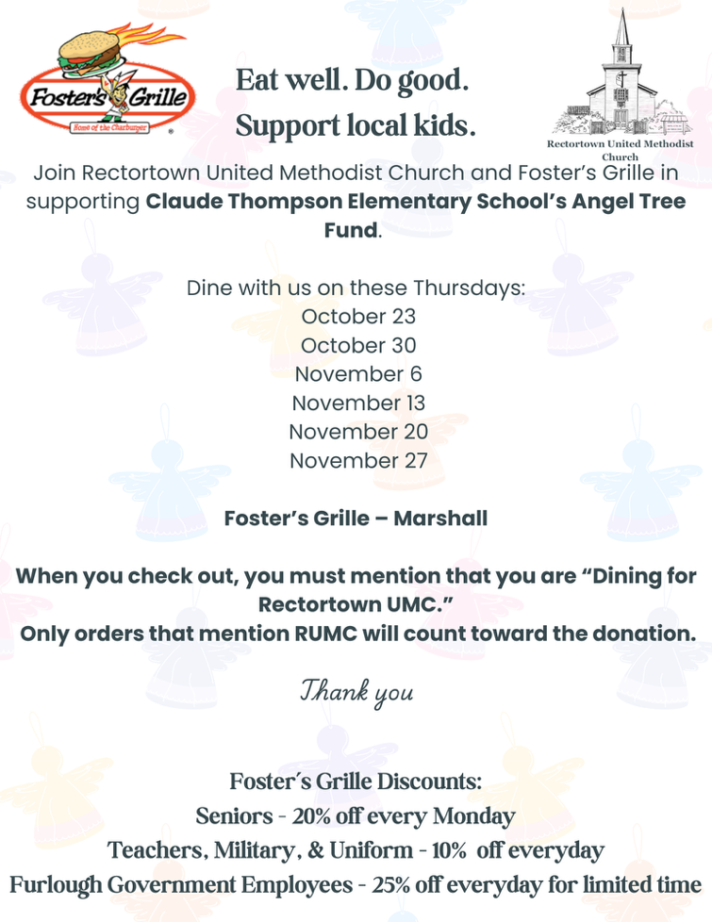

If you would like to contribute funds directly, designate your donations for CTE Angel Tree or choose 2025 CTE Angel Tree during Online Giving.

Rectortown United Methodist Church
  - Location: 3049 Rectortown Road, Rectortown, VA
Mailing Address: PO Box 301, Rectortown, VA 20140
Email: secretary@rectortownumc.org
Phone: (540)364.1066

