**Rectortown United Methodist Church**

June 1st, 2025 10:00 a.m.

*Ascension Sunday/ 7th Sunday of Easter/ Communion Sunday*

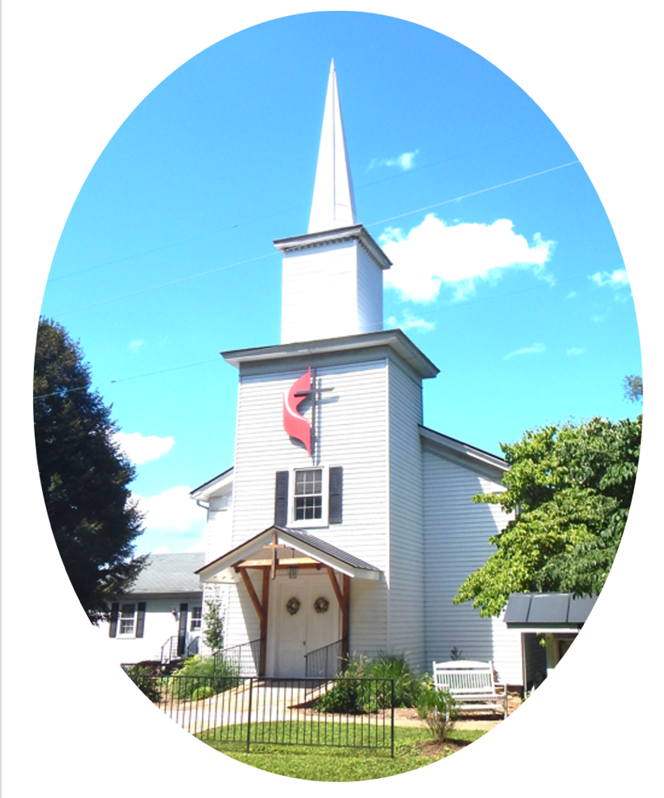

***Pastor****: TaeWon Kang*

*3049 Rectortown Road, Marshall, VA* 20115

*Pastor’s Cell Phone:* (470) 728 - 9060  
*Pastor’s E-mail:* pastortaewonkang@gmail.com

***Music Director****:* Karen Chase

***Ministers****: every member of the congregation*

Welcome to Rectortown UMC!

*“You are looking for Jesus the Nazarene, who was crucified. He has risen!”*

Mark 16:6 NIV

**\*** *Please Stand As You Are Able and Comfortable*

**PRELUDE** - *let us quiet our minds and hearts.*

**WELCOME, ANNOUNCEMENTS and CELEBRATIONS**

**\*BRINGING IN THE LIGHT OF CHRIST**

**\*CALL to WORSHIP**

Leader: Blessings on you all this day, from our

Lord Jesus Christ.  
**People: This is the day of his ascension. He**

**is seated on the right hand of God.**Leader: Honor, Power, glory and majesty are his!  
**People: Let us praise him with shouts of joy!**Leader: We are called to be witnesses to this

great wonder.  
**People: We are called to proclaim God’s**

**Good News of love for all God’s people.**

**AMEN.**

**\*OPENING PRAYER**

**Astounding God, we come before you this day as witnesses to Christ’s ascension from this realm to the heavenly kingdom. We stand in awe and wonder at what we hear and see. Open the eyes of our hearts to see the power and truth of your words.**

**Give us courage and joy that we might be witnesses to your eternal love through Christ Jesus our Lord. AMEN.**

**\* HYMN** “Spirit Song” UMH 347

**YOUNG DISCIPLES’ MESSAGE**

**\*PRAYER for ILLUMINATION** UMH 393

**Spirit of the living God, fall afresh on me.**

**Spirit of the living God, fall afresh on me.**

**Melt me, mold me, fill me, use me.**

**Spirit of the living God, fall afresh on me.**

**FIRST READING**

Acts 16: 16 - 34

This is the word of God for the people of God.

**Thanks be to God.**

**RESPONSIVE READING** Psalm 97 UMH 817

**\*GOSPEL READING** John 17: 20 - 26

**\*** Gloria Patri –“Glory Be to the Father” UMH 70

**SERMON**

“What Shall We Look At?”

**\*RESPONDING HYMN**

“Love Divine, All Loves Excelling” UMH 384

**INVITATION, CONFESSION, AND PARDON**

**INVITATION (UMH 12)**

Christ our Lord invites to his table all who

love him,

Who earnestly repent of their sin

And seek to live in peace with one another.

Therefore, let us confess our sin before God

and one another.

**CONFESSION (UMH 12)**

**Merciful God,**

**We confess that we have not loved you**

**with our whole heart.**

**We have failed to be an obedient church.**

**We have not done your will,**

**We have broken your law,**

**We have rebelled against your love,**

**We have not loved our neighbors,**

**And we have not heard the cry of the**

**needy.**

**Forgive us, we pray.**

**Free us for joyful obedience,**

**Through Jesus Christ our Lord. Amen.**

**PARDON (UMH 12)**

Hear the good news:

Christ died for us while we were yet sinners;

That proves God’s love toward us.

In the name of Jesus Christ, you are forgiven!

**PASSING OF THE PEACE**

**SHARING OUR JOYS and CONCERNS**

**PASTORAL PRAYER**

**GIVING OUR GIFTS and TITHES**

Offertory:

Doxology UMH 94  
 “Praise God from Whom All Blessings Flow”

Offertory Prayer

**GREAT THANKSGIVING** UMH 13

**LORD’S PRAYER, BREAKING THE BREAD, AND GIVING THE BREAD AND CUP** UMH 14

**\*PRAYER AFTER COMMUNION** UMH 11

***Eternal God, we give you thanks for this holy mystery in which you have given yourself to us. Grant that we may go into the world in the strength of your Spirit, to give ourselves for others, in the name of Jesus Christ our Lord, Amen.***

**\*CLOSING HYMN**

“Blest Be the Tie That Binds” UMH 557

**\*BENEDICTION**

**\* POSTLUDE**

* *Please stand as you are able and comfortable.*

|  |
| --- |
| ***This worship service has ended, and now your service begins.***  ***As you leave church today, you are entering the mission field.*** |

***PRAYERS FOR THE CHURCH AND FOR THE WORLD:***

|  |  |
| --- | --- |
| **For Family and Friends:** | |
| Jim Caylen  Towny Lunsford  Christine Felts & Mother | Russ & Ethel Muter  The Reed Family |
| **For the Family of those who grieve for:**  Laura Skirka  Judy Bailey  Winnie | |
|  |  |

**For the Church and For the World:**

For those in need of healing, and their caretakers.

For first responders, the military, and their families.

For God’s People, The Church, and the World.

Prayers for national, state, and local leaders; and for our Nation.

**If you know someone you would like to add to our prayer list, please forward your request to the church office by email at: secretaryrumc@gmail.com, or by calling (540) 364-1066.**

**RUMC CELEBRATIONS**

|  |  |
| --- | --- |
| **Birthdays** | |
| Kyle Peters – June 1st | Larry Underwood – June 3rd |
| Nathan Kridler – June 4th | Deborah McLaughlin – June 8th |
| Erika Harrington – June 8th | Tammy Frazier – June 8th |
| **Anniversaries** | |
| Diane & Jim Harrington – June 3rd | |

**UPCOMING MEETINGS AND EVENTS**

**Admin Council**

Thursday, **June 5th at 7pm**. In person and zoom.

**Trustees Meeting**

Tuesday, June 10th at 6pm. In person and zoom.

**Worship Meeting**

Cancelled

**Fig Leaf**

Tuesday, June 17th at 10am. Zoom and in person.

**Pastor’s Last Sunday**

June 8th

**Rectortown United Methodist Church**

Location: 3049 Rectortown Road, Rectortown, VA

Mailing Address: PO Box 301, Rectortown, VA 20140

Email: secretary@rectortownumc.org

Phone: (540)364.1066