Rectortown United Methodist Church
April 26th, 2026 10:00 a.m.
Fourth Sunday After Easter


Pastor: Eduardo Carrillo
3049 Rectortown Road, Marshall, VA 20115
Pastor’s Cell Phone: (703) 967-4361
Pastor’s E-mail: eduardocarrillo@vaumc.org
Music Director: Karen Chase
Ministers: every member of the congregation
Welcome to Rectortown UMC!

“This is the day that the Lord has made;
let us rejoice and be glad in it.” Psalm 118:24 NRSV

* Please Stand As You Are Able and Comfortable
PRELUDE - let us quiet our minds and hearts.
WELCOME, ANNOUNCEMENTS and CELEBRATIONS
GATHERING
*BRINGING IN THE LIGHT OF CHRIST

*CALL to WORSHIP
Leader: In the noise and rush of life, we pause and remember — we are not alone.
People: The Lord is our Shepherd; we shall not want.
Leader: He knows our name. He calls us. He leads us beside still waters.
People: We are His sheep, and His voice we know and trust.
Leader: Come, let us still our hearts and enter His presence with reverence
All: We come to worship the One who provides all we need.

*OPENING PRAYER
Gracious Shepherd, we quiet ourselves before You now. You know our needs before we speak them. You have led us through valleys we feared and restored us in ways we did not expect. Teach us today to trust You fully, not just for what You give, but for who You are. As we open Your Word, guide us through the gate of Your truth into the pasture of Your presence. Still our anxious hearts. Feed our hungry souls. You are enough. You have always been enough. Amen.

* HYMN
“Rock of Ages” UMH 361

PROCLAMATION
YOUNG DISCIPLES’ MESSAGE

*PRAYER for ILLUMINATION UMH 393
Spirit of the living God, fall afresh on me.
Spirit of the living God, fall afresh on me.
Melt me, mold me, fill me, use me.
Spirit of the living God, fall afresh on me.

FIRST READING
Psalm 23

*SECOND READING
John 10:1 – 10
This is the word of God for the people of God.
Thanks be to God.

SERMON “The Shepherd’s Flock”

RESPONSE
*RESPONDING HYMN
“Take Time to Be Holy” UMH 395

*AFFIRMATION OF FAITH UMH 881
Apostles’ Creed (Traditional Version)

SHARING OUR JOYS and CONCERNS

PASTORAL PRAYER & LORD’S PRAYER

GIVING OUR GIFTS and TITHES
Offertory:
Doxology UMH 94
“Praise God from Whom All Blessings Flow”
Offertory Prayer

*CLOSING HYMN
“Together We Serve” TFWS 2175

SENDING FORTH
*BENEDICTION

* POSTLUDE
* Please stand as you are able and comfortable.
This worship service has ended, and now your service begins.
As you leave church today, you are entering the mission field.

PRAYERS FOR THE CHURCH AND FOR THE WORLD:
For Family and Friends:
Russ & Ethel Muter  Gillian Payne  Ernestine Hall  Hall Family  Donna Olson  David Nalls | John McGuinn & Sydney  Kathleen Rhodes  Rick Willis  Austin  Dennis
For the Family of those who grieve for:
Georgie Ann Grimes
Katherine
For the Church and For the World:

For those in need of healing, and their caretakers.
For first responders, the military, and their families.
For God’s People, The Church, and the World.
Prayers for national, state, and local leaders; and for our Nation.
If you know someone you would like to add to our prayer list, please forward your request to the church office by email at: secretary@rectortownumc.org or by calling (540) 364-1066.

RUMC CELEBRATIONS
Birthdays
Payton Hall – April 30th

Anniversaries
None

UPCOMING MEETINGS AND EVENTS
Admin Council
May 7th at 7pm. In person & zoom.

Reminders
Annual Audit
Annual Clergy Evaluation
Parsonage Review
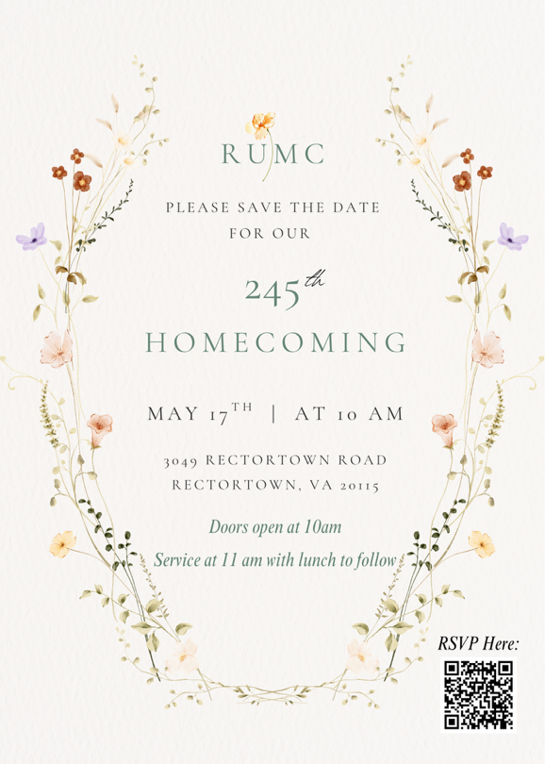

Rectortown United Methodist Church
  - Location: 3049 Rectortown Road, Rectortown, VA
Mailing Address: PO Box 301, Rectortown, VA 20140
Email: secretary@rectortownumc.org
Phone: (540)364.1066

