Rectortown United Methodist Church
February 15th, 2026 10:00 a.m.
Transfiguration Sunday
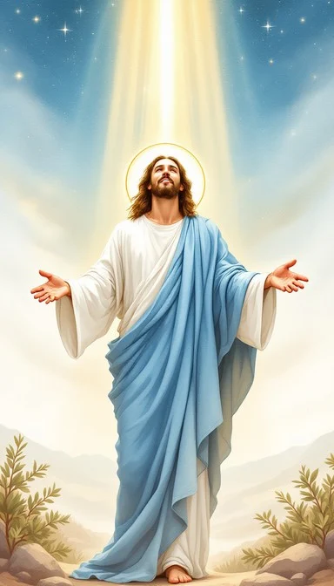

Pastor: Eduardo Carrillo
3049 Rectortown Road, Marshall, VA 20115
Pastor’s Cell Phone: (703) 967-4361
Pastor’s E-mail: pastor@rectortownumc.org
Music Director: Karen Chase
Ministers: every member of the congregation
Welcome to Rectortown UMC!

“This is the day that the Lord has made;
let us rejoice and be glad in it.” Psalm 118:24 NRSV

* Please Stand As You Are Able and Comfortable
PRELUDE - let us quiet our minds and hearts.
WELCOME, ANNOUNCEMENTS and CELEBRATIONS
GATHERING
*BRINGING IN THE LIGHT OF CHRIST
*CALL to WORSHIP
Leader: We leave the valley floor. We ascend the
holy mountain.
People: The glory of the Lord awaits us in
the cloud.
Leader: On Mount Sinai, God’s presence was a
consuming fire.
People: On the Mount of Transfiguration, the
face of Jesus shines like the sun.
Leader: Moses and Elijah stood as witnesses to
Christ’s power.
People: We have come to see the fulfillment
of all the prophets.
Leader: Hear the voice of the Father, ringing
from the light: "This is my Son, the Beloved."
People: We listen to Him. We follow His Light.

*OPENING PRAYER
Almighty God, we stand before you, having left the low places of the week to climb the sacred mountain of Your presence. Forgive us for the times we have been spiritually drowsy, tempted to build a comfortable tent in the valley of the ordinary, forgetting the radiant power we have witnessed on the mountain. Focus our hearts on Jesus, that we may follow his teaching and, in our own lives, reflect the glory we have seen, Amen.

* HYMN
“O Worship the King” UMH 73

PROCLAMATION
YOUNG DISCIPLES’ MESSAGE

*PRAYER for ILLUMINATION UMH 393
Spirit of the living God, fall afresh on me.
Spirit of the living God, fall afresh on me.
Melt me, mold me, fill me, use me.
Spirit of the living God, fall afresh on me.

OLD TESTAMENT READING
Exodus 24:12 – 18

*NEW TESTAMENT READING
Matthew 17: 1 – 9
This is the word of God for the people of God.
Thanks be to God.

SERMON “Transfiguration”

RESPONSE
*RESPONDING HYMN
“Lord of All Hopefulness” TFWS 2197

*AFFIRMATION OF FAITH UMH 881
Apostles’ Creed (Traditional Version)

SHARING OUR JOYS and CONCERNS

PASTORAL PRAYER & LORD’S PRAYER

GIVING OUR GIFTS and TITHES
Offertory:
Doxology UMH 94
“Praise God from Whom All Blessings Flow”
Offertory Prayer

*CLOSING HYMN
“Every Time I Feel the Spirit” UMH 404

SENDING FORTH
*BENEDICTION

* POSTLUDE
* Please stand as you are able and comfortable.
This worship service has ended, and now your service begins.
As you leave church today, you are entering the mission field.

PRAYERS FOR THE CHURCH AND FOR THE WORLD:
For Family and Friends:
Russ & Ethel Muter  Gillian Payne  Ernestine Hall  Sandra  Hall Family  Donna Olson  Joan Newsome | John McGuinn & Sydney  Kathleen Rhodes  Rick Willis  Don Williams  Austin  Dennis
For the Family of those who grieve for:
Larry Underwood
For the Church and For the World:

For those in need of healing, and their caretakers.
For first responders, the military, and their families.
For God’s People, The Church, and the World.
Prayers for national, state, and local leaders; and for our Nation.

If you know someone you would like to add to our prayer list, please forward your request to the church office by email at: secretaryrumc@gmail.com, or by calling (540) 364-1066.

RUMC CELEBRATIONS

Birthdays
None
Anniversaries
None

UPCOMING MEETINGS AND EVENTS

Fig Leaf
Friday, February 20th at 10 am. Zoom & In Person

Worship Meeting
Wednesday, February 25th at 10 am. Zoom & In Person

Pastor & Joint Secretary Meeting
Out of the Office
Friday, February 20th

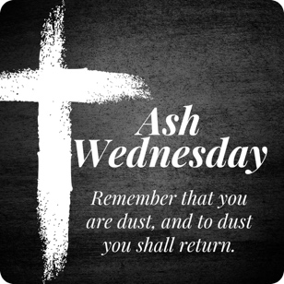
Ash Wednesday
February 12th
Two options for ashes!
Middleburg – 12pm
Rectortown – 5pm

Rectortown United Methodist Church
  - Location: 3049 Rectortown Road, Rectortown, VA
Mailing Address: PO Box 301, Rectortown, VA 20140
Email: secretary@rectortownumc.org
Phone: (540)364.1066

