Rectortown United Methodist Church
January 4th, 2026 10:00 a.m.
Epiphany Sunday

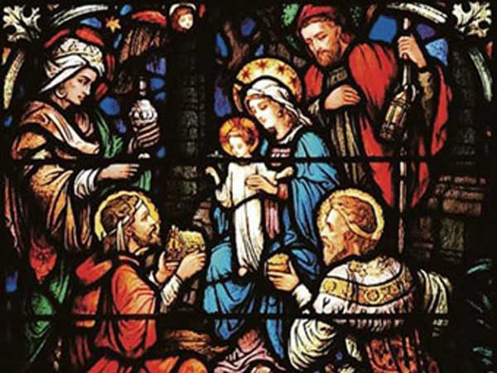

Pastor: Eduardo Carrillo
3049 Rectortown Road, Marshall, VA 20115
Pastor’s Cell Phone: (703) 967-4361
Pastor’s E-mail: pastor@rectortownumc.org
Music Director: Karen Chase
Ministers: every member of the congregation
Welcome to Rectortown UMC!

“This is the day that the Lord has made;
let us rejoice and be glad in it.” Psalm 118:24 NRSV

* Please Stand As You Are Able and Comfortable
PRELUDE - let us quiet our minds and hearts.
WELCOME, ANNOUNCEMENTS and CELEBRATIONS

GATHERING
*BRINGING IN THE LIGHT OF CHRIST

*CALL to WORSHIP
Leader: We gather as people looking for the star,
a sign that God is at work in the world.
People: God, help us find your glory.
Leader: We gather as people listening for the
whispers of the Spirit, hints of the good
news in the least likely places.
People: God, help us notice your glory.
Leader: We gather as people yearning for Love’s
presence, the assurance that we are not
alone and Love will have the last word.
People: God, help us encounter your glory.
Leader: On this Epiphany Sunday, may the Light
of Love shine among us, revealing divine
glory through neighbors known and
unknown, vulnerable children, and
unexpected gifts.
People: God, reveal to us anew the glory of
your expansive Love that gathers us
together and sustains us in loving
service to one another and all creation. Amen.
*OPENING PRAYER
Light of God, illumine the path that leads us to healing, hope, and salvation. Glory of God, fill this sanctuary and expose the darkness that stalks our souls. Light of God, shine with such brightness that we marvel in awe. Glory of God, fill each temple of the Holy Spirit present today. Light of God, Glory of God, we welcome you in this place. Amen
* HYMN
“We Three Kings” UMH 254

PROCLAMATION
YOUNG DISCIPLES’ MESSAGE

*PRAYER for ILLUMINATION UMH 393
Spirit of the living God, fall afresh on me.
Spirit of the living God, fall afresh on me.
Melt me, mold me, fill me, use me.
Spirit of the living God, fall afresh on me.

OLD TESTAMENT READING
Jeremiah 31:7 – 14

*NEW TESTAMENT READING
John 1: 1 – 18
This is the word of God for the people of God.
Thanks be to God.

SERMON “God Revealed”

RESPONSE
*RESPONDING HYMN
“In the Bleak Midwinter” UMH 221

INVITATION, CONFESSION, AND PARDON
INVITATION (UMH 12)
Christ our Lord invites to his table all who
love him,
Who earnestly repent of their sin
And seek to live in peace with one another.
Therefore, let us confess our sin before God
and one another.
CONFESSION (UMH 12)
Merciful God,
We confess that we have not loved you
with our whole heart.
We have failed to be an obedient church.
We have not done your will,
We have broken your law,
We have rebelled against your love,
We have not loved our neighbors,
And we have not heard the cry of the
needy.
Forgive us, we pray.
Free us for joyful obedience,
Through Jesus Christ our Lord. Amen.
PARDON (UMH 12)
Hear the good news:
Christ died for us while we were yet sinners;
That proves God’s love toward us.
In the name of Jesus Christ, you are forgiven!

PASSING OF THE PEACE

SHARING OUR JOYS and CONCERNS

PASTORAL PRAYER

GIVING OUR GIFTS and TITHES
Offertory:
Doxology UMH 94
“Praise God from Whom All Blessings Flow”
Offertory Prayer
GREAT THANKSGIVING UMH 13

LORD’S PRAYER, BREAKING THE BREAD, AND GIVING THE BREAD AND CUP UMH 14

*PRAYER AFTER COMMUNION UMH 11
Eternal God, we give you thanks for this holy mystery in which you have given yourself to us. Grant that we may go into the world in the strength of your Spirit, to give ourselves for others, in the name of Jesus Christ our Lord, Amen.

*CLOSING HYMN
“There’s a Song in the Air” UMH 220

SENDING FORTH
*BENEDICTION

* POSTLUDE
* Please stand as you are able and comfortable.
This worship service has ended, and now your service begins.
As you leave church today, you are entering the mission field.

PRAYERS FOR THE CHURCH AND FOR THE WORLD:
For Family and Friends:
Russ & Ethel Muter  Gillian Payne  Ernestine Hall  Sandra  Hall Family  Donna Olson  Joan Newsome | John McGuinn & Sydney  Kathleen Rhodes  Rick Willis  Don Williams  Austin  Dennis
For the Family of those who grieve for:

For the Church and For the World:

For those in need of healing, and their caretakers.
For first responders, the military, and their families.
For God’s People, The Church, and the World.
Prayers for national, state, and local leaders; and for our Nation.

If you know someone you would like to add to our prayer list, please forward your request to the church office by email at: secretaryrumc@gmail.com, or by calling (540) 364-1066.

RUMC CELEBRATIONS

Birthdays
Kristen Hylton – January 9th
Anniversaries
None

UPCOMING MEETINGS AND EVENTS

Admin Council
Thursday, January 8th at 7 pm. Zoom & In Person

Trustees Meeting
Tuesday, January 13th at 6 pm.
Zoom & In Person

Fig Leaf
Friday, January 16th at 10 am. Zoom & In Person

Worship Meeting
Wednesday, January 28th at 10 am. Zoom & In Person

Rectortown United Methodist Church
  - Location: 3049 Rectortown Road, Rectortown, VA
Mailing Address: PO Box 301, Rectortown, VA 20140
Email: secretary@rectortownumc.org
Phone: (540)364.1066

