**Rectortown United Methodist Church**

September 7th, 2025 10:00 a.m.

*13th Sunday after Pentecost*

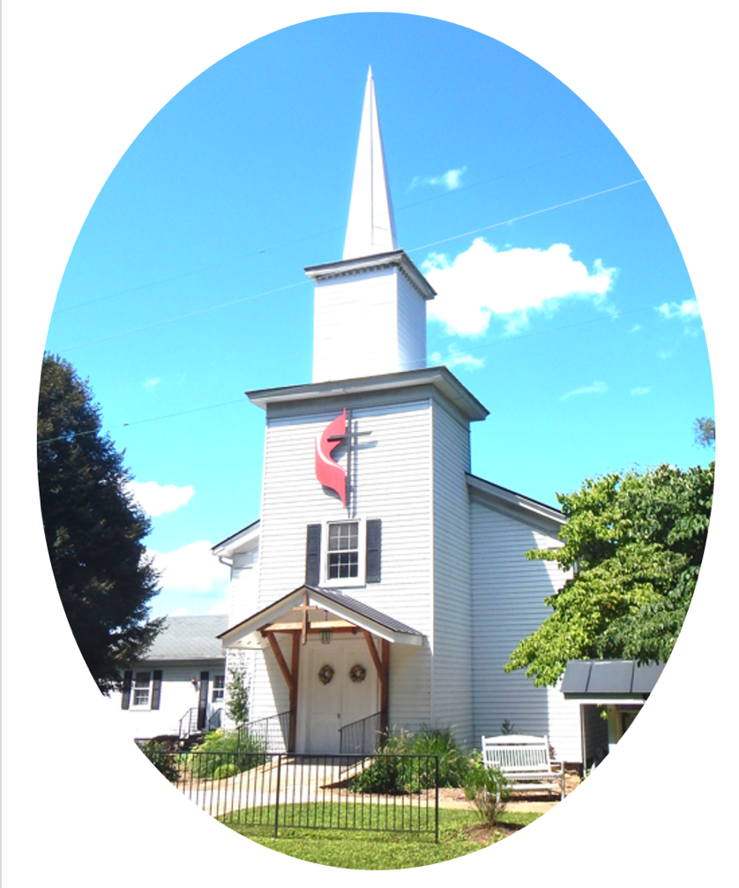

***Pastor****: Eduardo Carrillo*

*3049 Rectortown Road, Marshall, VA* 20115

*Pastor’s Cell Phone:* (703) 967-4361  
*Pastor’s E-mail:* pastor@rectortownumc.org

***Music Director****:* Karen Chase

***Ministers****: every member of the congregation*

Welcome to Rectortown UMC!

*“This is the day that the Lord has made;  
    let us rejoice and be glad in it.”* Psalm 118:24 NRSV

**\*** *Please Stand As You Are Able and Comfortable*

**PRELUDE** - *let us quiet our minds and hearts.*

**WELCOME, ANNOUNCEMENTS and CELEBRATIONS**

***GATHERING***

**\*BRINGING IN THE LIGHT OF CHRIST**

**\*CALL to WORSHIP**

Leader: O Lord, you search us and you know us.  
**People: You shape us with care, like a potter**

**at the wheel.**  
Leader: You call us to follow with open hands and

willing hearts.  
**People: We come, ready to be formed by**

**your love.**  
Leader: Let us worship the One who shapes and

sends.  
**People: We worship with trust and**

**thanksgiving.**

**\*OPENING PRAYER**

**Creator God, you are the Potter and we are your clay. You shape our lives with mercy and purpose. As we worship today, help us to release our grip on comfort and control. Mold us into disciples who reflect your grace. In Christ’s name we pray, Amen.**

**\* HYMN**

“Have Thine Own Way” UMH 382

***PROCLAMATION***

**YOUNG DISCIPLES’ MESSAGE**

**\*PRAYER for ILLUMINATION** UMH 393

**Spirit of the living God, fall afresh on me.**

**Spirit of the living God, fall afresh on me.**

**Melt me, mold me, fill me, use me.**

**Spirit of the living God, fall afresh on me.**

**OLD TESTAMENT READING**

Jeremiah 18: 1 – 11

**\*NEW TESTAMENT READING**

Luke 14: 25 – 33

This is the word of God for the people of God.

**Thanks be to God.**

**SERMON**  “In the Potter’s Hands”

***RESPONSE***

**\*RESPONDING HYMN**

“In Christ There is No East or West” UMH 352

**INVITATION, CONFESSION, AND PARDON**

**INVITATION (UMH 12)**

Christ our Lord invites to his table all who

love him,

Who earnestly repent of their sin

And seek to live in peace with one another.

Therefore, let us confess our sin before God

and one another.

**CONFESSION (UMH 12)**

**Merciful God,**

**We confess that we have not loved you**

**with our whole heart.**

**We have failed to be an obedient church.**

**We have not done your will,**

**We have broken your law,**

**We have rebelled against your love,**

**We have not loved our neighbors,**

**And we have not heard the cry of the**

**needy.**

**Forgive us, we pray.**

**Free us for joyful obedience,**

**Through Jesus Christ our Lord. Amen.**

**PARDON (UMH 12)**

Hear the good news:

Christ died for us while we were yet sinners;

That proves God’s love toward us.

In the name of Jesus Christ, you are forgiven!

**PASSING OF THE PEACE**

**SHARING OUR JOYS and CONCERNS**

**PASTORAL PRAYER**

**GIVING OUR GIFTS and TITHES**

Offertory:

Doxology UMH 94  
 “Praise God from Whom All Blessings Flow”

Offertory Prayer

**GREAT THANKSGIVING** UMH 13

**LORD’S PRAYER, BREAKING THE BREAD, AND GIVING THE BREAD AND CUP** UMH 14

**\*PRAYER AFTER COMMUNION** UMH 11

***Eternal God, we give you thanks for this holy mystery in which you have given yourself to us. Grant that we may go into the world in the strength of your Spirit, to give ourselves for others, in the name of Jesus Christ our Lord, Amen.***

**\*CLOSING HYMN**

“Together We Serve” TFWS 2175

***SENDING FORTH***

**\*BENEDICTION**

**\* POSTLUDE**

* *Please stand as you are able and comfortable.*

|  |
| --- |
| ***This worship service has ended, and now your service begins.***  ***As you leave church today, you are entering the mission field.*** |

***PRAYERS FOR THE CHURCH AND FOR THE WORLD:***

|  |  |
| --- | --- |
| **For Family and Friends:** | |
| Russ & Ethel Muter  Jeff Sisk  Patsy Williams | Priscilla Krick  John McGuinn & Sydney  Sandy Thomas |
| **For the Family of those who grieve for:**  Peggy Rose Goldsmith  Bobby Williams  Jerry Yowell | |
|  |  |

**For the Church and For the World:**

For those in need of healing, and their caretakers.

For first responders, the military, and their families.

For God’s People, The Church, and the World.

Prayers for national, state, and local leaders; and for our Nation.

**If you know someone you would like to add to our prayer list, please forward your request to the church office by email at: secretaryrumc@gmail.com, or by calling (540) 364-1066.**

**RUMC CELEBRATIONS**

|  |
| --- |
| **Birthdays** |
| None |
| **Anniversaries** |
| None |

**UPCOMING MEETINGS AND EVENTS**

**Admin Council**

Thursday, **October 2nd at 7pm**. In person and zoom.

**Trustees Meeting**

Tuesday, **September 9th** at 6pm. In person and zoom.

**Worship Meeting**

**September 24th** at 10am, in person and zoom.

**Fig Leaf**

Tuesday, **September 16th** at 10am. Zoom and in person.

**New Secretary Hours**

Monday & Wednesday – 8:45am to 11:45am

Tuesday & Thursday – Off

Friday – 8:45am to 2:30pm

**Rectortown United Methodist Church**

Location: 3049 Rectortown Road, Rectortown, VA

Mailing Address: PO Box 301, Rectortown, VA 20140

Email: secretary@rectortownumc.org

Phone: (540)364.1066