Rectortown United Methodist Church
September 6th, 2026 9:30 a.m.
Fifteenth Sunday after Pentecost


Pastor: Eduardo Carrillo
3049 Rectortown Road, Marshall, VA 20115
Pastor’s Cell Phone: (703) 967-4361
Pastor’s E-mail: eduardocarrillo@vaumc.org
Music Accompanist: Cheryl Kowalczyk
Ministers: every member of the congregation
Welcome to Rectortown UMC!

“This is the day that the Lord has made;
let us rejoice and be glad in it.” Psalm 118:24 NRSV

* Please Stand As You Are Able and Comfortable
PRELUDE - let us quiet our minds and hearts.
WELCOME, ANNOUNCEMENTS and CELEBRATIONS
GATHERING
*BRINGING IN THE LIGHT OF CHRIST

*CALL to WORSHIP
Leader: Come, gather in the presence of the God who claims us.
People: We come, bound together by the love of Christ.
Leader: Where two or three are gathered in God's name, Christ is here among us.
People: We bring our best and our worst.
Leader: The Lord is here! The one who blesses us
in the struggle and feeds us in the wilderness.
People: Gather closer, vulnerable and surrounded by God’s love.
All: Let us worship with joyful hearts and reconciled spirits!

*OPENING PRAYER
Gracious God, you have redeemed us out of bondage and gathered us into one body. Open our hearts this morning to hear your Word, that we may lay down our grievances, clothe ourselves in the light of Christ, and reflect your reconciling love in our community. Forgive us when egos, hate, misinformation, and our own understandings get on the way to reconciliation. Nudge us to walk closer to you and one another. Amen.

* HYMN
“God of Grace, God of Glory” UMH 577

PROCLAMATION
YOUNG DISCIPLES’ MESSAGE

*PRAYER for ILLUMINATION UMH 393
Spirit of the living God, fall afresh on me.
Spirit of the living God, fall afresh on me.
Melt me, mold me, fill me, use me.
Spirit of the living God, fall afresh on me.

FIRST READING
Exodus 12: 1 – 14
*SECOND READING
Matthew 18: 15 – 20
This is the word of God for the people of God.
Thanks be to God.

SERMON
“Bound Together in Love”

RESPONSE
*RESPONDING HYMN UMH 170
“O, How I Love Jesus!”

INVITATION, CONFESSION, AND PARDON
INVITATION (UMH 12)
Christ our Lord invites to his table all who
love him,
Who earnestly repent of their sin
And seek to live in peace with one another.
Therefore, let us confess our sin before God
and one another.
CONFESSION (UMH 12)
Merciful God,
We confess that we have not loved you
with our whole heart.
We have failed to be an obedient church.
We have not done your will,
We have broken your law,
We have rebelled against your love,
We have not loved our neighbors,
And we have not heard the cry of the
needy.
Forgive us, we pray.
Free us for joyful obedience,
Through Jesus Christ our Lord. Amen.
PARDON (UMH 12)
Hear the good news:
Christ died for us while we were yet sinners;
That proves God’s love toward us.
In the name of Jesus Christ, you are forgiven!

GIVING OUR GIFTS and TITHES
Offertory:
Doxology UMH 94
“Praise God from Whom All Blessings Flow”
Offertory Prayer
GREAT THANKSGIVING UMH 15
LORD’S PRAYER, BREAKING THE BREAD, AND GIVING THE BREAD & CUP UMH 15

*PRAYER AFTER COMMUNION UMH 11
Eternal God, we give you thanks for this holy mystery in which you have given yourself to us. Grant that we may go into the world in the strength of your Spirit, to give ourselves for others, in the name of Jesus Christ our Lord, Amen.

SENDING FORTH
*CLOSING HYMN
“Love Divine, All Loves Excelling” UMH 384

PASSING OF THE PEACE
SHARING OUR JOYS & CONCERNS
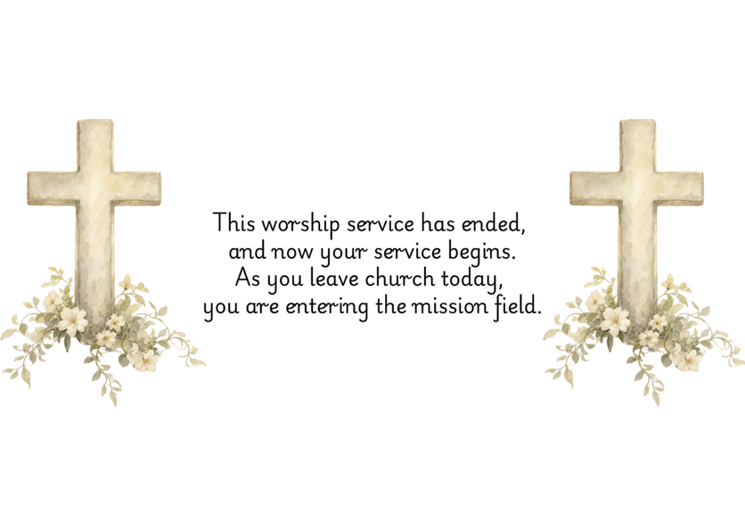
PASTORAL PRAYER
*BENEDICTION & POSTLUDE

PRAYERS FOR THE CHURCH AND FOR THE WORLD:
For Family and Friends:
Russ & Ethel Muter  Gillian Payne  Billy Wines  Gloria Shelton  Joan Newsome  Keith Kuck | Kathleen Rhodes  Rick Willis  Austin  Shirley Embrey  Marline & Warren  Billy Wines
For the Family of those who grieve for:
Butch Shelton
Ron May
Dennis Leohrs
For the Church and For the World:

For those in need of healing, and their caretakers.
For first responders, the military, and their families.
For God’s People, The Church, and the World.
Prayers for national, state, and local leaders; and for our Nation.
If you know someone you would like to add to our prayer list, please forward your request to the church office by email at: secretary@rectortownumc.org or by calling (540) 364-1066.

RUMC CELEBRATIONS
Birthdays
Jim Harrington – 30th

Anniversaries
None

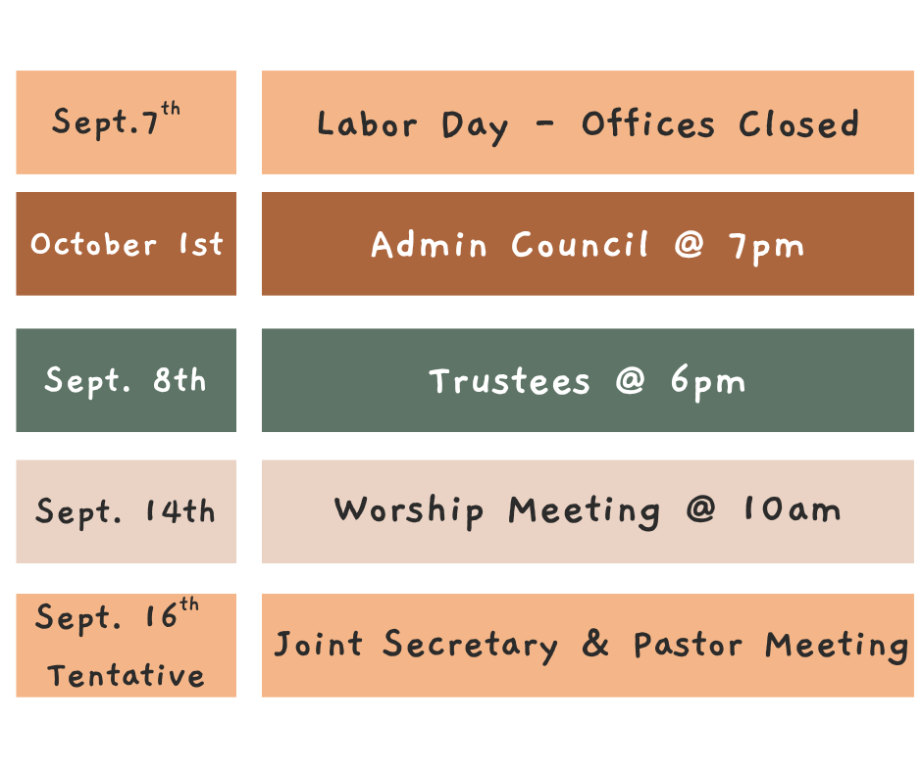
UPCOMING MEETINGS AND EVENTS

Rectortown United Methodist Church
  - Location: 3049 Rectortown Road, Rectortown, VA
Mailing Address: PO Box 301, Rectortown, VA 20140
Email: secretary@rectortownumc.org
Phone: (540)364.1066

