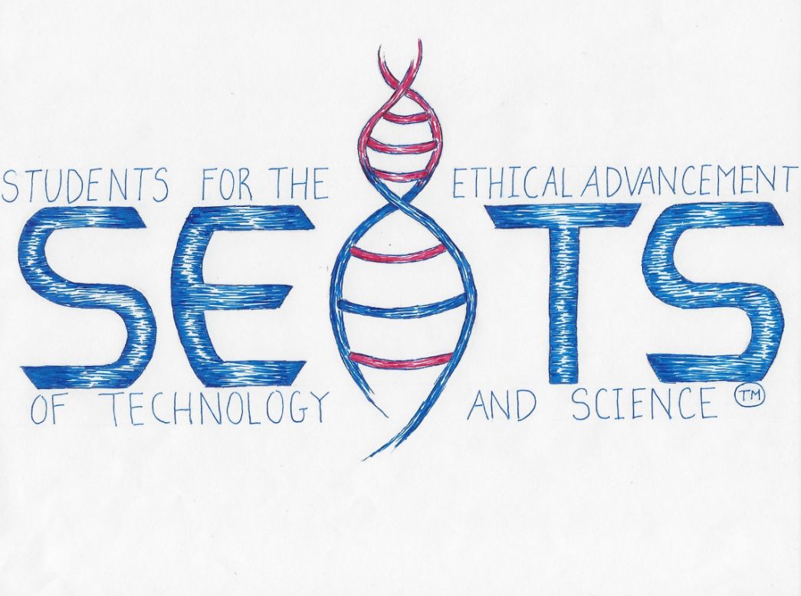
Students on STEM (SOS)
Student Generated Discussions
Topic: Ethics of Contact Tracing Apps

Students from three high schools in the Northern Virginia area met over Zoom on August 10, 2020, to discuss the ethics of a very current topic: COVID-19 contact tracing.
Contact tracing is the process of determining with whom a COVID-19 patient has recently interacted. It often involves reaching out to those who might be infected in an effort to slow the spread of COVID-19.
Many countries have automated this process by creating contact tracing apps that employ Bluetooth to track users’ whereabouts and interactions. While these contact tracing apps have potential to save lives, they also have potential for misuse (i.e., invading users’ privacy).
Some countries, such as India, have made contact tracing apps mandatory. Closer to home, Virginia recently launched COVIDWISE, its first contact tracing app. In response to these current events, and assuming that such apps will be used across America, students researched and discussed how contact tracing apps should be managed ethically to balance public health with user privacy.
The following discussion points, perspectives, ideas, and suggestions were raised and explored by students in SOS break-out groups.

Making the apps’ success feasible:

- Since contact tracing apps are only effective if 60%-80% of a population uses them, the U.S. government could create a survey to see if enough Americans would voluntarily use contact tracing apps

- Making an American contact tracing app mandatory would likely not come to fruition legislatively due to privacy concerns

- If federal, state, and local governments want to encourage Americans to use the app, they must first earn the trust of the American people

  - The terms and conditions of this app should be succinct, simple, and easy to understand

    - If Americans can understand how the app works and what it does with their data, they will be empowered to make a more informed decision

    - The terms and conditions should also clearly state when and how data will be deleted (see Data Security and Privacy below) and whether the data can be used in a court of law against them (see Uses in a Court of Law below)

  - If contact tracing apps became mandatory and measures to ensure public trust have not been established, individuals might turn to burner phones or research ways to sabotage the technology

Data Security and Privacy:

- Regardless of whether the apps are run by the public or private sector, appropriate security measures should be taken in a two-pronged approach:

  - Appropriate and current cyber security software should be put in place to prevent data breaches via hacking

  - All data linked to a specific person should be deleted every four weeks, limiting the information hackers could gain from a data breach

    - Since it takes up to two weeks for COVID-19 symptoms to manifest, four weeks, or two COVID-19 cycles, would be more than enough time to identify and use any relevant data for public health

- When app users are notified they may have been exposed to COVID-19, the identity of the potential infector should be kept completely anonymous to protect users’ privacy and safety

- Once COVID-19 is no longer a threat to public health, all contact tracing apps, both optional and mandatory, should be shut down and all remaining data should be deleted

Uses in a Court of Law:

- To prevent an invasion of privacy similar to that allowed by the Patriot Act:

  - A warrant should always be necessary in order to examine data from the app for any use in a court of law

  - Legislative clarification is needed regarding the use of the app’s data in a court of law as incriminating evidence (e.g., the locations of a user or with whom they interacted)

    - Voluntary users who employed the app for the honorable purpose of slowing COVID-19’s spread could be harmed

    - Using the data in a court of law might push criminals and law-abiding citizens alike towards burner phones, which could harm contact tracing efforts

Participants:
Thank you to the participants whose research, creativity, and lively debate made the session so robust and thought-provoking:
Aditi C.
Alex F.
Andrew H.
Ayush S.
Cole M.
Darika B.
Emerson R.
Emma C.
Hita Y.
Jennifer H.
J.W. S.
Lucy A.
Maanya S.
Nathanael T.
Sai V.
Shaun F.
Vikram B.

