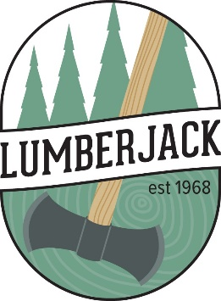
Lumberjack Grant Application

PROJECT TITLE: ____________________________________________

Submitted by (name):
Organization:
Address:
Phone:
Email:
Counties:

Mission Statement: Lumberjack Resource Conservation & Development Council, Inc., a multi-county, nonprofit in Northeastern WI, strives to enhance area natural resources, promote a higher standard of living and improve the quality of life for area citizens by fostering partnerships between public and private sectors and strategically investing in area natural resources.

SUMMARY: Review the Lumberjack Mission Statement above. How does your project align with Lumberjack’s mission? Be specific. The more alignment points, the better your project is viewed.
Answer:
OBJECTIVES: What problems, concerns or opportunities will this project address? You will be asked to show how your objectives were met when you present your follow-up presentation to the Council.
Answer:
FORMULATION & EVALUATION: Why is this project the best way to address the issues described above? How will the outcome be evaluated? Be specific – outcomes that can be measured are viewed more favorably.
Answer:
ASSISTANCE NEEDED: Why is assistance needed from Lumberjack? Who within your organization will run the project? Describe the assistance you are receiving from other partners. Include Letters of Support as outlined in Lumberjack’s Granting Policy.
Answer:
PROJECT OUTLINE & TIMETABLE: List the project steps and expected completion dates. Could there be any possible roadblocks? If so, list them here.
Answer:
BUDGET: Complete the attached Budget Form. Remember the 50% match value requirement with 15% of the match being cash. List each match donor in the ‘Match’ column and submit a corresponding Letter of Support with specific value of in-kind/services or cash for the project for which funds are being asked. Note: This form is available in excel online at: https://lumberjackrcd.org/projects

