Golden Ridge E-Newsletter

Guided and nurtured by God’s love, our mission is to extend fellowship, serve our community, and spread God’s Word.
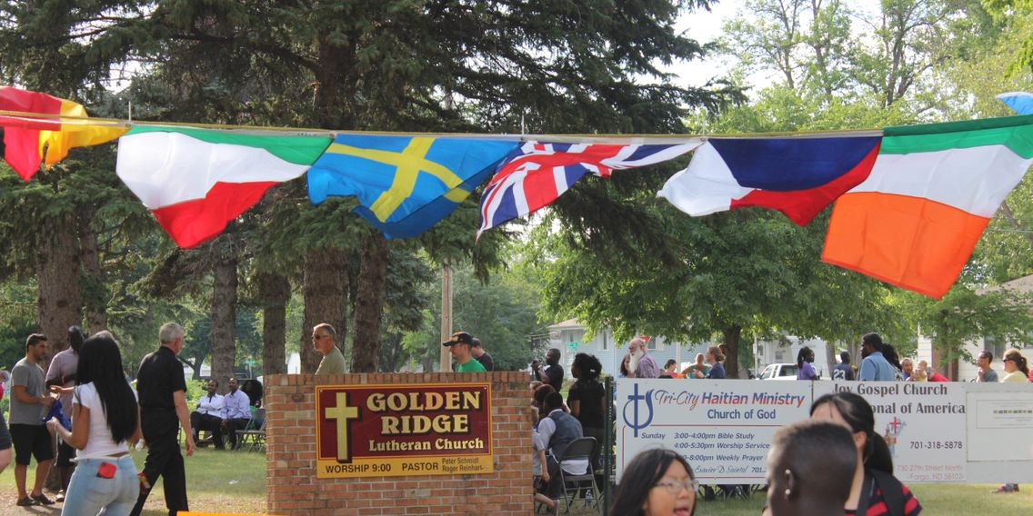
Sunday, February 25  Guest Preacher: Dr. Ivar Sorenson  Eleven years ago, Pastor Peter’s longtime friend Dr. Ivar Sorenson, who was a chiropractor in Bemidji, MN, fell from a deer stand high in a tree and broke his back, confining him to a wheelchair. Ivar will preach on Sunday February 25, telling his story and detailing his journey to redefine his life. It's a story that will inspire and motivate. Be sure to attend, and invite others to join you. | Sunday, March 4  BOLD WOMEN’S DAY  Bold Women’s Day is observed annually in the ELCA, and celebrates all Lutheran women who have acted or are acting boldly on their faith in Jesus Christ. Come March 4 to hear and celebrate stories of women who have boldly followed God’s call. |  | Wednesday, March 7  First Wednesday Neighborhood Dinner  Invite a neighbor and bring a main dish, salad or dessert to share for this growing night of community at Golden Ridge! Wednesday, March 7, 6-8 p.m.
 |  | a place for you: Learning about holy communion  March 14 & 21, 6:15-6:55 p.m. Holy Communion Celebration on March 29, Maundy Thursday. What is Holy Communion? Through stories of Jesus, discover God’s invitation that there is always a place for YOU at God’s table! For all ages and families. Sign up by March 1st!

Golden ridge lutheran church 730 27th St. n, Fargo, nd 58102 701.232.8613
listen.  a lenten journey  Join us for our mid-week dinners and worship this Lent, as we practice listening to God, our neighbors, and our selves.  Who in your life might appreciate an invitation to these candle-lit, meditative Taize services? Call, text, or forward this email to someone this week. | 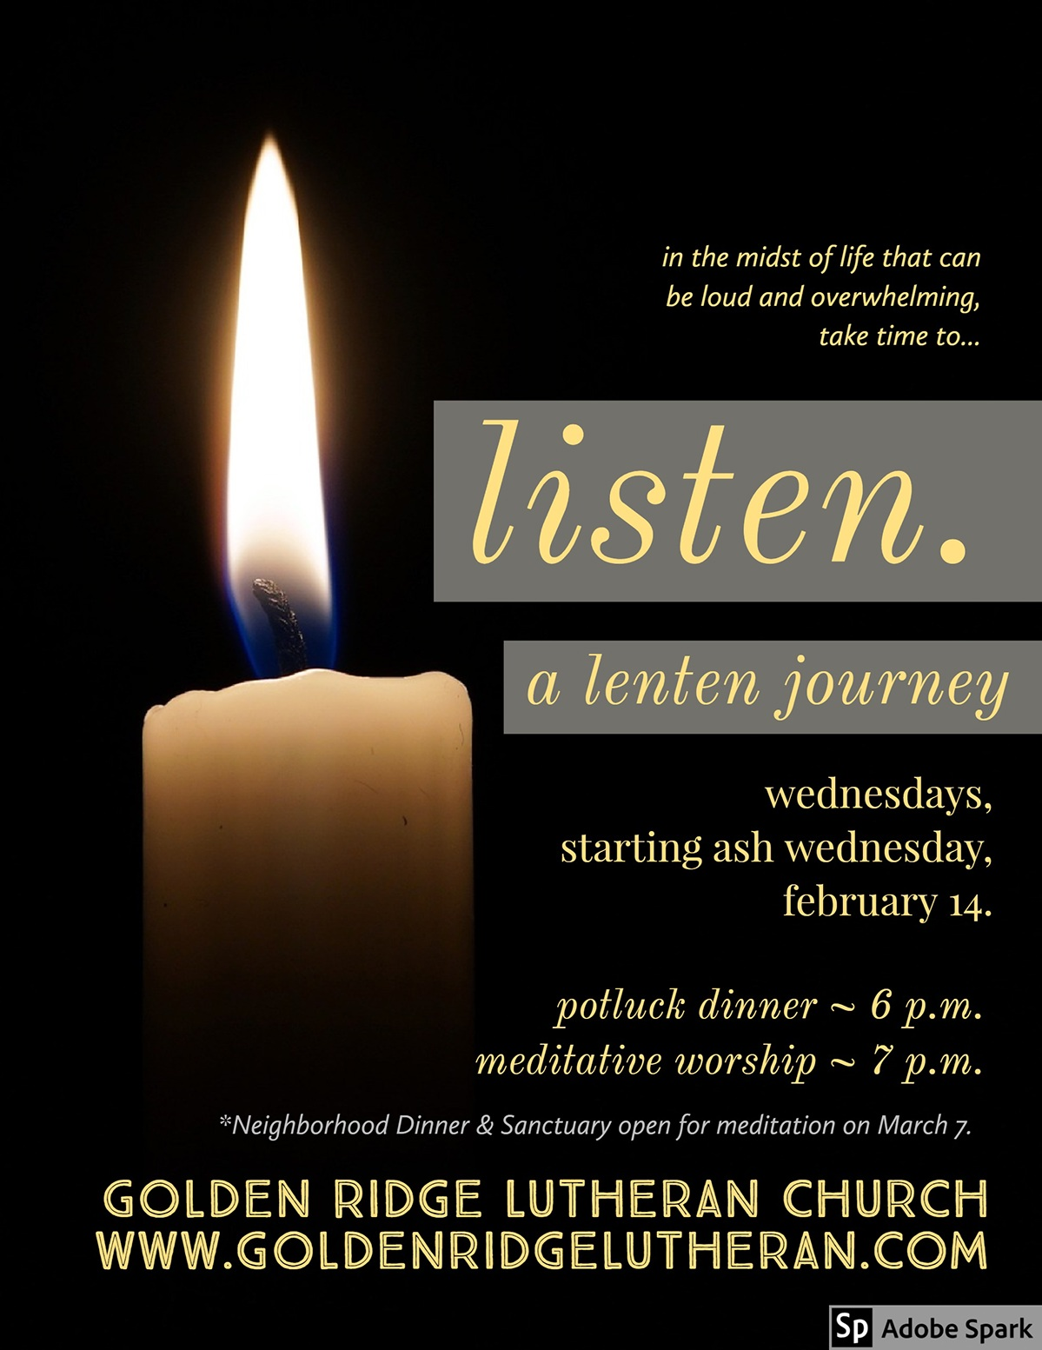
 | Lent Book Study: Green Card  Youth Voices  immigration Stories of Fargo Youth  We have a book for each household – pick yours up this week, and listen to the stories of 30 high school youth from Fargo. We will listen to a story during each Wednes- day evening Lenten service, and encourage reading at home throughout Lent. Check out the video of Nakafu’s story here.  Website

1st Wednesday Neighborhood Dinner – Wednesday, March 7, 6-8 p.m.

A neighborhood dinner to get to know our neighbors!
We have welcomed more and new people every month for our neighborhood dinners. This is so exciting! People are connecting and meeting one another. Kids are having fun making new friends and engaging in prepared activities. Please keep inviting your neighbors to come with you to this meal!

Email Pastor Jessica with ideas or to help with these dinners!

“The most revolutionary thing we can do is get to know our neighbors.” –Karl Hess

