City of Hopkinton
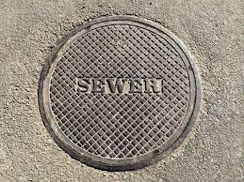
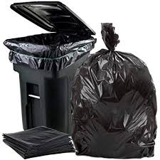
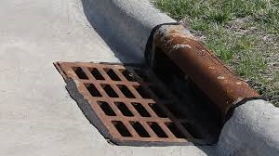
Utility Rates
Garbage
Residential…..$10.70/month
Commercial….. Billed directly with Kluesner Sanitation
Sewer
 | Base Rate | Usage Rate
Residential | $37.37/month | $4.55 per 1,000 gallons of water used each month
Commercial | $37.37/month | $4.55 per 1,000 gallons of water used each month
School | $37.37/month | $4.55 per 1,000 gallons of water used each month
Industrial | As set by contract | As set by contract
Customers outside City limits | $74.74/month | $4.55 per 1,000 gallons of water used each month

Storm Drain Rates
Residential……$3.00/month
Commercial…..$5.00/month

