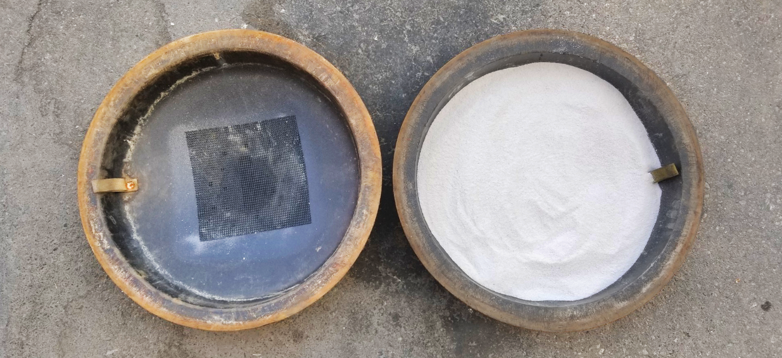
EnCapX Odor

Manhole Odor Control Media with Encapsulation Technology

TM

Product Info

The primary use of EnCapX Odor™ is to reduce organic gases emitting from manholes. EnCapX Odor™ is a unique media blend, specialized with our Encapsulation Technology which accelerates organic gas remediation.

Using our Encapsulation Technology, the gases trying to escape through the manhole covers are absorbed by EnCapX Odor™ eliminating any odors.

- Encapsulation Technology allows for the encapsulation of the organic gas with an all-natural plant extract.
- Encapsulation Technology ensures that contaminates are broken up by means of micro-fractionalizing.
- This unique encapsulation process is also used in our other products to disunite targeted F.O.G.’s (fats, oils, and greases) and provide a desirable food source for indigenous (existing) bacteria.

EnCapX Odor™ outperforms carbon filters by 8X to 10X. Ideal for odor remediation in collection systems (sanitary sewer lines), grease interceptors, oil/water separators, home heating oil storage, and any place where organic gases are generated.

Heavier than competing products by 40% ensures absorbent stays intact.

Cost-Effective - 40% less than traditional carbon systems.

Where to Use
EnCapX Odor™ is a media blend with a primary use to catch vapors reducing odors that are released out of sewer and grease interceptor manholes.

Benefits

- Easy installation vs. carbon systems
- Media can last up to 3 months
- Utilizes all-natural plant extract technology
- Ongoing maintenance is simple and cost-effective
- One 30-gallon drum will sufficiently treat twelve (12) manholes

Features

- White
- In granule form
- Lightweight
- Easy storage
- Non-toxic
- Controls odors before it escapes
Item # JCEOC130GD (Comes in a 30-gallon drum)
Appearance: White granules
Fragrance: n/a as it’s an odor absorbent
pH: 6.5 – 7.5
Non-flammable
Keep dry before use
Storage: Between 40° F and 110° F
Use Instructions

- Uncover Manhole
- Measure manhole entry space
- Outer dimension
- Inner dimension
- Type of manhole cover
- Order manhole insert through NewEraSOS
- Place the insert into manhole
- Place EnCapX Odor™ media (2.5gallons) into the insert
- Cover manhole and inspect monthly
- Replace media every 90 days or when media turns brown
- Replace fine mesh as needed

Note: If inserts exist in manhole or if you wish to purchase your own insert, contact NewEraSOS for instructions to modify insert to accept EnCapX Odor™.

Always refer to the product label prior to use.

Tips

- All traps will emit odors at different rates. Inspect media monthly and after pumping.
- Dump media into traps during pumping event and replace media.
- For easy transport, fill a 5-gallon pail with media for use in two manholes.

Warning

- Use rubber gloves and goggles to avoid skin and eye irritation.
- Respiratory protection is not required but avoid inhaling dust.

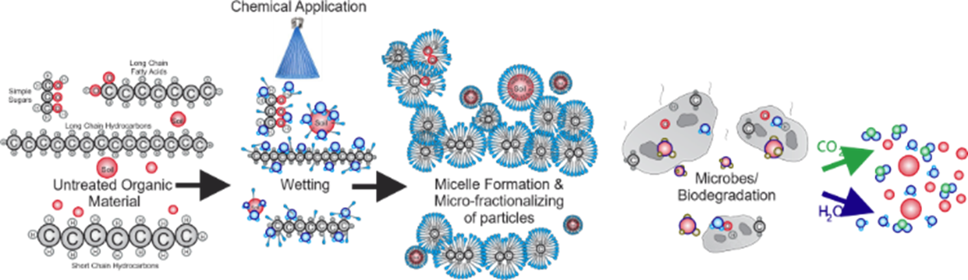

11700 W Charleston Blvd., #170-430, Las Vegas, NV 89135 888-637-6760 www.NewEraSOS.com

