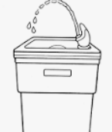

Don’t sit down in the dental chair without sparking clean teeth and appliances. If you haven’t had time to brush, just bring your homekit and brush at our restroom before you are called to be seated.

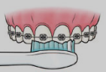

Do brush after each time you eat, even after snacks! If food is left trapped in and around bands and brackets, it can begin to decay the teeth leaving permanent marks. If you are unable to brush, do find a restroom and rinse your mouth thoroughly.

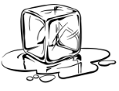

Don’t chew on ice, because this can shatter the cement holding the bands and braces.

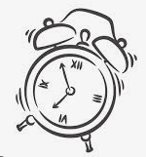

Do keep every appointment and be on time. When you miss appointments you are only putting off the day when your braces will come off.

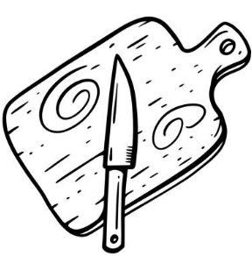

Do cut raw vegetables and hard fruit such as apples, carrots and celery into bite size pieces. Cut meat from the bone.

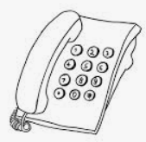

Do call our office if you notice a loose band or bracket that is hurting or poking.

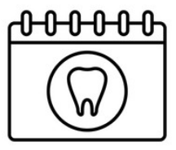

We will schedule a emergency appointment to get you out of pain and discomfort.

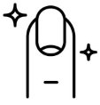

Don’t bite your nails, or chew on pencils or pick at wires. If you damage them the situation may prove to be costly and uncomfortable.

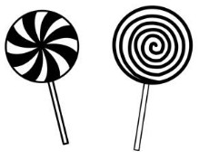

Don’t eat caramels, toffee, hard or sticky candy, popcorn or chewing gum (even sugarless). These can cause loose bands and brackets which will delay treatment time.

Do always bring your appliance, retainers, etc. to every appointment so that they may be checked and adjusted.