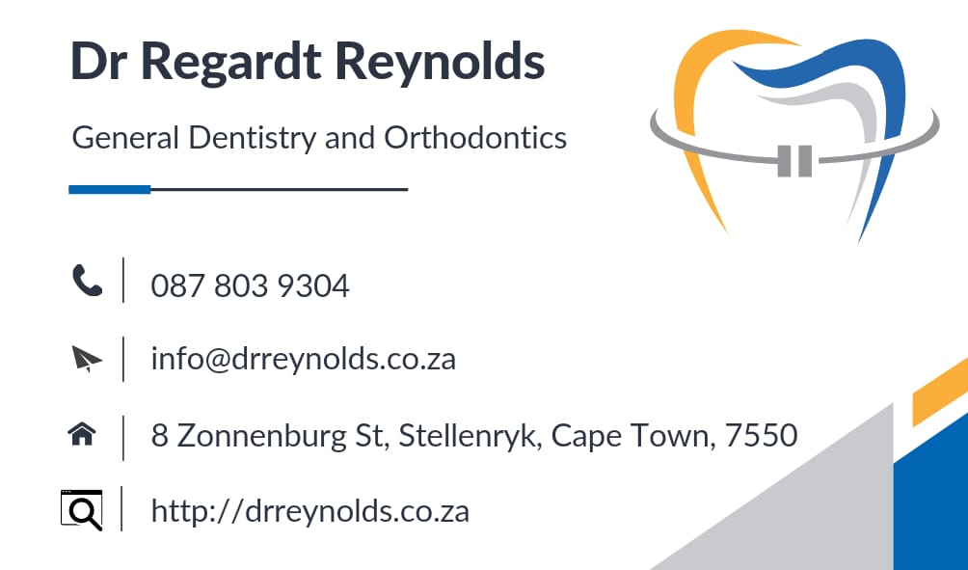

**Dear patient**

**We would like to share the following information to clarify how the process works with regards to orthodontic treatment at our practice:**

**The first visit is the orthodontic consultation where we examine the potential patient’s teeth and determine whether or not we will be able to treat the patient. (We are not specialist orthodontists and cannot treat severe malocclusion cases). If the patient can be treated by us then a second appointment will be scheduled in order to take the necessary records (Photos, X-rays and plaster orthodontic study models). This appointment is known as an Orthodontic Records.**

**After the second appointment, a report is compiled with all the necessary information. We will supply quotation and patient report that you must submit to your medical aid.**

**Once authorization is received the next appointment is booked where the braces are cemented onto the teeth. You will then pay a deposit directly to the practice and afterwards you can claim from your medical aid. The same apply for the monthly fees**

**NB - Orthodontic treatment at this practice falls under specialized treatment and is charged above medical aid rates in order for us to cover the necessary material costs involved.**

**The patient must be seen once a month during the duration of the treatment so that the necessary adjustments can be made in order for the teeth to be straightened. All the monthly appointments are compulsory and will determine the outcome of the treatment.**

**Fees 2024:**

**1 – Orthodontic consultation - ± R 500**

**2 – Orthodontic records - ± R 3100- R3400 (45 min)**

**3 - Full orthodontic treatment - ± R 30 000 – R 34 000 (Depending on the diagnosis)**

1. **An initial fee/deposit is payable when the braces are placed. - 30%**
2. **Balance of the fee payable in monthly installments during treatment.**

**4 – Retention and Dental Check up after Orthodontic Treatment - ± R 3800 (Can vary depending on lab fees)**

**Dr Regardt Reynolds**

**B.Ch.D (Stell)**