Dr.Regardt Reynolds

Practice number 0246662

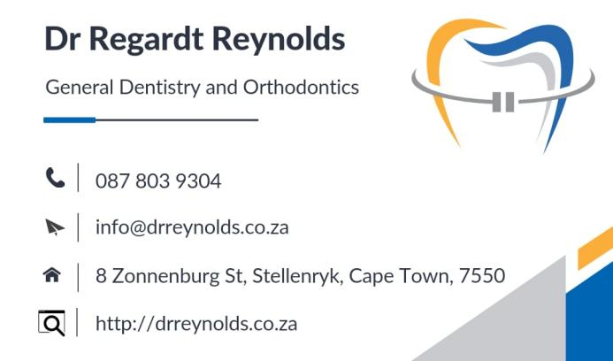

**RETAINER INSTRUCTIONS**

**It is imperative that you adhere to your retention schedule to maintain your finished result. Your teeth may shift, if you do not follow the schedule, to the extent that the results we both worked so hard to obtain will be compromised. This will require retreatment with additional expense. As we discussed, this can be avoided by simply wearing your retainers as directed.**

**CLEAR RETAINERS INSTRUCTIONS**

**Retainers are to be worn day and night for one month and after that at night only, unless instructed otherwise. Remove the retainers when eating, brushing or swimming.**

**Clean with soap (Sunlight Liquid), water and Q-tips. DON’T brush the appliance with toothpaste. It dulls the appearance.**

**Always store your retainer in the case we supplied when out of your mouth. Put a little water in the case to keep the retainers moist. Use Superfloss or Floss Threader to floss under the retainer wire.**

**While the retainer can be worn during sport activities, a regular sports mouth guard provides better protection.**

**If you miss a night or two, wear the retainer full time and bite down to seat it fully. The teeth may be a little sore but should realign. If they don’t, call the office immediately.**

**Retainer replacement is expensive…with proper care they last for years. So, please take care of your retainers**

**Dogs like to eat retainers – so keep them stored safely in the retainer case.**

**Always bring retainers to your appointments.**

**Initially, you may find it difficult to speak. Practice speaking, reading or singing out loud to get used to them faster.**

**Retainers are breakable, so treat them with care. If retainers are lost or broken, call us immediately.**

**Do not try to adjust them yourself.**

**Keep retainers away from hot water, hot car dashboards, pockets, the washing machine.**

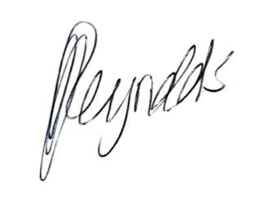

**Dr Regardt Reynolds**

BChD (Stell)