**Procedure for Getting IP PIN**



1. Go to the following website and click the Sign In to your online account

<https://www.irs.gov/payments/online-account-for-individuals>

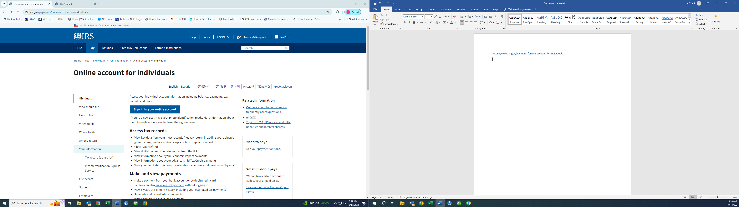



1. Next you will either need to Sign in with your existing account or if you have never used the IRS ID Me Website you will need to create an account.

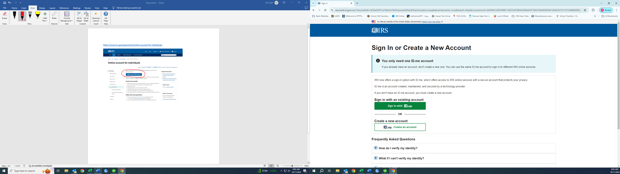

1. Once you are into your account you will be brought to your account home screen. Click on the profile tab at the top right corner of the Home Screen

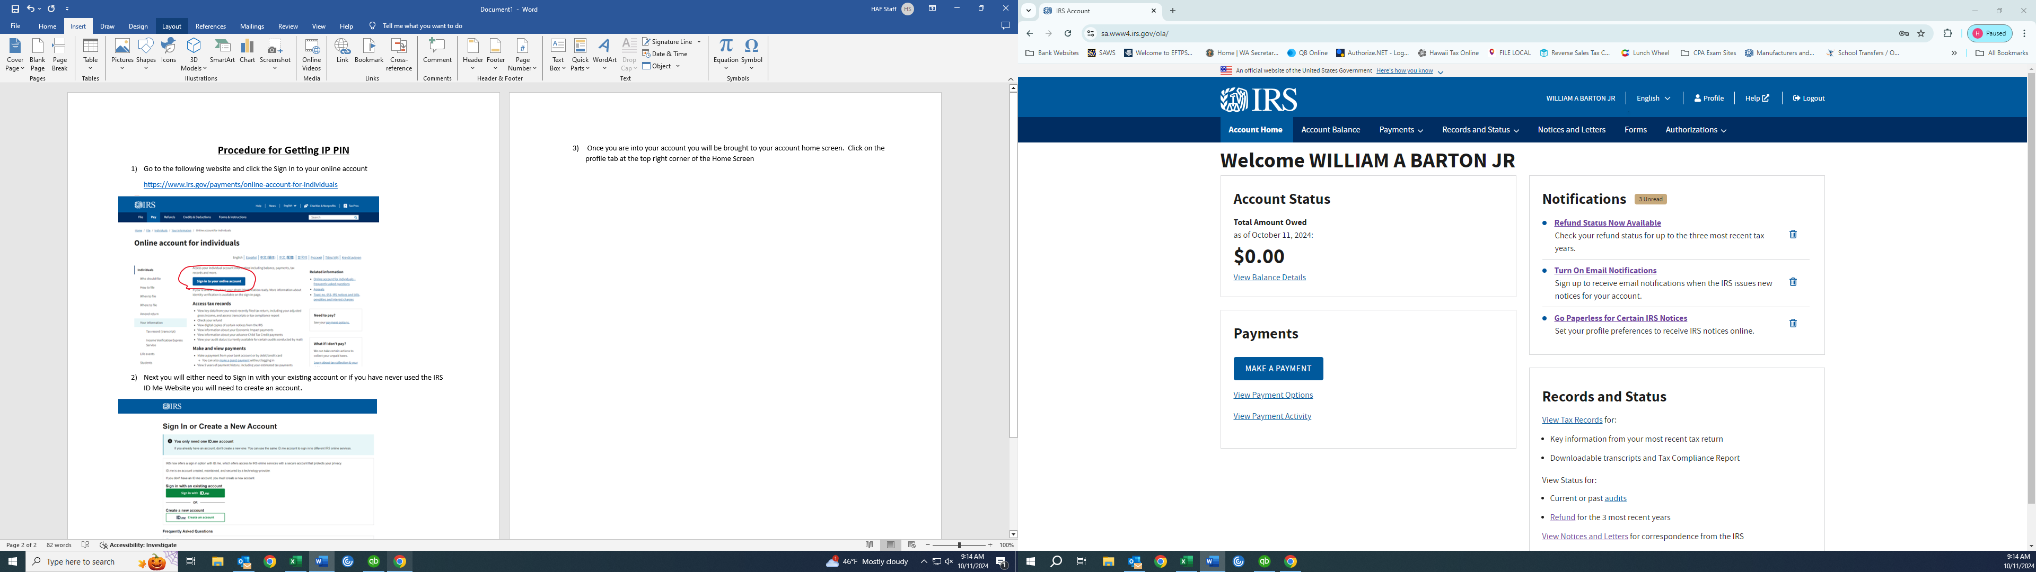



1. From the profile screen, scroll all the way to the bottom of the screen and that’s where you will find your IP PIN. Print a copy of your IP PIN and send to Haight Accounting Firm with all of your other tax info for the year.

