position:______________________
date: ________

EMPLOYMENT APPLICATION
updated 2019

Legal Name
First ___________________________ Middle ________________ Last _________________________
Nickname _________________________ Former name(s) used ________________________________

Address
Street______________________________________________________________________
City___________________________________ State/Zip ____________________________

Contact Information
Home Phone ____________________________________ Cell ________________________________
Email Address:_______________________________________________________________________

Occupation__________________________________________________________________________
Previous occupation (if any)_____________________________________________________________

Do you, your spouse, or an immediate family members have any connections with Options for Women | Morris?
□ Yes □ No If so, who? ________________________________________________________

References (if not previously provided)
Name Organization/ Relationship Phone
______________________________________ _______________________________ ______________________
______________________________________ _______________________________ ______________________
______________________________________ _______________________________ ______________________

Educational Background ( if not previously included in resume)
Name of School | Certificate or Degree | Dates Enrolled - Graduated

Other Education: _________________________________________________________________________
Employment History

Current (if not previously included in resume)
Employer | Address | City, State, Zip
Position | Phone | Length of Employment

Previous Employment
Employer | Position | Length of Employment

How did you hear about this employment opportunity?

Why do you want to work with Options for Women | Morris (OFWM)?

Share any experiences you have had with someone experiencing an unplanned pregnancy.

Share your thoughts on the following: (Feel free to use an additional sheet if you wish to elaborate)

Adoption

Abortion

Single Parenting

Contraception

Women who have had an abortion

The following information is helpful in selecting/assigning roles, planning training, and collecting data for evaluation. * Any information you choose to provide will be kept confidential.
Options for Women | Morris has attendance and punctuality requirements, can you comply (with or without reasonable accommodation)? __________ yes _________ no
Are you able to perform essential job-related functions (with or without reasonable accommodation), such as standing for two hours at a time or carry 50 pounds from point A to B? __________ yes _________ no

*Options for Women | Morris takes seriously our duty to protect the confidentiality of your private identifying information. We will not share such information with anyone outside of the center without your written permission.

Before signing please review Options for Women | Morris mission statement and organizational values.
My signature indicates that all the information I have provided is accurate to the best of my knowledge and that I am in agreement OFWM’s mission statement and organizational values. I understand that submitting this form is not a guarantee of placement as an employee of OFWM, and that placement will be made only after an interview and other background screening, including a criminal background check through the Bureau of Criminal Apprehension. I agree that OFWM may use the information provided on this form to conduct such background screening. Finally, I understand that this position may require training prior to being allowed to start serving in that position.

Signature ________________________________________________ Date ______________________________

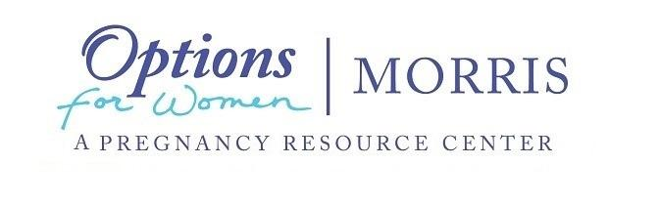

Mission Statement
Options for Women | Morris is a non-political non-denominational, faith based 501c3 dedicated to strengthening families and protecting the unborn. We provide emotional educational, spiritual and material support for families in need and women facing unplanned pregnancy.
We want women facing unplanned pregnancy to know they have options, they have support and they can choose life!

Organizational Values
We believe in:
- the inherent dignity, sanctity, and right to life of each person, from conception to natural death

- the right of women and men considering abortion to receive comprehensive, truthful information in a respectful and compassionate way

- the importance of fertility awareness and education, and the effectiveness and dignity of natural forms of family planning

- the importance of every affiliate to address consistently the needs of the whole person – physical, emotional, spiritual, social, and economic – when providing services

- our affiliates, their commitment to excellence, and their power to change and save lives for the good of their communities
I have reviewed and agree with Options for Women | Morris, (OFWM)’s mission statement and organizational values.

Signature ________________________________________________ Date ______________________________

