**ROOTS**

Relational Behaviour Policy

|  |  |
| --- | --- |
| Date policy last reviewed: | 28/09/2023 |

|  |  |  |  |
| --- | --- | --- | --- |
| Signed by: | | | |
|  | Co-Headteacher | Date: | 28/09/2023 |
|  | Chair of Trustees | Date: |  |

This policy will be reviewed annually.

**Contents:**

**Statement of Intent**

1. **Policy Aims**
2. **Purpose of the behaviour Policy**
3. **Staff Expectations**
4. **Legal Framework**
5. **Roles and Responsibilities**
6. **Staff Induction, development, and support**
7. **Environmental Consistency**
8. **Our views on exclusion**
9. **Sexual Abuse and Harassment**
10. **Allegations against centre staff**
11. **Smoking and controlled substances**
12. **Monitoring and review**
13. **Appendices**

**Statement of intent**

At ROOTS we strive to create a community which is trauma informed. This trauma informed approach is embodied in our aspiration to build a nurturing and caring ethos which permeates our environment. We have developed a behaviour policy that places relationships as the cornerstone for children/young people to thrive, both academically and in relation to their wellbeing.

We are committed to enable students to manage their own behaviour by making informed choices, with support from staff. We believe that the way staff relate to students and the way that they construct an appropriate learning environment are the key factors that will lead to student behaviour that supports the learning of all members of the community. The use of punitive approaches or any ‘tool for managing behaviour’ that in any way demeans, damages, threatens, shames, or humiliates a young person will never be tolerated or considered within our centre. Our whole purpose is to enable students to develop a positive self-identity. We view ourselves as an important part of any pupil’s journey to recovery.

Please also see our Child Protection and Safeguarding policy which is closely aligned to this policy.

1. **Policy Aims:**

* To create a behaviour Policy based not on punishment, sanctions, and isolation, but one that models enquiry, reflection, resolution, and interactive repair (e.g., restorative conversations).
* To ensure that all members of the centre will feel safe from disruption, violence, discrimination, bullying and any form of harassment.
* To encourage relationships between all members of the ROOTS community that facilitate effective learning.
* To allow children/young people to develop a strong sense of morality that allows them to take on board the thoughts and feelings of others.
* To teach children/young people how to communicate their thoughts and feelings in a way that will be beneficial for their future.
* Foster positive relationships with parents.
* Have a shared approach that involves pupils in the implementation of the policy and associated procedures.
* Create a culture, ethos, and environment – where the health and wellbeing of pupils and staff is promoted through the informal curriculum, including leadership practice, policies, values and attitudes, alongside the social and physical environment.

1. **Purpose of the behaviour policy:**

To provide guidance to staff and learners that can be:

* Accessible and applicable at all levels within the educational setting
* To help create and embed a nurturing, inclusive ethos that reflects the aims of the policy
* Monitored and evaluated as part of a plan-do-review cycle, with input from children/young people, parents/carers and governors.

**At ROOTS we seek to support students to become:**

* determined (encouraging resilience, tenacity, self-control, curiosity),
* optimistic (encouraging enthusiasm, confidence, ambition),
* emotionally intelligent (encouraging humility, respect, sensitivity, tolerance).

1. **Staff Expectations:**

* We value our relationships with children/young people and their families.
* We strive to understand the function behind a child/young person’s behaviour
* We consistently model the behaviour we wish to see
* We always give children/young people a fresh start as required
* We ensure that we support and implement the agreed trauma informed approaches
* We use the 3R’s (Regulate, Relate, Reason) Bruce Perry (Appendix 1)
* We use PACE modes of interaction (Hughes, 2015) being warm, empathic, playful and curious (Appendix 2)
* As a staff team we use TEAM PUPIL (Touchbase) (Appendix 3)
* We use trauma informed language in our daily routine
* We accept responsibility and apologise when we mis attune to a particular need

# Legal framework:

This policy has due regard to all relevant legislation and statutory guidance including, but not limited to, the following:

* Education Act 1996
* Education Act 2002
* Education and Inspections Act 2006
* Health Act 2006
* The School Information (England) Regulations 2008
* Equality Act 2010
* Voyeurism (Offences) Act 2019
* DfE (2013) ‘Use of reasonable force’
* DfE (2015) ‘Special educational needs and disability code of practice: 0 to 25 years’
* DfE (2018) ‘Mental health and behaviour in schools’
* DfE (2021) ‘Sexual violence and sexual harassment between children in schools and colleges’
* DfE (2022) ‘Behaviour in schools: Advice for headteachers and school staff’
* DfE (2022) ‘Keeping children safe in education 2022’

This policy operates in conjunction with the following school policies:

* Complaints Procedures Policy
* Special Educational Needs and Disabilities (SEND) Policy
* Child-on-child Abuse Policy
* Child Protection and Safeguarding Policy
* Anti-bullying Policy

# Roles and responsibilities:

The Trust board will have overall responsibility for:

* Ensuring that this policy, as written, does not discriminate on any grounds, including, but not limited to, age, disability, gender reassignment, gender identity, marriage and civil partnership, race, religion or belief, sex and sexual orientation.
* Promoting a culture at ROOTS where calm, dignity and structure encompass every space and activity.
* Handling complaints regarding this policy, as outlined in the centre’s Complaints Procedures Policy.
* Ensuring this policy is published on the website.

The Co-Headteacher’s will be responsible for:

* The monitoring and implementation of this policy at the centre.
* Ensuring all staff, parents and volunteers/ have a gold standard of training around the 3R’s (Bruce Perry), TEAM PUPIL and PACE. (See Appendix for more info)
* Introducing measures to ensure high expectations of pupils’ conduct and behaviour.
* Agreeing the centres rules and ensuring the environment is attuned to the needs of the students.
* The day-to-day implementation of this policy.
* Publicising this policy in writing to staff, parents, and pupils at least once a year.
* Reporting to the Trust board on the implementation of this policy, including its effectiveness in addressing any unmet needs.
* Establishing “TEAM PUPIL” for pupils in the centre that may need further support. (See Appendix 3)

.

The SENCO will be responsible for:

* Consolidating all the historical information around a pupil and allocating an appropriate and supportive group around a pupil when needed. TEAM PUPIL.
* Supporting teachers in the further assessment of a pupil’s strengths and areas for improvement and advising on its effective implementation.
* Initial assessments of well-being on entry to the centre, that includes the pupil’s own views on their wellbeing.

Teaching staff will be responsible for:

* Planning and reviewing support for pupils’ individual needs in collaboration with parents, the SENCO and, where appropriate, the pupils themselves.
* Aiming to teach all pupils the full curriculum, whatever their prior attainment.
* Plan and teach engaging well thought out lessons that encourage curiosity and interest around various subjects.
* Being equal members of the centre’s community, however in their role as teachers they hold authority and influence. Therefore, the way they behave models our values, in all interactions. They do this by both demonstrating clear and respectful communication and leadership, but also holding themselves accountable when things go wrong. No staff member will have infinite patience, unlimited time, or be able to perfectly articulate what they mean at every moment – but every staff member should be aiming to hold themselves accountable for doing their best and setting clear boundaries that model ways of always speaking respectfully.

All members of staff, including teaching and support staff, and volunteers will be responsible for:

* Adhering to this policy and applying it consistently and fairly.
* Endeavour to develop supportive relationships with young people and ensure that they have key adults through “TEAM PUPIL” that they are connected too.
* Promoting a supportive and high-quality learning environment.
* Ensure the use of Bruce Perry’s 3R’s. Regulate, Relate, Reason.
* Setting high expectations for every pupil.
* Being aware of the needs, outcomes sought, and support provided to any pupils with specific behavioural needs.

Pupils will be responsible for:

* Their own behaviour both inside school and out in the wider community.
* Reporting any distressed behaviour to a member of staff.
* Working towards own personal skills which support the 3Rs and a healthy centre environment.
* Have a curious and empathic mindset which accepts all individuals within the centre.

Parents will be responsible for:

* Develop healthy communication with the staff at ROOTS.
* Be open to attending workshops around PACE, TEAM PUPIL and the 3R’s

# Staff induction, development, and support:

All new staff will be inducted into the supportive culture at ROOTS. Staff will be provided with bespoke training around Attachment Aware and Trauma Responsive approaches.

The Staff Community will consider any appropriate training that is required for staff to meet their duties and functions in accordance with this policy, including an understanding of issues that may affect a pupil’s behaviour, e.g. SEND and mental health needs.

Members of staff who have, or are aspiring to have, responsibilities for leading behaviour or supporting pupil wellbeing will be supported to undertake any relevant training or qualifications.

The Staff Community and the Co-Headteachers’ will review staff training needs regularly.

# Environmental Consistency:

At ROOTS, we recognise that consistency and routine help children and young people to feel safe. We also acknowledge that there needs to be a sense of flexible consistency to ensure all individual needs can be met effectively. We aim to ensure that:

* All staff have read the behaviour policy and feel confident in it’s application.
* All staff at ROOTS are aware of the strategies being used to support individual children/young people with additional needs.
* All staff at ROOTS are trained in and able to use the PACE approach, the 3R’s and TEAM PUPIL to support children/young people’s emotional needs and provide co-regulation/problem solving opportunities when required.
* Staff only spaces within the centre that promote effective emotion regulation and an opportunity for reflection and supervision.
* Staff will come together at the end of the day to debrief each day.

**Differentiation:**

* We will differentiate our behaviour policy as appropriate to the needs of all children/young people within our setting, in line with the Equality Act (2010). For some students this approach will require an individualised emotional regulation approach that will include TEAM PUPIL. It is our aim to inform parents/carers at the beginning of each year about this differentiated approach in order for them to understand that “being ‘fair’ is not about everyone getting the same (equality) but about everyone getting what they need (equity).
* Children/young people have a wide range of individual needs that change over time. As such, children/young people require a flexible approach within an overall structure of consistency. Whilst we envisage that our Wave One behavioural approach (please see below) will be effective for the majority of children/young people at ROOTS, some children/young people will require extra support in order for us to ensure an equitable environment.
* A graduated response to behaviour allows staff to support children/young people according to their current level of need. The pyramid below provides some examples of support offered at each wave of our graduated response. Children/young people will be provided with support based on their level of need. Given that ROOTS views behaviour as a communication of need, frequent behaviour will be seen as an indication that level of support may need to be increased (e.g. a child receiving support at Wave One would begin to receive assessment and support at Wave Two). Decisions about the level of support required will always be made in consultation with the child or young person, their parents/carers and external professionals as appropriate.

**Graduated Behaviour Response Wave Chart**

The Co- Headteachers will keep a record of all reported incidents on CPOMMS to help support pupils whose behaviour may indicate potential mental health or safeguarding concerns. All staff will be alerted to changes in a pupil’s behaviour that could indicate they need help or protection. Support, such as targeted discussions with pupils, a phone call with parents, and enquiries into circumstances outside of the centre by the DSL.

# Our views on exclusion:

At Roots we are committed to not permanently excluding any child. Should we find ourselves in a position where we cannot meet their needs, we will do our upmost to provide a transition to a new education setting where needs can be fully met. We fully acknowledge the potentially detrimental impact of exclusion and consequently endeavour to avoid using any form of exclusion to respond to behaviour that challenges us. In order to avoid exclusions, we:

* Identify and meet the need being communicated through a behaviour at the earliest opportunity (rather than using sanctions to reduce the behaviour). This will include informing services within the Local Authority.
* Use restorative conversations alongside the child or young person to reflect on triggers, thoughts, feelings and what might help in the future.
* Use a relational approach to behaviour management.
* Use of TEAM PUPIL, 3Rs to provide co-regulation and to support a child or young person to understand their emotions.

On the rare occasion that we feel we cannot meet the child’s needs, we will:

* Maintain contact with the child or young person and their family throughout the process (e.g. telephoning the child or young person at the beginning and end of each day, to check how they are doing and how the work they have been set is going)
* Use Restorative Practice to structure reintegration meetings and reduce blame
* Hold a restorative group for staff involved in supporting the child or young person
* Place the child or young person’s (and parent’s/carer’s) voice at the heart of each step of the process.
* Find an alternative education setting that is more appropriate to meet the young person’s needs.

# Sexual abuse and harassment:

At ROOTS we prohibit all forms of sexual abuse and harassment, including sexual harassment, gender-based bullying and sexual violence.

The Staff at ROOTS will respond promptly and appropriately to any sexual harassment complaints in line with the Child Protection and Safeguarding Policy; appropriate steps will be taken to stop the harassment and prevent any reoccurrence. Discipline for incidents of sexual harassment will be determined based on the nature of the case, the ages of those involved and any previous related incidents.

# Allegations against centre staff:

The Department for Education (2022) requires that school behaviour policies “set out the disciplinary action that will be taken against pupils who are found to have made malicious accusations against school staff”. In line with our trauma informed approach to behaviour management, any malicious and unfounded accusations made against staff at ROOTS would be investigated on an individual basis, with staff, the child or young person and parents/carers working together to understand the possible functions of this behaviour. If appropriate, a Restorative Practice based approach (e.g. a restorative conference) would be used in order to repair relationships between the child or young person and the staff member, whilst aiming to avoid eliciting shame in the child or young person. The member of staff involved would also be provided with access to emotional support from staff on a more private basis, and/or counselling if required.

In some circumstances advice will be sought by the Local Authority Designated Officer (LADO) via the DSL.

# Smoking and controlled substances:

In accordance with the Health Act 2006, ROOTS is a smoke-free environment. Parents, visitors, staff and pupils will be instructed not to smoke on school grounds.

# Monitoring and review:

This policy will be reviewed by the Co- Headteachers’ and the Trust Board on an annual basis; they will make any necessary changes and communicate these to all members of staff and relevant stakeholders.

The next scheduled review date for this policy is September 2024.

**APPENDICES**

**Appendix 1.**

**The 3-R’s: Regulate- Relate-Reason**

Dr. Bruce Perry has developed a simple but powerful model to show how to re- engage the thinking brain when a person is stressed and operating in survival mode. This works well for students or adults whose stress response is always on or easily triggered.

**Regulate**

When someone becomes very stressed (dysregulated), they are operating in the survival part of their brain. An actual or perceived threat has triggered their stress response and they are no longer in the calm/relaxed state. This can lead to fight- flight-freeze behaviour as their ability to listen, learn, comprehend, and cope will be significantly impaired. It is important to help people to become calm and feel safe in order to enable them to access their ability to relate socially. This can be done through a pattern of repetitive and soothing tasks, such as deep breathing, doodling or walking. See figure 2 below.

**Relate**

Once someone is calmer we need to relate and reconnect with them in a way that reminds them that they are safe, understood and supported. Dr Perry states that *“the most powerful buffer in times of stress and distress is social connectedness.”* At this time we need to stay physically distant but emotionally close.

Instinctively, we may wish to talk and reason when someone is stressed but ways of communicating other than using words can be more effective at this time. Non-verbal communication and tone of voice used can be more significant than the actual words used. If you can relate to others in an attuned and sensitive way this will have a powerful effect in reducing the impact of stress on them. Examples of ways to relate include eye contact, listening, validating feelings See Figure 2 below.

**Reason**

Reasoning involves our thinking brain. It is only when someone is calm (**Regulated**) that they can form trusting relationships (**Relate**) and access their ability to understand think and reflect (**Reason**).

If this sequence is followed and modelled, it will help us to communicate effectively and support people to reflect, learn, remember and express themselves and their feelings. Relationships cannot be built and skills cannot be learnt when people feel stressed. Feeling safe and calm provides a foundation that allows all other elements of wellbeing to develop. Dr. Perry argues that an environment that is relational, relevant, repetitive, rhythmical, respectful, and rewarding helps in times of crisis.

**Figure 1.**

**Figure 2**.

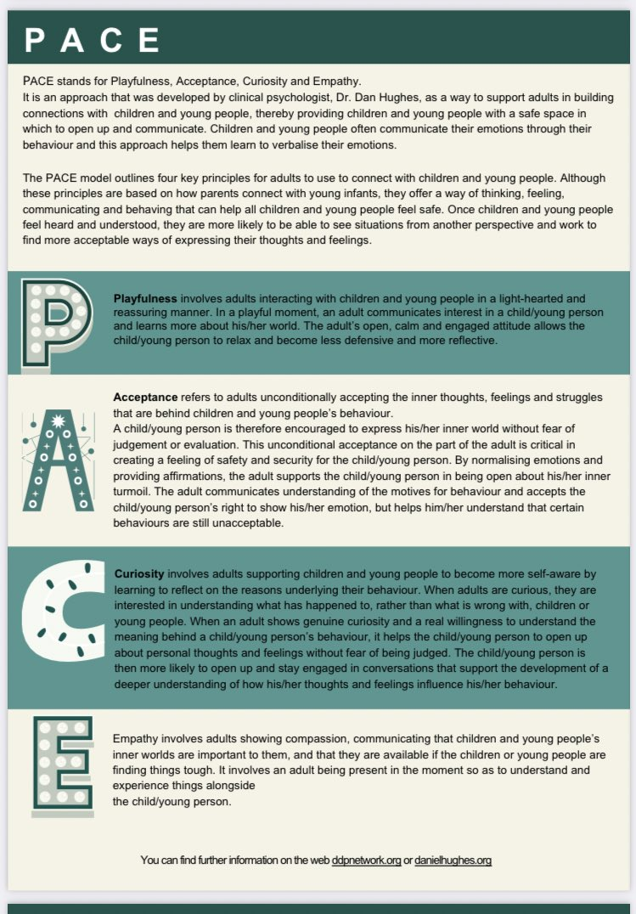**Appendix 2. The PACE Approach by Dan Hughes**

Appendix 3. TEAM Pupil Interventions chart (Bomber, 2016)