Domestic Violence, Human Sex Trafficking, Military PTSD and the way Forward in Trauma Informed Care
9:45 to 11:45 February 2, 2019
Salon E
Introduction
Trauma happens to us, our friends, our families, and our neighbors. Research by the Centers for Disease Control and Prevention has shown that one in five Americans was sexually molested as a child; one in four was beaten by a parent to the point of a mark being left on their body; and one in three couples engages in physical violence. A quarter of us grew up with alcoholic relatives, and one out of eight witnessed their mother being beaten or hit.
National Statistics Domestic Violence Fact Sheet
- On average, nearly 20 people per minute are physically abused by an intimate partner in the United States. During one year, this equates to more than 10 million women and men.1
- 1 in 4 women and 1 in 9 men experience severe intimate partner physical violence, intimate partner contact sexual violence, and/or intimate partner stalking with impacts such as injury, fearfulness, post-traumatic stress disorder, use of victim services, contraction of sexually transmitted diseases, etc.2
  - 1 in 3 women and 1 in 4 men have experienced some form of physical violence by an intimate partner. This includes a range of behaviors (e.g. slapping, shoving, pushing) and in some cases might not be considered "domestic violence." 1
  - 1 in 7 women and 1 in 25 men have been injured by an intimate partner.1
  - 1 in 10 women have been raped by an intimate partner. Data is unavailable on male victims.1
- 1 in 4 women and 1 in 7 men have been victims of severe physical violence (e.g. beating, burning, strangling) by an intimate partner in their lifetime.1
- 1 in 7 women and 1 in 18 men have been stalked by an intimate partner during their lifetime to the point in which they felt very fearful or believed that they or someone close to them would be harmed or killed.1
- On a typical day, there are more than 20,000 phone calls placed to domestic violence hotlines nationwide.9
- Women between the ages of 18-24 are most commonly abused by an intimate partner.2
- 19% of domestic violence involves a weapon.2
- Domestic victimization is correlated with a higher rate of depression and suicidal behavior.2
- Only 34% of people who are injured by intimate partners receive medical care for their injuries.2

RAPE
- 1 in 5 women and 1 in 71 men in the United States has been raped in their lifetime.1
- Almost half of female (46.7%) and male (44.9%) victims of rape in the United States were raped by an acquaintance. Of these, 45.4% of female rape victims and 29% of male rape victims were raped by an intimate partner.11

STALKING
- 19.3 million women and 5.1 million men in the United States have been stalked in their lifetime.1 60.8% of female stalking victims and 43.5% men reported being stalked by a current or former intimate partner.11

CHILDREN AND DOMESTIC VIOLENCE
- 1 in 15 children are exposed to intimate partner violence each year, and 90% of these children are eyewitnesses to this violence.5

Among Vietnam veterans, approximately 15 percent of men and 9 percent of women were found to have PTSD at the time of discharge. The incidence over a lifetime following involvement in a war, however, is much greater. Approximately 30 percent of men and 27 percent of women had PTSD at some point in their life following Vietnam.

PTSD in Persian Gulf War Veterans
Although the Persian Gulf War was brief, its impact was no less traumatic than other wars. From the time the Persian Gulf War ended in 1991 to now, veterans have reported a number of physical and mental health problems.
Studies examining the mental health of Persian Gulf War veterans have found that rates of PTSD stemming from the war range anywhere from nine percent to approximately 24 percent. These rates are higher than what has been found among veterans not deployed to the Persian Gulf.

PTSD in Iraq and Afghanistan Conflict Veterans
The conflicts in Iraq and Afghanistan are ongoing. That's why the full the impact the war has had on the mental health of soldiers in Iraq is not yet known. One study looked at members of four United States combat infantry units (three Army units and one Marine unit) who had served in Iraq and Afghanistan.
The majority of soldiers were exposed to some kind of traumatic, combat-related situations, such as being attacked or ambushed (92 percent), seeing dead bodies (94.5 percent), being shot at (95 percent), and/or knowing someone who was seriously injured or killed (86.5 percent).
After deployment, approximately 12.5 percent of these veterans had PTSD, a rate greater than that found among these soldiers before deployment.
One study of National Guard Soldiers highlighted the persistent effects of combat by looking at the rates of PTSD both three months and 12 months post-deployment. Rates of nine to 31 percent were noted overall, but of even more importance was the persistence of symptoms a year after return. In this study, there was also a high rate of alcohol misuse illustrating self-medication—a risky form of self-treatment for PTSD.
HT: 1.5 million in US; average age 11-14; every minute 113 people world wide are in danger of being trafficked according to the United Nations and US Dept of State.
Traumatic events are very common in most societies, though prevalence has been best studied in industrialized societies, particularly in the USA. Kessler et al3 found that in the USA at least 15% of the population reported to have been molested, physically attacked, raped, or been involved in combat. Men are physically assaulted more often than women (11.1% vs 10.3%), while women report higher rates of sexual assault (7.3% vs 1.3%). Half of all victims of violence in the US are under age 25; 29% of all forcible rapes occur before the age of eleven. Among US adolescents aged 12 to 17, 8% are estimated to have been victims of serious sexual assault; 17% victims of serious physical assault; and 40% have witnessed serious violence.4 Twenty-two percent of rapes are perpetrated by strangers, whereas husbands and boyfriends are responsible for 19%, and other relatives account for 38%. Men sustain twice as many severe injuries than women do. For women and children, but not for men, trauma that results from violence within intimate relationships is a much more serious problem than traumatic events inflicted by strangers or accidents: 62% of the almost 3 million attacks on women in the USA were by persons whom they knew, while 63% of the almost 4 million assaults on males were by strangers. Four out of five assaults on children are at the hands of their own parents. Over a third of the victims of domestic assault experienced serious injury, compared with a quarter of victims of stranger assault.5 This illustrates that an assault by someone “known” is not less serious than assault by a stranger. Domestic abuse and child abuse are closely related: in homes where spousal abuse occurs, children are abused at a rate 1500% higher than the national average (National Victim Center)6 .
In short, whether it is domestic violence, war related trauma, human sex trafficking trauma or any sort of trauma that could happen to a human being the statistics tell us that more and more people are dealing with trauma and as clinicians we have to be prepared to partner with each patient/client as they seek to heal and recover.
The primary way we do so is by utilizing what is referred to as “Trauma Informed Care.”
A trauma-informed approach incorporates:
- Realizing the prevalence of trauma
- Recognizing how it affects all individuals involved with the program, organization or system, including its own workforce
- Resisting re-traumatization
- Responding by putting this knowledge into practice
Core Principles of a Trauma-Informed System of Care:
- Safety – ensuring physical and emotional safety
- Trustworthiness – maintaining appropriate boundaries and making tasks clear
- Choice – prioritizing (staff) consumer choice and control (people want choices and options; for people who have had control taken away, having small choices makes a big difference)
- Collaboration – maximizing collaboration
- Empowerment – prioritizing (staff) consumer empowerment and skill-building

Section ONE: Definitions and How Memory is Built
Trauma results from an event, series of events, or set of circumstances that is experienced by an individual as physically or emotionally harmful or life threatening and that has lasting effects on the individual’s functioning and mental, physical, social, emotional, or spiritual well-being. SAMHSA, 2014.
File cabinet, files, event, encoded with a language...

Section TWO: How Trauma is Imprinted upon the Brain
The brain’s job is to ensure our survival.
An event takes place that is traumatic. We experience it in some way. Sigmund Freud said about trauma in 1895, “I think this man is suffering from memories.”
Gateway to our brain is the first to receive it: Hypothalmus. As part of that the Amygdala looks at it and determines if this information is a threat. HPA axis. If not, homeostasis. If it is, then sends an SOS signal to the Pituitary Gland and the PG releases the stress hormones to battle the crisis. (adrenaline and cortisol increase heart rate, blood pressure, our rate of breathing and prepare us to fight or run away).
A hormonal flooding ensues. As part of that response, the Vegus Nerve gets stimulated and depending upon whether we believe there is an escape or not…the sympathetic or parasympathetic system gets activated. It is either fight/flight or fear/freeze. (when you are in survival mode common sense leaves you)
Then the information is encoded into our memory—the hippocampus. (sights, sounds and smell). Distorted as the brain cannot handle trauma. No rational way to make sense of it. (if elements of the trauma are repeated or replayed over and over, the accompanying stress hormones engrave those memories even more deeply within the mind).
As this part of the brain is activated, another area of the brain is deactivated, the right and left dorsolateral prefrontal cortex. As a result, people lose their sense of time and get trapped in the moment without a sense of past, present or future.
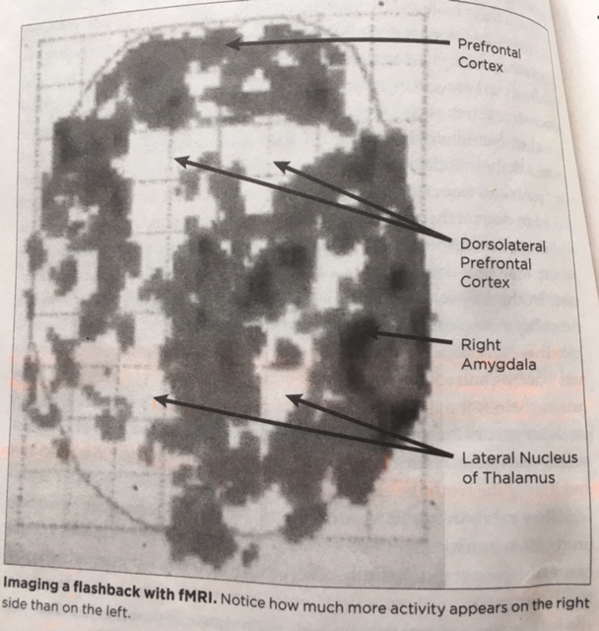
Functional magnetic resonance imaging fMRI. Found trauma survivors, dictated their memory of the trauma word for word and then put them in the fMRI machine and read their story back to them. Their brains were mapped as they processed through their traumatic stories.
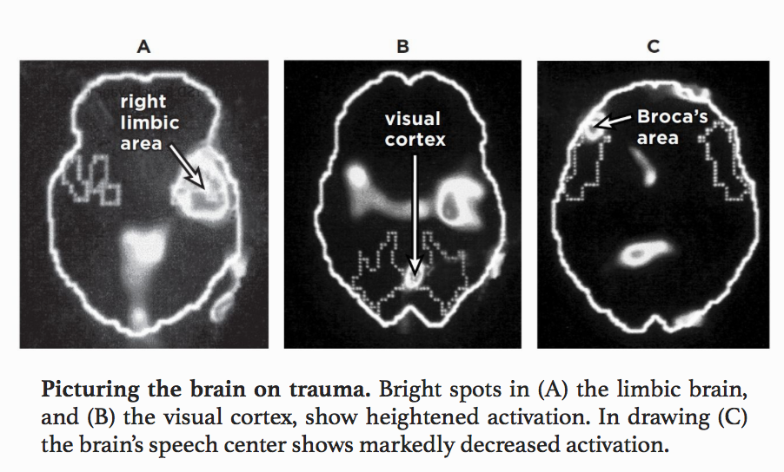

This is what they discovered:
The biggest area of brain activation was the right limbic area (the amygdala is in this area). No surprise as the amygdala is involved in determining whether what we are experiencing is a threat or not.
The big surprise was that the area known as Broca’s area went offline whenever a flashback was triggered. This is one the speech centers of the brain. Without a functioning Broca’s area, you cannot put your thoughts and feelings into words. (their bodies re-experience terror, rage and helplessness as well as the impulse to fight or flee, but these feelings are almost impossible to articulate...we freeze.
When words fail, haunting images capture the experience and return as nightmares and flashbacks. When the traumatic memories were read the visual storage area of the brain was activated so that the image could be brought forward.
No words to describe the image...just the image...which caused us to trip the amygdala...we now have a flashback.
It was also discovered that only the right side of the brain was lit up when the trauma was re-experienced and the left side was deactivated. Right is intuitive, artistic. Left is logic and rational thought. The deactivation of the left side of the brain (the left hemisphere) has a direct impact on the capacity to organize experience into logical sequences and to translate our shifting feelings and perceptions into words.

It was also discovered that in the PreFrontal Cortex (PFC) back in 1994 that in the frontal lobe there were specialized cells that were called mirror neurons. It was seen that when someone does something and then we do it...it is because of this mirroring effect, which also helps us develop empathy. It is like we have wifi in the brain and we pick up not only another person’s movement but their emotional state and intentions as well. However, the mirror neurons make us vulnerable to a persons negativity and anger as well.
A well working frontal lobe is important in our socialization and harmonious relationships with others.
If we are survivors of trauma this mirror ability is damaged and we struggle to pick up threats...which means we have to maintain a hypervigilant state at all times.

Once we enter into this state of hypervigilence, we are in essence stuck in survival mode. Then our sympathetic nervous system (arousal, activation of fight or flight) or our parasympathetic nervouse system (triggers the release of acetycholine which puts the brake on arousal and can lead to being frozen).

The sense of smell is unique, with a direct connection into the brain with no filter between, from the outside environment to the inner part of the brain.
Vagal nerve pathway. It is the 10th cranial nerve and stretches from the medulla in the brain stem down through the neck and throat, chest, and the abdomen. The vagus nerve plays a role in maintaining many bodily functions. It is connected to the endocrine (hormonal) and immune systems. It is part of the autonomic nervous system. That system has two parts: Sympathetic (fight or flight) and the parasympathetic (rest, digest and rebuild). There is a primitive part of the Vagus nerve called “the Dorsal Vagal Complex.”
When danger is perceived, the dorsal vagal branch may mediate a sympathetic flight or fight response in connection to the danger. Under extreme duress, and coupled with an inability to escape the threat, a dorsal vagal response may also include immediate parasympathetic activation, lowering heart and respiration rates and causing one to freeze or immobilize.
HPA axis hypothalamic-pituitary-adrenal. Signal sent from hypothalmus to pituitary gland to adrenal glands. This triggers the release of stress hormones.
Hippocampus-memory imprinting
Thalmus-pay attention, activating switch.
GABA flips off the switch of panic…tells the brain it is alright, relax.
The cortisol released in acute stress responses will temporarily suppress functions of the body that are reparative in the long term-immune functions and provide a burst of energy, increased memory, and a decreased sensitivity to pain. Allows for the evasion of danger. But if the cortisol levels remain high for a prolonged period of time, the adrenal glands become overworked, resulting in lower levels of release of cortisol, decreased immune functioning, and susceptibility to breaking down. (epigenetics states that this can pass from generation to generation).
Oxytocin is produced by hypothalmus and is stored in the pituitary gland then released throughout the bloodstream. Promotes bonding, euphoria and pleasure in sex, blocks some memory pathways, allows for healing after trauma by connecting with “people.”
When danger is detected, the HPA axis, beginning with the hypothalmus, is stimulated to release regulator chemical messengers called corticotropin releasing factor within central nervous sytem neurons; this activates the pituitary gland, which then signals the adrenal glands to release a further burst of stress response hormones. This galvanizes the body into action and we head into one of the four F’s. Fight or flight; freeze or faint.
When the perception is that escape is not possible, or that the fight option is being lost, there may be a concurrent activation of the parasympathetic nervous system.
A trauma survivor is often in a constant state of hyper-arousal.
The average person battling PTSD usually waits 7 years before getting help.
Section FIVE: What is the result?
If we are able to move and do something to protect ourselves from the trauma then the trauma will usually not leave long lasting scars. Especially if we grew up in a healthy home with good relationships and bonds.
Three levels of safety:
- We call out for help or support.
- Fight or flight.
- Freeze. Shut down to preserve itself, expend as little energy as possible.
Things to be aware of...it is not all cookie cutter...
Edgy, sense of hyperarousal, untrusting, triggers, inability to bond, survival instinct PLUS physical symptoms.
Some don’t leave because of what Freud termed, “the compulsion to repeat.” Reenactments were an unconscious attempt to gain control over a painful situation that would eventually lead to mastery and resolution.
Abused, isolated girls with incest histories mature sexually a year and a half earlier than the non-abused girls. Sexual abuse speeds up their biological clocks and the secretion of sex hormones. Early in puberty the abused girls had three to five times the levels of testosterone and androstenedione, that hormones that fuel sexual desire, as the girls in the control group.

Section SIX: How to help?
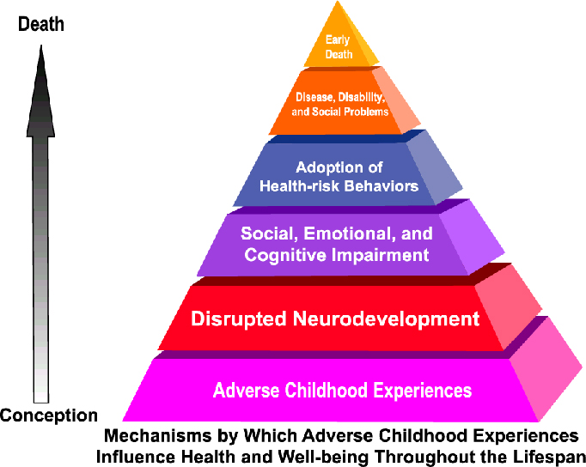

- CBT counseling
- Aromatherapy: Rose, Eucalyptus, or Lavender.
- Mandala (Carl Jung)
- Safety in counseling and at home
- Mindfulness-reduces amygdala activity
- Exposure of skin to sunlight…produces Vitamin D
- Grounding
- Development of good support/loving relationship
- Bodywork (massage, yoga, etc...)
- Meditation
- Drugs (They cannot cure trauma. Instead they dampen the response)
- Writing to yourself
- EMDR...rapid eye movement is similar to REM level of sleep where our mind puts together trauma and makes sense of it. Have to make sure that if a person is triggered and the trauma is re-experienced that they don’t get stuck. Research is there for adults but not for trauma that started as a kid. Because it is encoded differently.
- Heart Rate variability. Learning to control our breathing and heart rate. Neurofeedback. Change dysfunctional brain waves. (ADHD and PTSD)
- PBSP psychomotor therapy. Pesso. Restructure, rescripting, theater type of approach. A witness would say...

Section SEVEN: Questions

Stress response physiological systems Research has identified two primary physiological systems involved in stress responses to trauma exposure: • the SAM system (i.e. sympathetic-adrenal-medullary system), and • the HPA axis (i.e. hypothalamic-pituitary-adrenal axis) (Yates, 2007). What is the SAM system? The SAM system is part of the body’s sympathetic nervous system. It plays a role in short-term flight-or-fight responses to stress. The body physiologically responds to stress by releasing adrenaline, which increases sweat, heart rate and blood pressure, and reduces digestion (Van Horn, 2011). The SAM system’s activation also reduces a child’s ability to engage in ‘the present’ by affecting body and brain systems involved in processes such as attention and memory (Gaskill & Perry, 2012). Children with histories of trauma show evidence of disrupted functioning of the sympathetic nervous system, and may have higher baseline adrenaline and heart-rate levels (van der Kolk, 2003). What is the HPA axis? The HPA axis is part of the body’s endocrine system and is involved in the body’s longer-term responses to stress, regulating complex interactions between the body’s hypothalamus, pituitary and adrenal glands. The HPA axis is also involved in regulating the immune system and emotions. The HPA axis helps activate or deactivate glucocorticoid hormones (e.g. cortisol) in response to stress. Impaired functioning of the HPA axis has been identified as a key pathway between trauma exposure and later developmental outcomes (Kearney et al., 2010). The HPA axis develops throughout childhood. Frequent activation of the HPA axis may lead to overloading the body’s stress-response systems (Bradley & Corwyn, 2002) thereby damaging the body’s central nervous system and organs. The HPA axis may then not activate when required, activate when not required, or continue to be activated after stress has subsided (Kearney et al., 2010). Research has found irregular levels of glucocorticoid hormones in children with histories of trauma (Kearney et al., 2010), which has also been associated with reduced school engagement and academic achievement (Perkins & Graham-Bermann, 2012). Childhood trauma: Developmental pathways and implications for the classroom 5 Glucocorticoid hormones affect brain and body systems through changes to gene transcription, which may help explain why changes to HPA axis functioning are related to longer-term physiological and developmental outcomes (Gunnar & Quevedo, 2007). Furthermore, impaired HPA axis functioning affects the way in which traumatised children respond to future stressors. It often takes lower stress levels to provoke full-blown stress responses. This may help perpetuate a cumulative effect of trauma throughout development (Grasso, Ford, & Briggs-Gowan, 2012). Prolonged exposure to certain types of glucocorticoids have also been associated with impaired neural plasticity (Glaser, 2000), which is the brain’s ability to reorganise itself in response to the environment

Intestinal tract “referred to as the 2nd brain.” Connected to the vagus nerve. 95% of bodies serotonin is produced in the gut.
Epigenetic transmission is directly related to a person’s vulnerability to psychological trauma.
The amygdala is the first responder, receives information from the thalmus (gatekeeper of incoming sensory information) which is rapidly screened for danger, with the potential of activating the pituitary gland.
People are neurobiologically hardwired to be emotionally connected with others. Happens in the first three years of life (Is the world safe, am I loved unconditionally, do I have self-efficacy).
Neurological imprint is made that the world is safe or not. If not, people produce anxiety.
70% of U.S. adults experience trauma at least once in their lifetime. 20% will develop PTSD.
Triune Brain Model:
Reptilian (brainstem): survival instincts
Mammalian (limbic): emotions
Neomammalian (cortex): cognitive processing, decision making, memory
Hippocampus shrinks as a result of stress cortisol exposure. This is key to memory.
Hypothalmus-houses the pituitary gland, release of hormones.
Pituitary gland-master gland
Oxytocin-facilitates social bonding and acts as a buffer against stress, anxiety and depression. It cements attachment between mothers and babies, bathes the brains of couples falling in love, and floods the body during orgasm, strengthening intimate connections.
Consequences of trauma: alarm system no longer working properly, over reacting to minor misunderstandings, trouble calming down, impulsive, numbing, poor bonding, problems with boundaries, guarded, isolates, disruptions in memory.
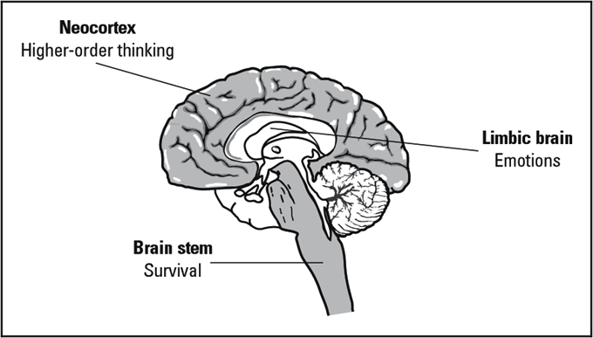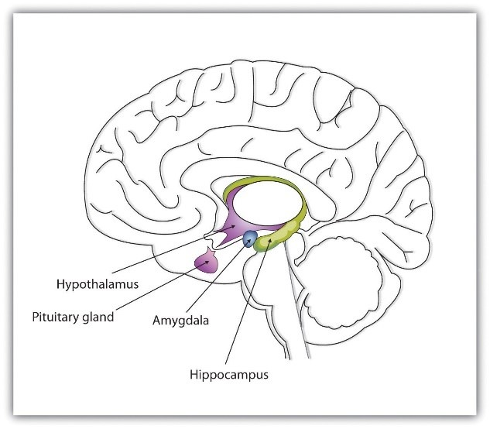

vanderKolk BA., vanderHart O. The intrusive past: the flexibility of memory and the engraving of trauma. Am imago. 1991;48:425–454.
2. Felitti VJ., Anda RF., Nordernberg D., et al. Relationship of childhood abuse to many of the leading causes of death in adults: the adverse childhood experiences (ACE) study. Am J Prev Med. 1998;14:245–258. [PubMed]
3. Kessler RC., Sonnega A., Bromet EJ., Hughes M., Nelson CB. Posttraumatic stress disorder in the National Comorbidity Survey. Arch Gen Psychiatry. 1995;52:1048–1060. [PubMed]
4. Kilpatrick DG., Acierno R., Saunders BE., Resnick HS., Best CL., Schnurr PP. Risk factors for adolescent substance abuse and dependence: data from a national sample. J Consult Clin Psychol.2000;681:19–30. [PubMed]
5. van der Kolk BA. Adult sequelae of assault. In: Friedman, Kaplan, Sadock, eds. Comprehensive Textbook of Psychiatry. Baltimore, Md: Williams and Wilkins. 2000
6. National Victim Center. Crime and Victimization in America: Statistical Overview. Arlington, Va; 1993

