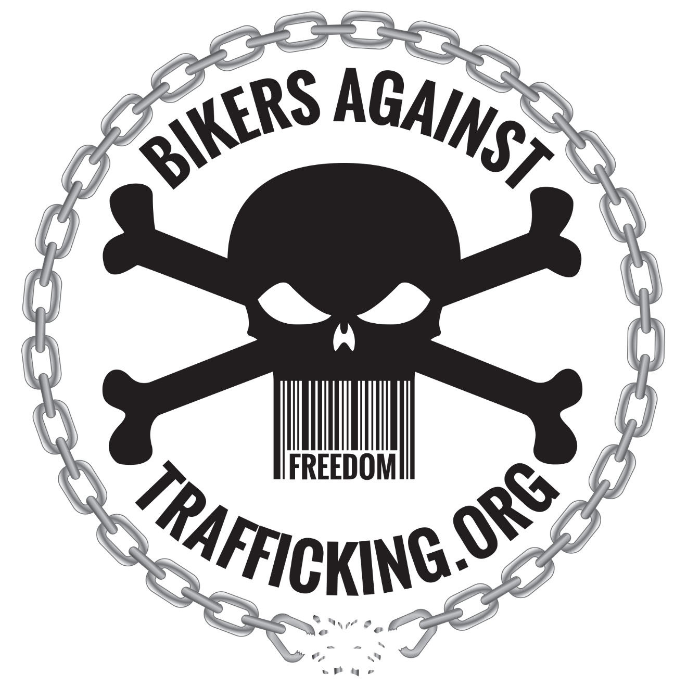

Bikers Against Trafficking
Handbook

Approved May 2019 by:

Dr Patrick “Doc” Nave, D.Min., LMHC, MCAP, CET.
CEO/Chairman of the Board of Directors
Bikers Against Trafficking

Preface

Welcome to the Bikers Against Trafficking (BAT) Handbook! Your participation in BAT makes you part of a worldwide organization that is dedicated to breaking the chains of human sexual trafficking around the world.

Through BAT we primarily target motorcyclists and those who identify with them (have a similar mindset and determination) by building a network of awareness, outreach and intervention. We provide counseling, treatment, empowerment, education and awareness around the world, in an attempt, to eradicate the tragedy of human sexual trafficking. In some areas we have extraction teams that work with local law enforcement and we also are in the process of developing some homes, Healing Place homes, for survivors to live as they recover.

BAT is an association comprised of Chapters and groups that seek to be active in our community and world. To become a part of BAT means that you have determined that you want to make a difference and “do something” for the greater good. To learn more about what we are doing you can access our website and Facebook pages.

Http://www.BikersAgainstTrafficking.org

Https://www.Facebook.com/BikersAgainstTraffickingFL

This handbook is designed to provide information and insight into BAT. Our goal is to provide a handbook that will help you take your participation to the next level. As you review this handbook, we hope and desire that you will strive to do all that you can to make a difference for those who are being subjected to slavery.

Our goal is to create a reference guide for our members. BAT provides freedom to its group members, but with accountability. If an issue should arise that is not covered in this handbook, we encourage you to contact your national leadership for help in clarification.

Mission Statement of Bikers Against Trafficking

We are a 501(c)3 non-profit that exists to educate, equip, empower and mobilize members of the motorcycle community (and those who are like minded) to combat human sex trafficking by building awareness, providing clinical trauma counseling & providing housing.

Vision Statement of Bikers Against Trafficking

Vision: Breaking the Chains of Human Sexual Trafficking, one person at a time

We will accomplish our vision through:
- Attending motorcycle rallies, events and runs around the world to build awareness.
- Holding at least one poker run for BAT in your area (each year) to raise financial support and build awareness.
- Equipping our members and supporters with the latest information and training about human sex trafficking.
- Humbly partnering with all organizations that seek to eradicate human sex trafficking.
- Building an ongoing awareness through social media and by participating in area events.
- Speaking at all opportunities offered to us, provided that we are able and it does not conflict with our mission and vision.
- Providing clinical trauma counseling and treatment for those who have survived so that they can transition into being “thrivers.”
- Providing safe housing for those who have come out of human sex trafficking.
- Working behind the scenes to eliminate child abuse.
- Working with those who are involved in creating the “demand” for trafficking by providing sexual addiction training, counseling and recovery. As part of this step we work with State licensed individuals who have experience in working with sexual addiction. (not all areas work in this aspect as there is a special process that one has to go through to be able to offer this specific addiction therapy)
- Build relationships with area clubs, organizations and churches so that information can be shared and resources can be provided. It is important that each chapter establish itself in its community.
- Establishing local chapters of BAT in every State and Country.
- Holding monthly area meetings for encouragement, training and camaraderie.
- Building a world wide family.

How to Become a BAT Chapter Member

BAT is an organization made up of individuals from all walks of life who are working together to eliminate human sex trafficking. We are a chapter and members are free to work with other clubs/organizations of their choosing as long as they do not interfere with the mission and vision of BAT. We are organized on a State leadership level that all report to the International leadership. The members are integral in the fabric of who we are. As you seek to determine if BAT is the right organization for you, we highly encourage you to learn all you can about human sex trafficking.

The specific requirements to become part of a BAT chapter are as follows:
- All members are required to complete Basic Training. This training can be found online on our website under the Chapter link. Please watch the training and then we will follow up with you in an interview and discuss what you learned.
- All members are required to complete the application and pay the appropriate fees. Part of the application fee goes to the mandatory background check. There is only one crime that will prevent you from becoming a member. That crime entails you being a perp in a sex crime.
- To be a part of a BAT chapter you must ride BUT you can be active in the chapter without being a member and we encourage everyone to do so.
- To become a full member you must be involved in BAT activities for a certain amount of time. There is no “prospecting” but in essence you earn the right to wear the back patch and becoming part of the chapter by your involvement and participation in what we do. Hang around us, get to know us, make sure you can identity with our unique sense of family. We don’t wear the patch on our cut because it is cool looking rather we wear it because it is a signal of our determination to make a difference while being active in this family. (all that become members of BAT can be asked to return their patch if they fail to adhere to the rules, stop becoming active in what we are doing or end up committing a crime that makes them ineligible. The BAT logo is trademarked.)

It is important to provide key information about BAT and Basic Training (BT) to anyone desiring to join this organization, and as such, anyone desiring to join BAT will need to complete the Basic Training (BT) and pass the mandatory background check. This is part of the requirements for all those who desire to wear the back patch. Anyone can wear the smaller support patch provided they support our mission and vision and seek to make a difference.

The Basic Training (BT) AND the background check application is available via links on our website.

Upon completing the Basic Training (BT), you will be asked to have a phone conversation with someone in the national office to touch base on your training and to answer any questions you might have.

Member Training

Basic Training is designed to focus your attention on preparing yourself for becoming an active, functioning member of BAT and its battle against Human Sexual Trafficking.
Information about BAT will be presented. Training will be given on the topic of Human Sexual Trafficking and you will hear the story of our Vice-President, who has survived a life of being forced into a life of Human Sexual Trafficking.
This training is available on our Facebook page as a Facebook live video or you can choose to watch the initial training via Youtube. The link is on our website.
You will also be asked to view other videos that are created from time to time. We are a motorcycle association and it is important that as you go about representing who we are that you understand the “right” way to do so.

Active Membership

BAT is an organization with high standards. We expect our members to:
- Model good character.
- Be a person of integrity in their walk and actions.
- Complete Basic Training (BT).
- Support BAT at both local, national and international levels.
- Be 14 years or older.
Reaching the world is important to BAT and our members enable that task. Active membership at a national level is based on completing one of the following criteria in a 12-month period plus paying the yearly $25.00 dues:
- Being a regular participant at local BAT meetings.
- Partnering with the International office in Lake Mary, Florida in its worldwide outreach.
- Participating in the local Poker Run and Rallies.
- Representing BAT at local biker events by working at one of our booths.
- Holding monthly local meetings and getting involved in your community.
- Each chapter holding quarterly meetings with the International leadership. (this can be done via phone)

BAT Support

BAT is a 501(c)3 nonprofit organization. All funds given to BAT are used directly for BAT events, materials and support.

Some funds are raised through the suggested donations that are given for items such as shirts, hats, patches, etc… on our store page.

All leaders give a portion of the funds that are raised on a local level to the International office to help with the overhead expenses of BAT.

There are many methods in which a person can donate to BAT. Here are a few options:
- Utilize bill pay through your bank to set up regular monthly donations.
- Go to the website and donate via the Paypal button.
- Send a check to our mailing address.

Year-end donation receipts are sent out by January 20 every year via bulk mailing. This includes all donations made to BAT International.

Poker Run “Breaking the Chains”

Breaking the Chains (BTC) takes place each year and is one of BAT’s official fundraisers. BTC allows us to partner with different organizations around the world and to help supplement those groups who need financial support to continue to spread awareness about Human Sex Trafficking either nationally or internationally.

We are aware that not all groups will be able to do a May poker run but we do ask that each group conduct a poker run yearly to raise awareness and build a presence in your community.

BAT Logo

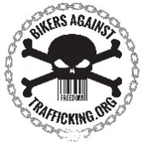The BAT logo is our trademark and is worn as a back patch by BAT members who have completed Basic Training (BT). People who have not completed Basic Training may wear BAT gear and the smaller support patch.

Definition of BAT Logo:
Chains broken | = | Represent our mission to break the chains of slavery
Skull | = | Each of us at the end of the day have a similar skull within. We are all the same. (ultimate sign of hope in Ezekiel)
Bar code | = | Many trafficked people have been branded by their traffickers
Freedom | = | Our goal is to bring freedom to all in slavery and to bring freedom to people in all walks of life.

BAT Artwork

All BAT artwork is owned, licensed, and controlled by the Bikers Against Trafficking. It may not be copied, reproduced, republished, reprinted, or distributed in any way without written permission from the International office. All trademarks, service marks, logos, and trade names are proprietary to BAT. Any submissions or concepts become BAT’s property and BAT shall not be liable for any use or disclosure of them.

BAT Vest Standards

The BAT standard for vests states that:
You can wear the back patch as long as you don’t wear any other patches that would go against what the back patch represents. All patches that take you out of a neutral position are not allowed (no support patches).

We ask that you commit to one back patch while serving as a member of BAT. Anyone who practices by word or deed anything that would discredit the mission of BAT will be asked and expected to remove his or her BAT back patch. If a member is asked to remove or return their back patch, no reimbursement should be expected, or given, by BAT or its affiliates.
If you are part of another motorcycle organization group and want to support BAT programs please wear the smaller support BAT patch and get as involved as you can.
Be careful that you don’t clutter the back of your cut. Be aware that we go about representing many and so your awareness of this is appreciated.

BAT Name Badges

There are no official BAT name badges. However we recommend 1 x 3 patch and we can order them. White letters on black background.

Chain of Command/Communication

BAT has developed a chain of command and communication to aid members in receiving the information they need on a timely basis and provide State Leaders and members with support as needed. It is the responsibility of each leader to make sure that the next leader in the chain receives the communicated information.

Members are encouraged to refer to this chain of command/communication. It provides a communication link to leaders in your area that are best equipped to answer questions and issues.

Phone numbers for your leaders are available on the website.
BAT Board of Directors
International President of BAT
International VP of BAT
State (Nation) Coordinators/Leaders
Chapter Presidents and Officers
Members

BAT International Positions

Board of Directors
BAT’s Board of Directors consists of at least five Directors and includes the International President and International Vice-President. The Directors meet quarterly throughout the year to seek direction, set the vision, and review/update policies. The International President is the Chairman of the Board and oversees, in cooperation with the Board, the BAT International organization.

Leading with Accountability

BAT is a non-governmental organization. We recognize that there are differences in all organizations that seek to eliminate Human Sex Trafficking and we seek to represent BAT with integrity and honor and to work alongside of each group with humility.

Reaching Out to Minors

BAT reaches out to motorcyclists of all ages, including Youth and Children. In order to protect children and the integrity of BAT and its members, it is required that all BAT members complete a national criminal background check.
It is also required that if a BAT member is reaching out to a minor that they always have another BAT member with them as a witness. Safety in numbers is emphasized for accountability.

State/Region Leadership “Leader”
State leadership is in place to help lead and coordinate the members in the individual states/Region. They function on a volunteer basis and they are a vital part of BAT. Leaders will be developed as more states start groups.

State and Country Officers
State and Country officers are appointed to help lead and coordinate the organization's involvement in various activities. Officers are a reflection of BAT and represent the quality of the organization because of their visible leadership and their dedication to the mission. They should work together as a team and promote unity throughout BAT.

The officers and their titles that we use:

International President: The national/international president.
International Vice-President: The national/international vice-president only.
Chaplain. The local chapter chaplain.
State/Region Rep: This title is used for the leader of a particular state/region.
Nation Leader: This title is used for the leader of a particular nation.

Chapter President, Chapter Vice-President, Secretary, Sargent of Arms, Treasurer, Road Captain, Chaplain, etc... are up to individual States and Nations to use if they believe they are necessary and would help facilitate the mission more effectively in the local chapters. Each patch is to be purchased from BAT international or ordered to fit on a 1 inch by 3 inch black background with white writing and it must be approved by the international office.

Finances

Bikers Against Trafficking is a not for profit corporation.
Only the International office can issue tax receipts for donations of any kind:
- If you are raising money please contact the international office and submit a request as to what you are going to do as a fundraiser. After the request is approved all funds must be accounted for and deposited into the main financial account. A check will then be given back to the local group to use as requested. That way all financial matters can be taken care of. Exceptions are if the local group desires to have their own checking account. (You will have to register your area chapter with the State and then open a local checking account but this account will not be tax exempt). The donations given directly to the local group will not fall under the 501 (c) 3 non-profit.
- Be aware that every penny raised must be accounted for.
- We have a letter from the IRS stating we are a not for profit. If you need this please contact the national office and it will be provided for you.
- Donations to the organization can be made online via paypal on the international website.

Setting up a checking account

If the local group does not wish to utilize the national account then each group can create their own bank account. You will have to set up the account in the name of Bikers Against Trafficking- (the name of your local area) and it will NOT be a not for profit. You will have to first purchase/register the name in your State/Region. This usually costs somewhere around $100 and then you can have a checking account that your local area will be responsible for. If you go this route a monthly statement must be sent to the international office for accountability.

**IMPORTANT NOTE: State and Nation accounts are NOT non-profit. Members and other entities’ donations made directly to the State or Nation are not tax-deductible.

Ride Safety

Make sure that you carefully determine your routes and lead rides for State and Nation rides and functions.

Some will utilize a Road Captain to be in charge of leading the rides. Regardless, your goal should always be to make sure that everyone has a safe and enjoyable time while riding their bikes together. You should look for different types of rides that you can host (i.e. map run, scavenger hunt, etc.). Having active runs will promote growth and fellowship. You are encouraged to contact other areas in your state/region to work together on ideas for rides.

We also encourage you to ride other events together as well.
Key functions of the Road Captain or Rider Leader:
- Plan rides in advance. Tentatively schedule rides as far as six months in advance and present the ride plans at meetings for approval.
- Announce ride information (i.e. dates, departure/arrival times, locations, distance, known expenses/fees, etc.) at meetings and before rides. This will help attendees make plans that are needed in order for them to participate.
- Practice safe riding habits.
- Consider scheduling a special group-ride instruction class for new or interested riders.

Social Media

We have a national Facebook page at BikersAgainstTraffickingFL and an active website at BikersAgainstTrafficking.org

Your local communication should be posted on both sites. For Facebook please communicate directly on the site via posting. For the website we will create a link to a local website which we will ask you to develop and monitor or we can set up a simple one that you can have an email posted on and send us basic information to post.

Please be careful as to what is posted as every posting reflects BAT as a whole.

