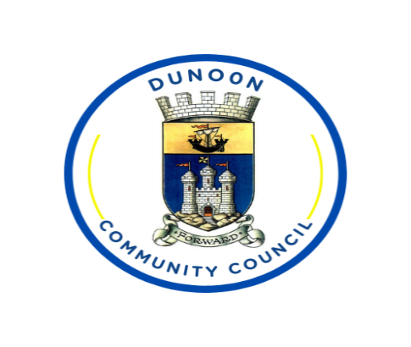

Dunoon Community Council
Meeting of the Dunoon Community Council held in Queen’s Hall, Dunoon on Monday 12th January 2026.

Community Councillors Present:
Gill Robertson (GR) (Convener) Tom McCowan (TMc) Secretary
Debz Wright (DW) Lindsey McPhail (LM)
Paul Graysmark (PG)

Via Teams:
David Clough (DC) Councillor Ross Moreland (RM)

ABC Councillors Attending: Dunoon Observer:
Chris Martin (CM)

Police Scotland:

PC M Cunningham

Guest Speakers:

Kevin Anderson (KA) – Live Argyll

Members of the public:

Anne Robertson MBE (AR) Frauke Thornton (FT)

Apologies
Tim Moss (TM) (Treasurer) Tom Warren (TW) (Vice Convener)
Councillor Audrey Forrest (AF) Abigail Apps (AA) (Leave of Absence)
Yvonne Love (YL) Councillor Daniel Hampsey (DH)

1. Welcome and Apologies
- The meeting was opened with a welcome to all, including new and prospective members. It was noted that Anne Robertson and Frauke Thornton would officially join after 15 January due to election timings. The Convener also spoke about Social Media behaviours and how comments and posts could be construed as Community Council views and opinions.
- The meeting was recorded for minute-taking purposes only; the recording will be deleted once minutes are approved at the next meeting.
- Apologies were received from several members, including Tim Moss (who also submitted a resignation letter), Tom Warren, Abigail Apps(on six months’ leave), Yvonne Love, Audrey Forrest, Daniel Hampsey,
- David Clough and Councillor Moreland attended via Teams.
2. Minutes of Previous Meeting
- The minutes from the previous public meeting (10 November) were approved without objection.
3. Membership, Appointments, and Resignations
- Eric Owen was nominated for co-option to the council, pending formal vote at the next meeting. Other new members (Frauke Thornton and Anne Robertson MBE) will also take their seats after being elected at the upcoming By-Election.
- Tim Moss resigned as Treasurer due to work commitments. His letter of appreciation and thanks was read out.
- Anne Robertson MBE was proposed and approved as the new Treasurer, effective from when eligible.
4. Police Update
- Police provided an update on recent activities, including increased patrols, partnership work, and youth engagement initiatives.
- No significant trends or incidents were reported over the past six months. Theft and shoplifting cases are under investigation.
- Discussion took place regarding late-night ferry services during the Cowal Games and the lack of reported incidents. Police agreed look into incidents recorded over the last Cowal Games weekend and report back to DC by end of week, he also agreed to provide a summary for Calmac if needed.
5. Presentation: LiveArgyll Update
- Kevin Anderson delivered a presentation on LiveArgyll’s operations, funding, and community impact.
- Key points included:
  - LiveArgyll is a non-profit delivering a range of community services (libraries, leisure, events, etc.) under a service agreement with the council.
  - Funding is a mix of council payment and self-generated income, with increasing pressure to generate more income due to static council funding.
  - Usage statistics for facilities and events were shared, highlighting positive economic and social impacts.
  - The “Fairer Funding” campaign was discussed, aiming to secure sustainable funding for services.
  - Questions were raised about disabled parking, event programming, and membership models. Financial constraints and the need for income generation were emphasised.
6. Reports and Updates
- Convenor’s Report: No specific items to highlight.
- Secretary’s Report: Clarification provided regarding a newspaper report on traffic regulation order consultations; the council had not responded as it was not relevant to their activities. Ongoing efforts to recruit new and younger members, including outreach to schools. Members were notified about an upcoming beach clean.
- Treasurer’s Report: Bank balances and recent expenditures were summarised. Funds are allocated for the play park and other community activities. Financial report was accepted and approved without objection.
- Transport: Discussion on ferry services, the reliability of Calmac vs. Western Ferries, and the potential for a new bus service. It was agreed to make this a major agenda item for the next meeting and to seek wider community input.
- Emergency Resilience: Plans to organise a meeting for the resilience committee.
- Planning and Licensing: No updates.
- Education and Youth: Ongoing efforts to address youth members and engagement.
- Infrastructure: Updates on block drains, gritting,
- Environment: Discussions were held about Bishops Glen and Morag’s Fairy Glen were held. A request was made for a visit to Morag’s Fairy Glen for a site recce.
7. Community Engagement and Social Media
- The council’s Facebook group has grown significantly. Plans are in place to increase public engagement at local markets and events, including the purchase of a branded gazebo for outreach.
8. Other Business
- Updates on the Aldi public consultation and local business reactions.
- Discussion on insurance for volunteer activities and the need for clarity on public liability coverage.
- The council agreed to revisit several topics at the next meeting, including the ferry service and Aldi development.
9. Date of Next Meeting
- The next meeting is scheduled for Monday, 9 February.
Meeting closed with thanks to all attendees.

Signed by:
{Original Signed}

T McCowan
Secretary Dunoon Community Council

Distribution:
All DCC Councillors
Cllr Moreland
Cllr Forrest
Cllr Hampsey
Melissa Stewart
Argyll & Bute Council
Police Scotland
BID Manager
BID Chair
Dunoon Community Development Trust
Chris Martin (Observer)
Queens Hall Reception
Library
DCC Facebook page
DCC Website
Minutes compiled by Microsoft 365 copilot.

Annex A to
Dunoon Community Council
Meeting 12th January 2026
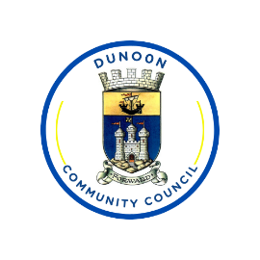
Dunoon Community Council
Members Reports.
January 2026
Secretary:
New tasks that have been undertaken since last meeting:
1. Dealing with public complaints regarding parking
2. Finalising details of Westbay Play Park. Plans sent out to members on 06/01/2026.
3.
4.
Ongoing Project Updates:
1. Ongoing emails answered
2. Minutes and Agenda published
3. Website and social media maintained. Dunoon Community Council Facebook group is now closed, The Facebook group is getting more attention
Proposals:
1. DCC purchase a branded gazebo for use at public events such as markets. This can also be used when holding work parties in local area such as Bishops Glen and Morag’s Fairy Glen. Cost of cover is £316.00 inclusive of VAT and delivery. I have a metal gazebo frame and side walls, all in good condition that I will donate to DCC. If DCC wanted to buy a new frame, this would cost and additional £330 + VAT. {See attached design and Quote}
2.
3.
Further Updates requiring Dunoon Community Council attention:
1. Promoting DCC and trying to attract new members, possibly have 2 people lined up. We do need more, especially youth members. This is a priority moving forward otherwise we are at risk of not being quorate should a couple of people leave.
2. Markets have been announced for 2026, These are on Saturday’s 04/04/26, 27/06/26, 29/08/26, 31/10/26, 21/11/26, & 28/11/26. Need to look at volunteers for these dates. Tea/Coffee will be provided for a small donation and all money raised will be donated to Xmas Lights Committee. It is also a good opportunity to advertise what we are doing and recruit volunteers.
3. TRO – Why has this not been sent out to any Community Councils as it was reported in the local paper. Strachur CC have also confirmed that they never received the TRO Consultation.
4. Co-Opting Eric Owen onto Dunoon Community Council. This will be added to the agenda for next month meaning we will have three new members taking their seats in February, Anne Robertson, Frauke Thornton and Eric Owen.
5. Treasurer, With Tim now having resigned from Dunoon Community Council, we are now needing a new treasurer, Anne Robertson has volunteered, but if anyone else wishes to take the role, please send me their nomination by 02nd February. This will be voted on at our February meeting.

Report Compiled By: Tom McCowan
Date: 07/01/2026

Transport:
Tasks that have been undertaken since the last meeting.
- Attended Cowal Transport Forum on 24th November.
- Attended Hi Trans meeting on Monday 8th December.
- Transport Scotland responded on 21st November to request for update on new ferries – see Appendix 1.
- Meeting held with CalMac timetable planners and West Coast Motors to see if improvements can be made to inbound services in the afternoons particularly when a single vessel service is operating.
- Train / ferry / bus connectivity workbook for inbound and outbound services to /from Dunoon and surrounding areas circulated to CGTL CC’s and all DCC members.
- CalMac have published their Vessel Deployment, Disposal & Cascade Plan (VDD&CP) on the CalMac website. You can view it online here: https://corporate.calmac.co.uk/en-gb/about-us/chfs3/delivery-plans/ - click on the link for Strategic vessel deployment, disposal and redelivery plan. Note on page 12 that Argyll Flyer and Ali Cat are referred to as “workboats”.
- Dealt with a query on connectivity received via the website from a resident.
- CalMac update on Gourock Improvements received – see Appendix 2.
- Correspondence received from MSP Ariane Burgess’s office – see Appendix 3.
- Further work on costing for a new 907 Dunoon / Gourock Service. Please see Appendix 4 for a draft timetable for comment.
- Standard letter of support for the Argyll Rally provided to Motorsport UK – see Appendix 5.
Items requiring discussion/approval from members.
- At what stage do we seek the Community Views on the provision of a new 907 service? Until we can approach Western Ferries with a demonstrable support for the service will we ever get Western Ferries to agree.
  - Note that I see the 907 service as a direct replacement for the CalMac ferry service, not as an alternative service.
Possible options on Dunoon Gourock Service.
- Do nothing.
- Await Transport Scotland / Holyrood to provide updates.
- Continue to lobby MSP’s, Transport Scotland, Minister for Agriculture and Connectivity for replacement passenger only ferries.
- Continue to support the CGTL in efforts to make a Community Asset Transfer of Dunoon linkspan and seek alternative operator.
- Replace existing CalMac service with a combined Bus / Ferry service.
- Other

Items requiring further action by Transport Lead member.
- Issuing summary actions from meeting with Mull CC (o/s from last meeting x 2).
- Update distribution workbook with latest updates from volunteers in readiness for 2026 (o/s from last report x 5).
- Continue to lobby 16 x MSP’s and Minister for Agriculture and Connectivity ref ferries.
- Further work on proposal from WCM for revised 907 service.
- Continue to lobby Transport Scotland for clear plan for replacement ferries.
- Continue to make ‘noise’ with MSP’s about possibly worst ferry service in Europe.

Report compiled by: David Clough
Date: 7th January 2026
Appendix 1
Update from Transport Scotland on new ferries for Gourock / Dunoon.
Apologies for the time taken to respond, please see below the latest position with the Gourock Dunoon Kilcreggan Infrastructure and Vessels Programme.
The Working Group has been considering interlinked vessel replacement and port infrastructure matters to develop the options for investment in ferry services to Dunoon and Kilcreggan. The review of services reported following the completion of the Community Needs Assessment work has been included in the ongoing business case works. Programme costs, budgets and timelines are currently being reviewed and will be included in the Outline Business Case (OBC) which is expected to report around summer 2026.
A review of alternative vessel options being introduced around the UK was due to take place in early 2026. The work to be conducted was based on the potential options of hydrofoil craft, which were to be delivered to operators. Given the potential benefits for ferry connections on the Clyde, the Working Group was hoping to include in-service data of the new vessels to ensure that all appropriate options for vessel replacements were analysed before the most suitable variant(s) were taken forward via the business case process. However, we have now been advised that due to amended delivery timescales, the operational data for the vessels of a similar size to those likely required for Dunoon services will not be available until the end of 2026 / beginning of 2027.
In terms of moving forward with replacement vessels and infrastructure, approvals from Transport Scotland’s Investment Decision Board and Ministers will be required following completion of the OBC, which will be subject to budget considerations and investment priorities across the transpoort network. As noted above, the Working Group is actioning efforts to complete the OBC and is targeting summer 2026 for reporting. Timescales beyond that will be dependent on the approvals process, available budgets and procurement processes for the preferred solution.

I trust this provides an approriate update at this stage and we look forward to further progress in the comming months.

Appendix 2
CalMac update on Gourock Improvements.

I’m pleased to share an update below on the improvements taking place at Gourock Port as part of our ongoing work to enhance staff facilities and the customer experience.

Enhanced customer experience

Customers using Gourock will see a number of upgrades designed to make their journey smoother and more comfortable, including:

- Refreshed indoor waiting areas with new flooring and a fresh coat of paint.
- Additional outdoor seating under the canopy coming soon, which will increase overall capacity.
- Improved visibility of port staff, with the team now located directly beside the waiting room.
- A point-of-sale hatch between the port office and waiting area for weekend ticket sales.
- New digital screens displaying timetables and travel information (we are still working on this improvement)
- Updated branding throughout the area.

These changes are intended to improve accessibility, reduce anti-social behaviour, and create a more welcoming environment for everyone using the port.

Next steps
CMAL will confirm and communicate plans for the demolition of the former warehouse once timelines are finalised. We will share further updates as soon as they are available.

Appendix 3
Correspondence received from MSP Ariane Burgess’s office.

Ariane lodged a couple of written questions with the Cabinet Secretary for Transport earlier this month. Below are the questions and their answers:
Question reference: S6W-42300
Question
To ask the Scottish Government what instructions have been given to Transport Scotland regarding accelerating the procurement of new vessels for the Gourock-Dunoon route.
Answer
The Programme Working Group, comprised of representatives from CMAL, CalMac, Transport Scotland and Argyll and Bute Council, has been considering various replacement vessel and infrastructure options to ensure the optimum solution for ferry services to Dunoon and Kilcreggan.
In terms of moving forward with replacement vessels and infrastructure for the route, approvals from Transport Scotland’s Investment Decision Board and Ministers will be required following completion of the Outline Business Case, which will be subject to budget considerations and investment priorities across the network. An investment decision is currently scheduled for Q2 2026.
Question reference: S6W-42301
Question
To ask the Scottish Government whether it will commit to a clear deadline for introducing new vessels on the Gourock-Dunoon route before the 2026 Scottish Parliament election.
Answer
I refer the member to the answer to question S6W-42300 on 11 December 2025.
Programme costs and budgets as well as construction and delivery timelines are currently being reviewed alongside vessel and infrastructure options and will be included in the Outline Business Case.
So, in short, it looks like there will be some progress in Q2 of next year, however that rather unfortunately coincides with the election after which we will have a new Transport Minister as Ms Hyslop is not standing for election.
Do let us know if Ariane can lodge further questions on this. She will certainly be keeping a close eye on progress, regardless of the election!

Appendix 4
Draft timetable for a new 907 bus service

Provide a 2 hourly service 6 times a day between Dunoon and Buchanan Street with the first bus leaving Dunoon at 06:50 arriving Buchanan Street 08:38, last bus back returning at 19:30 arriving 21:15.

Provides a bus between Dunoon / Hunters Quay and McInroys Point / Gourock Railway station every 20 to 30 minutes from 06:50 to 21:15.

We still have the issue about Western Ferries providing a priority boarding service for the 6 return journeys per day.

No costs are being published yet as they still need validating by West Coast Motors. However I can confirm that the service can be provided at a significant reduction in cost to the current CalMac service. How we get Transport Scotland to fund any subsidy for the 907 service is also an unknown quantity and will require further investigation once we have a firm costing and overwhelming support from the Community.
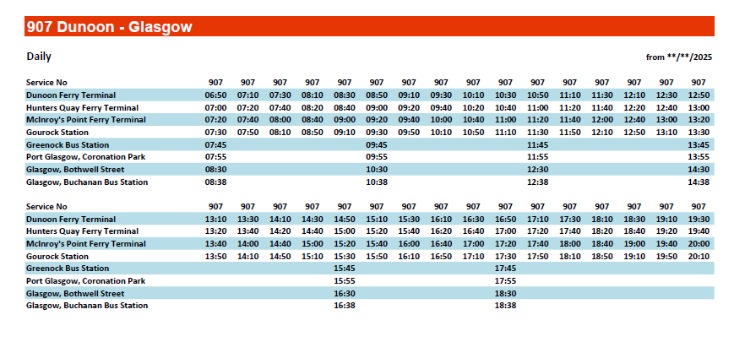

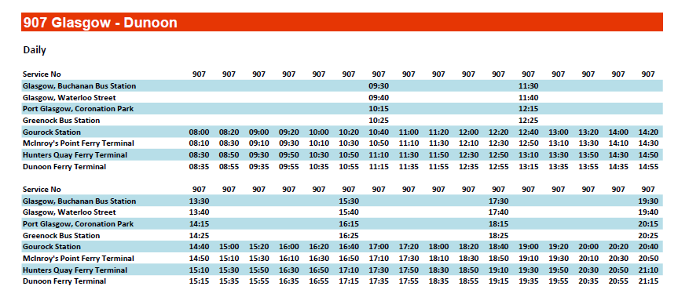

Appendix 5
Letter of support to Motorsport UK for the Argyll Rally through Dunoon

David Powell
Competition Authorisation Office
Motor Sport UK

Reference: DCC/MSU/251208 Date: 9th December 2025

Dear Sir,
Road Traffic Act 1988 Section 12(1A)
Mull Car Club
Dunoon Presents Argyll Rally 2026
19th / 20th June 2026

Thank you for your e-mail of 6th October.
After the 2025 Rally, Dunoon Community Council (DCC) conducted a survey on its social media channels. We split the survey results to identify the views of the DCC electorate whom we represent. We had 270 responses of which 94 were from the DCC electorate. A copy of the positive comments (Dunoon only) is attached to this letter, complete with spelling mistakes and typographical errors. 88% of the DCC respondents supported the rally taking place in 2025.

There are some Health and safety issues raised by some of our residents which we have raised with Mull Car Club and they are working positively to address those concerns.

As there is no change to the route through our area and all of the respondents to our survey support it, on behalf of the Dunoon Community we are happy to support the Rally taking place in 2026.

Yours sincerely

Community Councillor - Transport Lead
Dunoon Community Council

Community Council Liaison:
New tasks that have been undertaken since last meeting:
- Introductions made by phone call to Roland Zielinski, Convener and Dave Cooper, Secretary of Hunters Quay CC (HQCC) as they have some new Officers and the previous email address is no longer in use. Not to be used: hqccsec@gmail.com
No confirmation reply to new email addresses provided yet. An in person meeting or invite to DCC meeting would be beneficial.
- Email correspondence from Alan Stewart of South Cowal Community Council (SCCC) to all Cowal & Gourock CCs.
Summary:
Dunoon - Gourock Ferry Expression of Interest has attracted some responses to date, but for reasons of confidentiality these can't be named. We are going to start some initial discussions with the interested parties soon.

So far it has been a focussed working group of Michael Breslin (SCCC) and Tom Warren (DCC) who have been having the various discussions with CMAL and ABC, and who have been involved with creating the EOI with David Clough (DCC). We will shortly need to start discussions with the companies that have responded to the Expression of Interest. All Cowal and Gourock CCs have been invited to be involved to represent this group (of Community Councils). To date there’s been no objections to SCCC and DCC leading on this action.

Ongoing Project Updates:
1.
Proposals: Dunoon - Gourock Ferry Expression of Interest to test the market for alternative commercial town centre to town centre operators.
Further Updates requiring Dunoon Community Council attention: Non

Report Compiled By: Tom Warren
Date: 05/01/2026
Environment:
New tasks that have been undertaken since last meeting: Environment (Morag’s Fairy Glen).
• Early planning underway: A structured action plan has been created to guide the phased reopening of the Glen.
• Volunteer insurance explored: Quotes for Volunteer & Public Liability cover range from £3/month to £56/year for covering volunteers working on a site.
• Funding options reviewed: Thanks to David Clough for sharing ideas, including woodland improvement grants, urban woodland management schemes, and approaching organisations such as the Woodland Trust or Scottish Wildlife Trust.
• Crowdfunding potential: Strong interest in community-recognition ideas such as plaques, tree adoptions, named bridges/structures, and memorial trees with What3Words locations.
• Community sponsorship ideas/ involvement: Local businesses, groups, and families could sponsor benches, footpaths, habitat areas, tools, or other restoration elements. Use social media Instagram/TikTok etc to generate outside interest in the project. Possibly get Chris Lawlor to come out and document our site visit. He produces videos on hidden places in Scotland. Use his social media to generate interest in the project from across the world. We will need a MFG website to send people to after the video has been broadcast.
• Other Funding for ongoing maintenance: Parking revenue option, exploring the idea of charging for parking at Glenmorag car park, with all proceeds supporting MFG maintenance (similar to the Fairy Pools model on Skye). QR codes on entrances and exits to MFG.
• Future use of surplus funds: Any remaining money after restoration would support other Dunoon green spaces, including Bishop’s Glen.
• Long-term volunteer structure: Once a volunteer group is established, we could approach organisations like The Conservation Volunteers to explore creating a formal salaried role to oversee volunteers, site visits, work programmes, and act as a point of contact. Similar models in use by Devon County Council who manage the Grand Western Canal. United Utilities Water who manages the Elan Valey in Wales, and Rivington Pike and The Bungalow Gardens in Horwich Lancashire.
Ongoing Project Updates:
1.
2.
3.
Proposals:
• Request permission from DCC to begin contacting Argyll & Bute Council about site-access arrangements for an initial survey.
• Seek DCC permission to obtain insurance quotes for volunteer work.
• Ask the community for volunteers who can help with filming, photography, and social media content.
• Arrange an initial site survey during winter (Jan–early March) while vegetation is dormant.
• Develop risk assessments and site-inspection sheets to support safe volunteer involvement.
• Create a plan for attracting funders and recruiting volunteers.
• Promote opportunities through local newspapers, social media, What’s On Dunoon, job centres, schools, and volunteer-support organisations.
• Ensure the project remains community-focused, strengthening local involvement and connection by getting other community groups involved such as Dunoon Presents, Dunoon Community Development Trust etc.

Resilience Planning:
New tasks that have been undertaken since last meeting:
1.
2.
3.
4.
Ongoing Project Updates:
1.
2.
3.
Proposals:
1. Meet with David to discuss Resilience planning
2. Organise a meeting with the committee
3. Meet with Andy Macpherson on the 9th February 2026
Further Updates requiring Dunoon Community Council attention:
1.
2.
3.

Report Compiled By: Debz Wright
Date: 07/01/2026
Police:
Community Council Debrief
Dates Between: 05/11/2025 – 08/01/2026
Location & Beat: Dunoon LB46
Reporting Officer: PC Michael Cunningham

Between the dates above the number of Incidents and Crime Reports respectively are 421 & 99

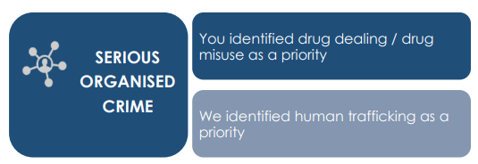 | Class A/B/C drug offenses  4 detected  3 undetected
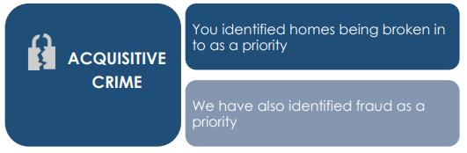 | Fraud  9 undetected  Theft  3 undetected  Theft by housebreaking  1 detected.  Theft by shoplifting  8 undetected  3 detected
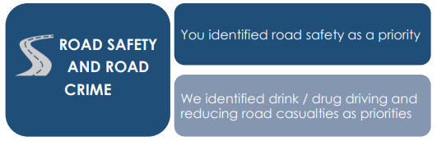 | Fail to wear a helmet.  1 detected.  Fail to stop after an accident.  1 detected.  Fail to provide blood.  1 detected.  No insurance  1 detected.  Drive unregistered MV with provisional licence.  1 detected.  Drive unregistered MV on a footpath.  1 detected.  Careless driving  2 detected.
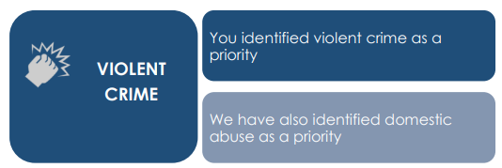 | Police assault.  2 detected.  Assault  3 detected  11 undetected  Serious Assault  1 detected.  Resist arrest  3 detected
 | Threatening and abusive behaviour  Undetected 3  Detected 16  Racially aggravated behaviour  1 detected.  Refuse to leave licence premises.  1 detected.  Breach of bail  1 detected.  Vandalism  4 detected  4 undetected  Sec127 comms act  2 undetected  4 detected
Useful Links/Contacts | Crimestoppers – Crimestoppers in Scotland | Crimestoppers (crimestoppers-uk.org)  Distress Brief Intervention - Distress Brief Intervention - Connected Compassionate Support | DBI.scot  Scottish Partnership against Rural Crime - Scottish Partnership Against Rural Crime | Scottish Partnership Against Rural Crime (scottishparc.co.uk)  Women’s Aid - Home - Women's Aid (womensaid.org.uk)  Citizens Advice – 08081646000  Trading Standards - 08081646000

