Connections…

Join me and other liked minded women for a yoga based weekend away on the Llyn Peninsula, an area of Outstanding Natural Beauty known for its magical serenity.

The theme is Connections… where you will enjoy three inspiring days exploring all forms of connections with yoga, gentle walking in nature and sculpture, art, sound bathing and optional sea swimming and massage.

Stunning Grade 2 Listed Gothic Mansion
The venue for this retreat is the traditional village of Llanbedrog, overlooking Cardigan Bay on the Llyn Peninsula declared an Area of Outstanding Natural Beauty and part of the National Trust, with the coastal path detouring through. Plas Glyn-y-Weddw, a Grade 2* Listed Gothic Mansion is your home for the weekend. The accommodation is in a private wing and entrance with the rest of the house an Art Gallery and gorgeous café open to the public 10-5pm after which we have the Grounds to ourselves. The beach is approx. 300m away.

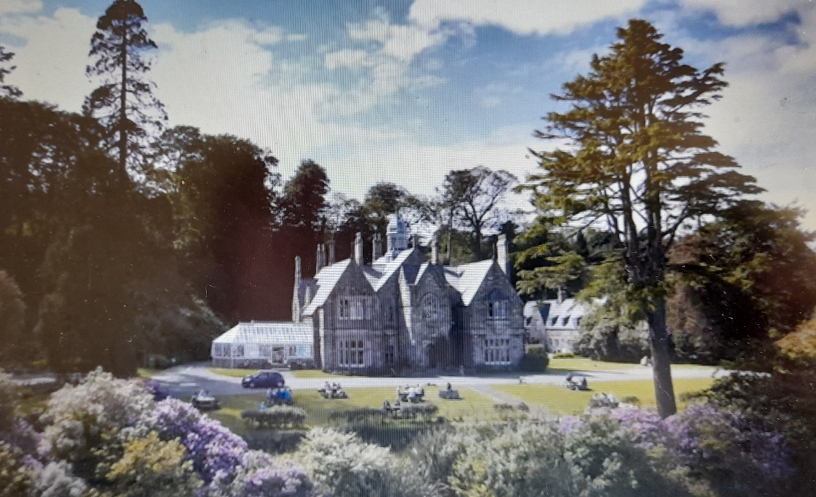
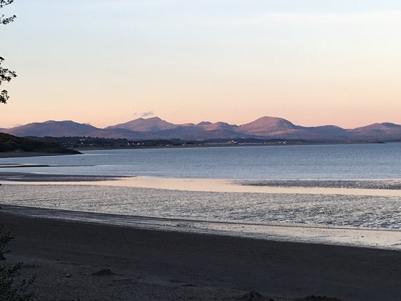

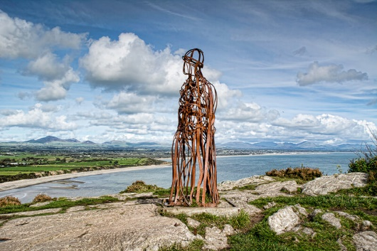
Located
L

Inspirational Yoga Space
Having run Summer Yoga Abersoch classes from the beautiful St. Pedrog’s Hall I’ve been able to negotiate the use of this space for our yoga and sound bathing. As it is a Church building there is something inherently spiritual or ethereal about the light and airy space enhanced by 29 window remaining one of her favourite yoga spaces. The acoustics are fantastic for a sound bath.
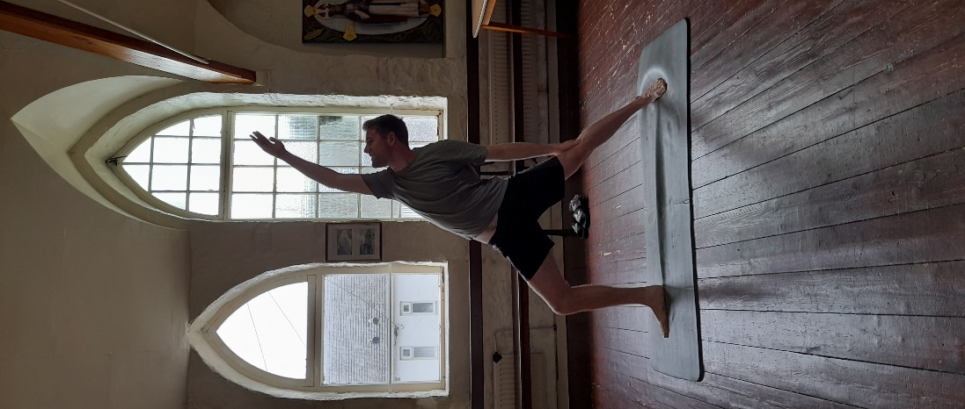
Massage
Appreciating all forms of connection each guest will have their choice of 45 minute massage treatments scheduled throughout the weekend around the main yoga sessions (optional)

Eating
Friday and Saturday vegetarian dinner, Saturday and Sunday continental breakfasts and lunches all included.

Should you wish, you have access to a kitchen space with all facilities within the House. There is always the option of walking to the local pub or heading into Abersoch for a meal or drinks should you wish

Extra Night Stay on Sunday
The retreat ends at 4pm on Sunday 3rd May but should you wish you are very welcome to stay over (self-catering) and check out by 9.00am on Monday morning.

A La Carte Weekend Activity

Included in price
- 3 nights stay in a Listed Gothic Mansion situated in the heart of Llanbedrog and 300m from the beach in AONB.
- Spiritual yoga space
- Up to 6 hours of yoga, meditation, yoga nidra and relaxation practices
- 1.5 hours sound bath in spiritual space with great acoustics
- Guided Walks within this spectacular landscape on Saturday & Sunday approx. 1-1.5 hours each including Forest Bathing
- Interactive Meditation/Contemplative Inquiry and Journalling workshops
- 6 meals included and a range of teas, soft drinks and coffee. You are welcome to bring your own alcohol should you wish,
Optional extras
- 45 minute massage – choice of Back, Neck, Shoulder & Head or Thai Foot Massage (£50)
- Additional night stay @ £45

Date and Time: Retreat runs from Friday 5pm 1st May to 4pm Sunday 3rd May with the option to stay on for another night self-catering

Bespoke Weekend Prices
Accommodation, meals, sound bath, yoga, and all activities included except optional massage (£50) and additional night on Sunday if required (£45).

The variance in pricing is due to the difference in rooms within each accommodation. There are 10 places initially. Any questions at all please phone me on 07474 296940
House/Room Choice | Bedroom | Occupancy | Bathroom | Weekend Package
Gothic Mansion  Bedroom 1  Serenity | OPTION 1  Superior Double  Sumptuous double room with stunning artwork (standard double bed size)  OPTION 2 | Single  Two friends sharing | En Suite  £310 each | £560  £620
Gothic Mansion Bedroom 2  Tranquility | OPTION 1 Double Room with En Suite and original artwork  OPTION 2 | Single  Two friends sharing | En Suite | BOOKED
Gothic Mansion Bedroom 3  Serendipity | Twin | Two sharing | En Suite with shower and wash basin but no WC. The house WC is 100m away | BOOKED
Gothic Mansion Bedroom 4  Synchronicity | Twin | Two sharing | Shared House Bathroom is next door | BOOKED
Gothic Mansion Mezzanine | Twin beds on mezzanine above Dining Hall. Spiral staircase access. After 10pm other guests will be asked not to enter Dining Hall | Two sharing | Shared House Bathroom is 100m away | BOOKED

How To Book Email susie@literarytwisted.co.uk with full name, phone number and choice of accommodation. Thank you.

Booking Terms On booking a £50 deposit for your place is required then 50% of the remaining balance by 30.01.26 and final balance 03.04.26. All payments are non-refundable. Obviously if there are exceptional circumstances I will refund if the place is filled. Thank you.

RETREAT OVERVIEW (may be subject to slight changes)
Friday May 1st
Arrive from 5pm and get settled into accommodation
6.30pm Welcome Drinks & Introduction. Debate, meeting like-minded women and sharing experiences is one of the benefits of a weekend like this and ties with the Connections… theme. Come with a friend or come solo.
7.30 pm – Vegetarian Meal (Drinks not included so BYO)
9 – 10 pm Relaxation Movements and Deep Sleep Yoga Nidra Session
Saturday 2nd May
8 – 8.45 am Say Hello To The Sun Yoga Session
9 – 9.45 am Continental Buffet Breakfast
From 9.30am - massage sessions commence and continue throughout the weekend – book your time on booking form once registered for the weekend
10 – 10.30am Guided Walking Meditation on Beach (if weather not good held in Yoga Space)
10.45 -11.45 Guided Walk around the Glyn-y-Weddw grounds and artwork.
Free time to explore the Art Gallery and Grounds, walk the coastal path, sea swimming, head into Abersoch or explore Llanbedrog.
1 – 1.45 pm Buffet Lunch at Gothic Mansion
2 – 2.30pm Guided Chakra Breathing, Visualisation and Journalling
2.30 - 3.40pm Chakra Cleansing Yoga Session included guided relaxation
3.40 - 4pm Refreshments at Yoga Space
4 – 4.45pm Interactive Meditation/Contemplative Enquiry
4.45 – 5.15pm TRE (Tension Release Exercises) session
5.30pm – 7pm Sound Bath at Yoga Space
7.30pm Vegetarian Supper at Gothic Manor or you may prefer to do your own thing and head out to eat elsewhere.
Sunday May 3rd
8.15 – 8.45am Option to join Abersoch Dunkers for sea swim (not organised or part of this retreat but I have allowed time in the programme for those who wish)
8.30 – 9.15 am Continental Buffet Breakfast (massages continue throughout the day)
9.30 – 11am Guided Walk along the Coastal Path on Llanbedrog Head including walking meditation and Forest Bathing
11-11.30am Coffee and Refreshments at yoga space
11.30 – 1pm Grounding Yoga Session including guided relaxation with focus on nature and connection
1.15 – 2pm Buffet Lunch at Gothic Mansion
2 – 2.45 pm Contemplative Enquiry with journalling
3 – 3.30am Heart Based Movement and final meditation
3.30 – 4pm Refreshments and Closing Circle. Group Reflection and final short relaxation/connection session to finish retreat weekend.
The Retreat formally finishes 4pm Sunday but you are invited, should you wish, to continue your stay at the accommodation until 9am Bank Holiday Monday 4th May at additional charge of £45. Self catering.
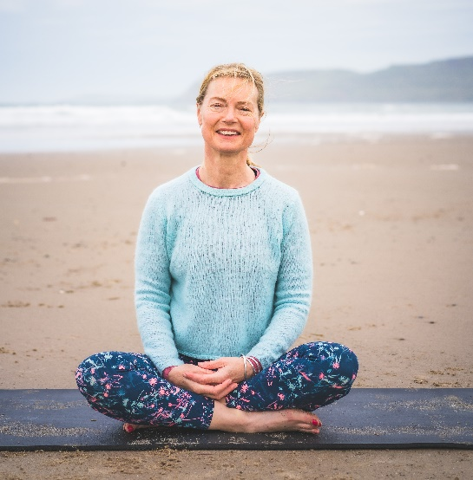
Meet Your Host: Susie Delves BWY Teacher
Hello. I’ve practiced yoga since 16 but am by no means a super bendy yoga bunny, with my focus for teaching being inclusive and accessible for all abilities, including beginners. And to create a sense of fun. Even if you don’t currently practice yoga this retreat could still be for you as I can adjust each pose (asana) for all levels and any joint or health issues.
My former career was in Marketing which was very competitive and I was eventually signed off with stress. Without doubt yoga helped my recovery and was recommended by all health professionals, traditional and alternative.
I then re-trained as a yoga teacher with the British Wheel of Yoga recognised by Sport England as the highest level of yoga training and the governing body for yoga in the UK. I now teach weekly yoga classes and at events as Literary Twisted Yoga.

My belief is that yoga release stress, emotion and stiffness, helping us achieve balance both in mind and body. The mind-body connection. Throughout the weekend we’ll be exploring different types of connection – with nature, art, with each other – and how to be aware and grow or nurture these connections.
.
I also can’t emphasise enough what a special location the Llyn Peninsula and the Gothic Mansion (and Arts Centre), Grounds and Llanbedrog headland is. The weekend programme is designed to be a la carte so choose if you wish to attend all or some of the sessions and make the most of any downtime to enjoy your surroundings. Susie x

M: 07474 296940 E: susie@literarytwisted.co.uk W: www.literarytwisted.co.uk https://www.facebook.com/literarytwisted/ https://www.instagram.com/summeryogaabersoch/

Co- Collaborator
Laura from Dear Soul Holistic Therapies based in Abersoch will be joining the retreat as co-collaborator performing the Sound Bath and giving all the massage treatments.

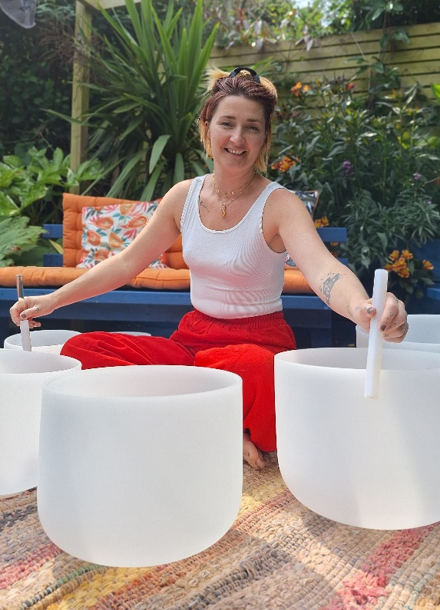
Laura is a holistic therapist born and raised in Abersoch on the Llyn Peninsula. Living in an area of such natural beauty that's steeped in the myths and legends of magic, she is excited by the change in seasons and cycles of the moon, this connection to nature has led Laura to believe from an early age that we are more than just our physical forms, leading her to practice and study meditation, Reiki, massage and sound therapy. These modalities have taught her the relevance and importance of us taking the time out to breathe, be still and connect deeper to our mind, body and spirit in a whole-istic way in order for us to release, heal and grow.
https://www.instagram.com/dearsoul_holistic/
https://www.facebook.com/dearsoulholistictherapies

