{unanticipated urgent financial need}

page 9

Urgent financial need scholarship requirements

Improving Lives Scholarship

This scholarship is funded through the United Way of Crawford County and the Lincoln Trail College Foundation. It is intended to help those who have unanticipated circumstances that may keep them from their pursuit of higher education at Lincoln Trail College.

PURPOSE:
The IMPROVING LIVES SCHOLARSHIP is available to residents of Crawford County only. Students (current or prospective) enrolling at Lincoln Trail College pursuing
educational advancement in any of the following programs of study are eligible: GED,
Certificate, 2 year Degree or Transfer Degree. The primary focus of this scholarship is to address the financial hurdles associated with continuing education. Preference will be given to single parents with financial needs associated with childcare/daycare expenses; however all
unanticipated financial needs that are prohibiting Crawford County residents from achieving educational goals will be considered during the awarding process of this scholarship. Award amounts will vary based on the needs of the selected candidates. In rare cases an interview may be requested.

Please include the following items and checklist with application:

Completed and signed Improving Lives scholarship application
(See next page)

Letter of recommendation/support

Personal Letter to Foundation scholarship committee describing:

- The unanticipated circumstances causing need for assistance
- Your specific financial hurdles that are prohibiting your
educational goals
- The amount of assistance you are requesting to achieve your
educational goals

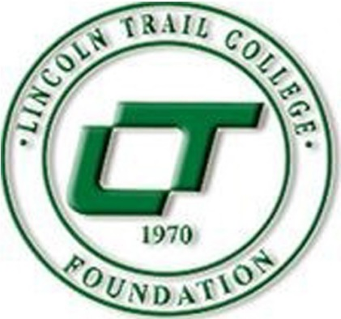

LINCOLN TRAIL COLLEGE FOUNDATION IS ORGANIZED AND SHALL BE OPERATED EXCLUSIVELY TO ASSIST IN DEVELOPING AND AUGMENTING THE FACILITIES AND CARRYING OUTTHE EDUCATIONAL FUNCTIONS OF LINCOLN TRAIL COLLEGE IN ROBINSON ILLINOIS.

IMPROVING LIVE CHOLAR HIP application

LIVE UNITED
United
Way

United Way
of Crawford County

MEASURABLY IMPROVING LIVES BY IDENTIFYING HEALTH AND HUMAN SERVICE NEEDS AND UNITING THE RESOURCES OF DONORS, VOLUNTEERS, AGENCIES, AND THE COMMUNITY TO ADDRESS THOSE NEEDS.

ELIGIBILITY:
D Must be a Crawford County resident
D Must be a current or prospective LTC student pursuing: (circle one)
Degree Certificate G ED
D Must have an unanticipated financial need prohibiting student from acheiving a((]demic goals.

APPLICANT INFORMATION:
REQUIREMENTS:
D Completed Form
D Letter of recommendation
D Personal Letter to Foundation scholarship committee describing:
-Your specific financial hurdles that are prohibiting your educational goals
-The unanticipated circumstances causing need lor assistance
-The amount of assistance you are requesting to achieve your educational goals

Name: DOB: I I Email: Current Address: Apt# City State Zip

_Te_le-L-ph_o_n_e:
Permission to text this number: {circle one) YES or NO

Marital Status: 0 Married 0 Single Is out-of-pocket childcare expense necessary for you to be able to attend college? YES or NO

If Yes, please fill out the following: Number of children _

Name of liscenseJ chilcare provider _

Monthly cost for child care _

Do you receive benefits from Project Child? YES or NO

Have you received any other scholarships or financial assistance while attending Lincoln Trail College? YES or NO

If yes, please list source and amount:-----------------------

CIRCUMSTANCE OF SCHOLARSHIP REQUEST:

Unanticipated life event/expense: (please address in letter as well) _ Requested amount: If awarded, assistance will be used for: _ If used for tuition & fees, account balance after ALL financial aid pays: _

I certify that all information is correct and that if a warded a scholarship, lincoln Trail College is hereby granted permission to release this information lor publication lor a period of one year from the date stated below. Also, my signature below gives permission lor my high school to provide any academic information requested on this application form. I authorize lincoln Trail College to provide information pertaining to my enrollment status, hours enrolled, grades, financial assistance, tuition and lees to the director of the lincoln Trail College Foundation.
Applicant Signture: Date: _

I authorize lincoln Trail College Foundation (LTCF) and lincoln Trail College (LTC) to contact me at my current and any future cellular phone number(s), email address(es) or wireless device(s) regarding general information from LTCF or LTC. I understand that I am responsible lor keeping LTCF/LTC records up to date with my current physical addresses, email addresses and phone numbers by contacting the offices.
Applicant Signture: Date: _

PLEASE RETURN COMPLETED APPLICATION TO:
Lincoln Trail College attn: Financial Aid Dept. 11220 State Highway 1 Robinson, IL 62454

