For immediate release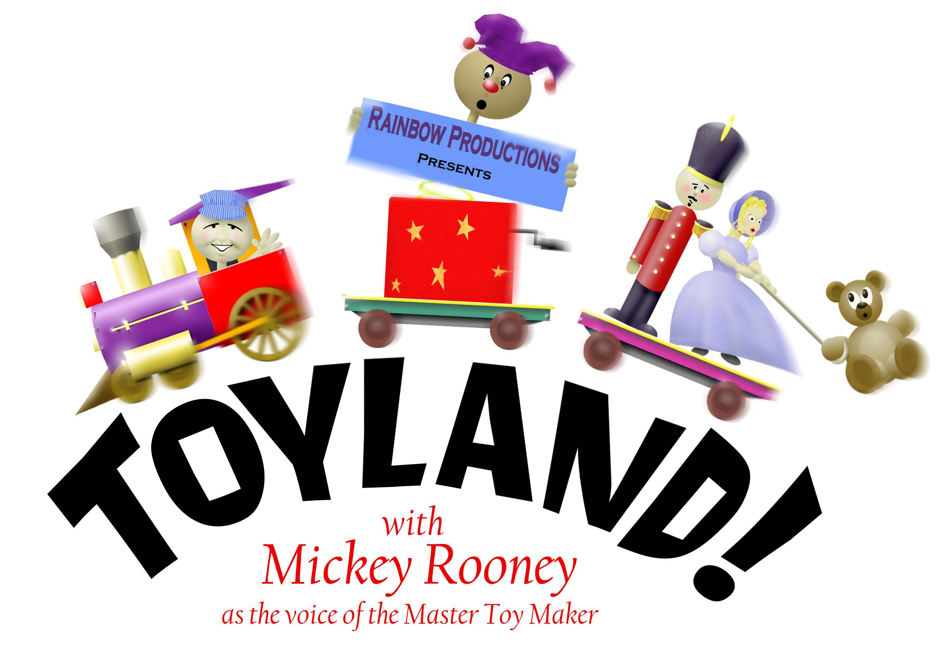

You Can Return to Toyland!

The song says you can never return again… but actually can return to Toyland as Rainbow Puppets presents a new version of the classic Victor Herbert show. ….

While the original production opened over a century ago, the program features a brand new script by Rainbow director David Messick. “We’ve taken all of the familiar musical themes and songs including ‘The March of the Toys’ and ‘I Can’t Do the Sum’ and woven them together into a brand new production,” says Messick.

The late, great Mickey Rooney provides the voice of the Master Toymaker. He’s won two Oscars, starred on Broadway, appeared in a series of classic movies with good friend Judy Garland.

Little Bo Peep has lost her sheep and cannot find them anywhere. Could her evil Uncle Barnaby somehow be involved? In her search, she meets a bumbling pirate, get trapped in the scary Spider Forest, and eventually makes her way to Toyland where she seeks protection from the Master Toymaker.

The production features many styles of puppets including fast moving Irish Dancing marionettes created by master puppet maker Frank Lakus from Tampa. Virginia puppet maker Laura Huff created the high-jumping Russian dancers as well as several of the main characters. Other characters are created by

Continued

Toyland! Release / Page 2 of 2
Pittsburgh puppet maker Jill Harringtion, marching Toy Soldiers created by Kathie Davis and costumes by Rainbow puppeteer Regina Smith.

Sets and scenic art are by Rainbow Puppeteer Jason Wiedel. His work features a cypress tree that springs to life and aids Bo Peep in her escape from the Spider Forest. Musical arrangements and audio engineering are by Steve Scheffler. Steve has produced many Rainbow programs including the new “Wright Brothers” musical that is now on tour.

In addition to Mickey Rooney, many other talented performers fill out the cast including Mickey’s wife Jan who co-stars as Mother Goose. Jan Chamberlain Rooney has appeared with Mickey on several television programs including “Love Boat.” She is formerly an artist at Hanna-Barbera Cartoon Studios and currently tours the country with Mickey in their “One Man, One Wife” show.

Kara Dennison, who has provided voices for many animated films is Bo Peep. Tiffany Haas is Little Miss Muffet. Miss Haas recently appeared on Broadway in the hit show “Wicked.” She also sang and danced in a PBS musical special starring Denyce Graves and John Schneider. Cindy Kays of the award-winning children’s musical team C-Shells provides the voice of Red Riding Hood. Craig T. Adams is Gonzorgo the Pirate. His own puppet company, Fuzz-n-Stuffing is celebrating its 25 anniversary this year. In addition, Craig can be seen weekly on the long running television program “Dr. Madblood.” Jim Stensvaag, who played Orville Wright in Rainbow’s Wright Brothers musical is Tom, the Piper’s Son.

Rainbow’s long running team of vocal performers rounds out the cast. Don and Chris Bartlett are the Big Bad Wolf and the Old Woman in the Show, respectively. Tim Tharrington is Jack and Lisa Ryan is Jill.

Rainbow puppeteers include James Cooper, Wesley Huff, David, Joshua & Marcy Messick, and Michael Singleton.

Messick’s association with “Babes in Toyland” goes back to the 1970’s when he appeared in regional theater productions of the show. He soon graduated to choreographer and then director of annual productions, culminating in an 80th anniversary tour featuring a cast of 100 singers, dancers and actors. “I promised myself we’d do the show again on the 100th anniversary… who would have guessed we’d be doing it with Hollywood legend Mickey Rooney? My happiest experiences in the theater are seeing Mickey in ‘Sugar Babies’ and then ‘The Wizard of Oz’ so this production is like a dream come true.”

A limited edition cast album featuring all the songs and story will be available after the performance. More details about the show and a behind the scenes glimpse into the recording studio can be found at www.rainbowpuppets.com.

The people at Rainbow Productions began producing shows for local libraries in 1977. Since that time, the company has grown into one of the leading providers of arts-in-education in the state of Virginia. The company now tours nationally, having presented workshops at the Puppeteers of America’s national convention in Tampa and at the Fellowship of Christian Puppeteers national convention outside of Chicago.

For additional information, call 757 851-3266 or info@rainbowpuppets.com

