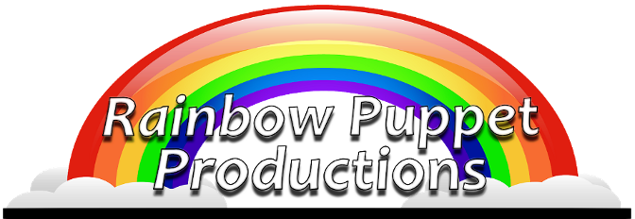

Rainbow Puppet Productions
18 Easthill Court
Hampton, Virginia 23664
www.rainbowpuppets.com
(757) 851-3266

for immediate release

Join us for an “Amazon Adventure!”

Rainbow Puppet Productions invites you to join them for "Amazon Adventures" as the company presents its newest musical production. It's a surprise-filled trip down the Amazon river featuring ten new musical numbers.

Meet Montee, the Waxy Monkey Tree Frog. He serves as your tour guide and is quick to explain, he is not made of wax and he is not a monkey. Things are never as they seem in the Amazon. The croaking frog in the distance is actually a Toucan. The lion you meet is only a foot tall. That giant cat is not a cat at all but a fish, rumored to swallow a man whole.

The voice of Montee is provided by two-time Tony Award winning talent Geoffrey Holder. A world acclaimed painter, dancer, and choreographer. He is perhaps best known for television and movie appearances and for his booming voice. Mr. Holder was a towering presence in the James Bond movie “Live and Let Die,” as Punjab in the movie “Annie,” and more recently, as the narrator for Johnny Depp’s “Charlie and the Chocolate Factory.”

While audience participation has always been a hallmark of Rainbow's programs, it's never been more pronounced than in "Amazon Adventures." Do a line dance with Eel-lo the Electric Eel. Do the twist with King, the Golden Lion Tamarin. And join the Carnival as everyone is invited to join the grand finale.

"People who have followed our work will hear a distinct difference in this program," says show composer, writer and director David Messick. "Much of the music sounds like it comes from the mid-sixties or earlier. The sting ray perform to a song reminiscent of
Continued

Rainbow Press Release - page 2 of 2

great car songs of the sixties. The Anaconda and Lion Tamarin song could have been originally sung by the Coasters or other great comic doo-wop groups. And out of the blue, the Toucan and Caiman sing and dance to a song that feels like something out of one of the great MGM musicals of the forties. Somehow it all seems to work out."

Puppets for this production were built by master puppet makers across the east coast including Hampton's own Laura Huff and Norfolk's Craig T. Adams. Laura built many of the dinosaurs for Rainbow's "Really Big Dinosaur Show" and Craig is known for his work television's cult favorite Dr. Madblood. How appropriate that he built the Vampire Bats and Piranha for this program. From Florida, Frank Lakus created the Waxy Monkey Tree Frog and the Caiman and from Pittsburgh, Jill Harrington built neon fish and talking grass.

Vocal talent includes brother's Michael and Moby Lemelle creating voices that would have made the original Coasters proud. Cynthia Tademy appears as Katt, the giant and quite hungry catfish. Rainbow veteran Tim Tharrington sings "Sting Ray." Kara Dennison, of anime fame, is the singing Toucan.

A rare cameo comes from 94 year old Meinhardt Raabe, the coroner munchkin from the movie "The Wizard of Oz." In this production, his character swirls in on a tornado-like funnel of fish and devour everything in sight.

Rainbow's sound engineer Steve Scheffler doubles as the voice of the singing Caiman. Rainbow's puppeteer James Cooper serves double duty as arranger and all the voices for Eel-lo and the Electrics who sing "Eel Glide."

The show was created by David Messick. His other credits include producing voices and characters for Chuck E. Cheese. He has worked on development projects for the Disney Channel, FOX TV, and Paramount Pictures. He has also worked with such legendary performers as Mickey Rooney, Carol Channing, and at the New Orleans World’s Fair with the late Jim Henson.

Rainbow Puppeteers include James Cooper, Wesley Huff, David, Joshua, and Marcy Messick and Michael Singleton.

Rainbow started in 1977. Since the mid-90’s, as part of Young Audiences of Virginia, they have grown into one of the largest touring companies in Virginia, performing for hundreds of thousands of children in schools and libraries. Rainbow is a non-profit arts company. The group is a member of Puppeteers of America and The Puppet Arts Center of Virginia. To learn more about the company and the upcoming show, visit www.rainbowpuppets.com.

