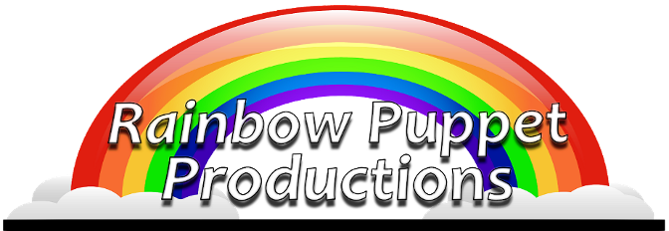

Rainbow Puppet Productions
18 Easthill Court
Hampton, Virginia 23664
www.rainbowpuppets.com
(757) 851-3266

for immediate release

Creatures are Coming

There’s a tiny caterpillar, a giant stegosaurus and practically everything in between in Rainbow Puppet Production’s latest edition of “Creatures Great and Small.”

“We have been presenting children’s shows since 1977,” says show creator, David Messick. “We have taken our favorite songs and our favorite puppets and put them together for this show.”

During the course of the program, you’ll meet all sorts of marine life hear all types of singing styles including “The Fish,” a group of neon colored fish singing in the style of the Beach Boys and an Elvis-inspired Blue Crab singing “I’m So Blue.”

The program is a musical review of animal songs written by David Messick, an award winning author who has created many touring children’s musicals including the long running “Amazing Adventures of Chessie the Manatee” and “Noah’s Floating Zoo.”

“Over the years, our tours have taken us to Virginia, North Carolina, Kentucky, Florida, Illinois, Indiana, and Missouri,” says show creator David Messick. “Along the way, we’ve been able to work with Hollywood legend Mickey Rooney, Broadway legend Carol Channing, and local Grammy winner Bruce Hornsby.”

Voices for this performance were created by many Rainbow veterans. Tim Tharrington sings some of the show’s most memorable songs including “I’m So Blue,” performed by Crabis the Blue Crab. He sings the tongue-twisting “Animal Parade Song” and concludes the show singing “The Dinosaur Hop.” He was Hansel in Rainbow’s 1980 tour of “Hansel and Gretel” as well as a principal countless other Rainbow shows.

Continued

Rainbow Press Release - page 2 of 2

Wife and husband team Chris and Don Bartlett provide voices for a singing amoebae and a vain dinosaur. Lisa Ryan is the musical director and lead singer in “The Three Little Pigs Opera.” Steve Scheffler provides the voice to Farley the Fiddler Crab.

David Messick is the voice of Grandpa. His other credits include producing voices and characters for Chuck E. Cheese. He has worked on development projects for the Disney Channel, FOX TV, and Paramount Pictures.

Artists from Virginia, Florida, and Pennsylvania created the puppets. Among others, dinosaurs are by Tampa’s master puppeteer Frank Lakus and Newport News artist Laura Huff. The Blue Crab is by Fuzz and Stuffing puppeteer Craig T. Adams. Puppet Arts Center of Virginia president Christine Frank created the fiddler crabs. Additional puppets are by Puppet Arts Center of Virginia founder Helen Spaetzel, Prince Puppet’s Jill Harrington, and Rainbow’s puppeteer Fiona Andrews.

Rainbow Puppeteers include James Cooper, Wesley Huff, David Joshua and Marcy Messick and Michael Singleton.

Rainbow started in 1977. Since the mid-90’s, as part of Young Audiences of Virginia, they have grown into one of the largest touring companies in Virginia, performing for hundreds of thousands of children in schools and libraries. Rainbow is a non-profit arts company. The group is a member of Puppeteers of America and The Puppet Arts Center of Virginia. To learn more about the company and the upcoming show, visit www.rainbowpuppets.com.

