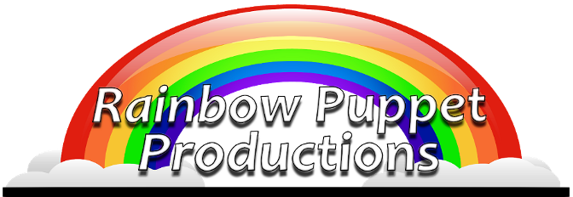

Rainbow Puppet Productions
18 Easthill Court
Hampton, Virginia 23664
www.rainbowpuppets.com
(757) 851-3266

for immediate release

The Dinosaurs Are Back!

The dinosaurs are back and in a huge way as Rainbow Puppet Productions presents an all-new production of “The Really Big Dinosaur Show.” <insert time/date/location/fee… if free, say so.>

It’s not called The Really Big Dinosaur Show” for nothing… there’s a long-necked dinosaur that stretches out over 16 feet from nose to tail, there’s a nine foot tall T-Rex, and there’s a mountain that comes to life and begins singing a song. And this time, the dinosaurs and their friends will actually be brought out into the audience so that you can experience them face-to-face.

According to show creator David Messick, “This show is one of our most popular, touring from 1999 until 2002. We only stopped because of the sheer size and logistics of touring with so many puppets and other creatures. Have you tried moving a mountain from theater to theater?”

New to this production is the amount of audience participation. “We’ll be randomly selecting people from the audience to operate puppets and props. Three audience members will participate in the Miss Dino-World Beauty Pageant. And of course, the show ends with the entire audience dancing ‘The Dinosaur Hop.’ Says Messick. The song is Rainbow Puppets most downloaded and most requested song over 33 years of presenting children’s theater on the east coast.

Continued

Rainbow Press Release - page 2 of 2

Speaking of the songs, the stage voices were created by many Rainbow veterans. Tim Tharrington sings “The Dinosaur Hop.” He was Hansel in Rainbow’s 1980 tour of “Hansel and Gretel” as well as a principal countless other Rainbow shows.

Wife and husband team Chris and Don Bartlett provide voices for a singing amoebae and a vain dinosaur. Steve Scheffler is the voice of the announcer and serves as audio engineer for the show.

The late Frank Mailander provided the voice of the “Mighty Megazostrodon” who saves the day against the fierce T-Rex. According to Messick, “Frank was the first actor I recall seeing in a live theater production. I was maybe seven or eight at the time and he was hilarious. I was thrilled to later get to work with him on many of our productions… he’s considered something of a local comic legend so through pre-recording his work, it’s great to hear him onstage again in a really funny role.”

Show creator David Messick is the voice of Ptom the flying Pteranodon. His other credits include producing voices and characters for Chuck E. Cheese. He has worked on development projects for the Disney Channel, FOX TV, and Paramount Pictures. He has also worked with such legendary performers as Mickey Rooney, Carol Channing, and at the New Orleans World’s Fair with the late Jim Henson.

Artists from Virginia, Florida, and Pennsylvania created the puppets. Among others, dinosaurs are by Tampa’s master puppeteer Frank Lakus and Newport News artist Laura Huff. Prehistoric fish are by Fuzz and Stuffing puppeteer Craig T. Adams. Puppet Arts Center of Virginia former president Christine Frank created the flying pteranodon. Additional puppets and sets are by Puppet Arts Center of Virginia founder Helen Spaetzel, and Rainbow’s puppeteers Kathie Davis, Regina Smith, and Fiona Andrews.

Rainbow Puppeteers include Carrie Cavin, James Cooper, Kathie Davis, Tony Gabriele, David, Joshua, and Marcy Messick and Michael Singleton.

Rainbow started in 1977. Since the mid-90’s, as part of Young Audiences of Virginia, they have grown into one of the largest touring companies in Virginia, performing for hundreds of thousands of children in schools and libraries. Rainbow is a non-profit arts company. The group is a member of Puppeteers of America and The Puppet Arts Center of Virginia. To learn more about the company and the upcoming show, visit www.rainbowpuppets.com.

Performances are at the Virginia Living Museum will be at 1:00 and 2:00 every day through August 10, 2008. A third performance will be held on Saturdays and Sundays at 3:00 pm. The show is included at no extra charge with admission to the museum.

