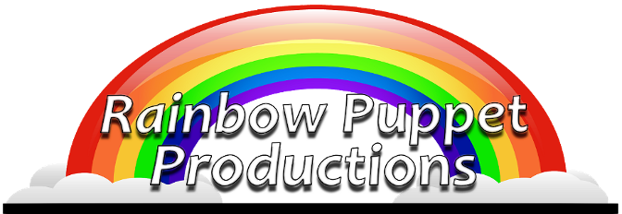

FOR IMMEDIATE RELEASE
Rainbow Puppet Productions
18 Easthill Court
Hampton, Virginia 23664
(757) 851-3266
www.rainbowpuppets.com
info@rainbowpuppets.com
November 19, 2013

Brand new Holiday CD recorded in Williamsburg

One of the world’s most beloved children’s poems teams up with one of Hollywood’s most beloved stars as legendary entertainer narrates “The Night Before Christmas” for Rainbow Puppet Productions. This musical re-telling of the holiday classic will be presented at <insert details here… time, date, cost –even if free.>

“T’was the Night Before Christmas” was written in 1823 by author Clement C. Moore. Since that time, it has become a favorite around the world. And who better to tell the story than Mickey Rooney. Mr. Rooney has excelled in practically every entertainment medium he’s performed. He was born into a vaudeville family and practically grew up on stage. In the 1920’s he starred in silent movies. By the 1940’s he was the most popular star in Hollywood starring in movies with such luminaries as Judy Garland, Spencer Tracey, and James Cagney. When television arrived, Mickey provided voices to such holiday classics as “Santa Claus is Coming to Town” and “The Year without Santa Claus.”

Mr. Rooney began his association with Rainbow Puppet Productions in 2003 when he headlined the 100th anniversary production of “Babes in Toyland.” Since that time, he has also starred in Rainbow’s productions of “Pirate Party” and “The Tortoise and the Hare.” Now in his nineth decade of performing, Mickey continues to entertain, appearing in “The Muppets” for Disney and now in “The Night Before Christmas.” Portions of this production, including Mr. Rooney’s performance, were recorded right here in Williamsburg.
Continued

Page 2 of 2

This production features an original score by Rainbow Puppet Productions founder David Messick. The award winning playwrite has created programs for The Smithsonian Institute, The Virginia Aquarium, and in recognition of the 400th anniversary of the founding of Jamestown. “This show is filled with so many wonderful of my favorite Chrismas memories. There’s Christmas Eve services with all the beautiful music, a Santa Claus Parade with St. Nick appearing on a Firetruck, gingerbread cookies, music from Tchaikovsky’s “The Nutcracker,” and the voice of Christmas Television specials… Mr. Mickey Rooney. And this is the perfect place to release the CD… in the place where we recorded it. We’ve worked with Mr. Rooney many times but this session was our favorite. He was in a great mood and was really happy at the end of the session when I told him, ‘You’re still the king of one take!’ Now don’t think this is the last time we’ll be working with Mr. Rooney… he recorded three other shows at that session.”

Additional voices include anime vocal artist Kara Dennison, and Rainbow Puppet veterans Chris Bartlett, Michael Singleton, and James Cooper.

Puppets are hand-crafted by master puppet maker Jill Harrington. Settings were created by Helen Spaetzel. Musical arrangements are by Steve Scheffler.

Digital downloads and samples can be heard now on iTunes, Amazon.com, and at a special, discounted price directly through www.rainbowpuppets.com.

