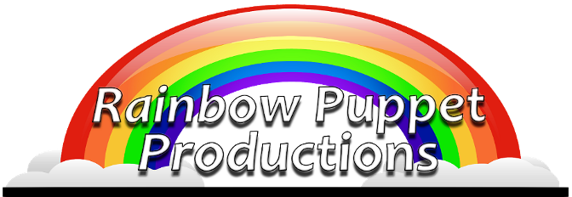

Rainbow Puppet Productions
18 Easthill Court
Hampton, Virginia 23664
www.rainbowpuppets.com
(757) 851-3266
for immediate release

“Take a Giant Leap” from Here to Space!

Rainbow Puppet Productions invites you to join them for "Take A Giant Leap" as the company presents its most active musical production ever. We start out looking at the stars and end up trying to leap into history.

<insert dates, times, and admission costs… if free, be sure to say so>

Since the dawn of time, it is believed that humans looked up into the sky in wonder. And that’s the starting point of this program. We dream that we can see shapes created by the stars and these shapes (or constellations) come to life. There’s a rabbit, a lion, a dog, and even a giant butterfly. Soon we are singing and dancing along with the stars.

At some point, we stop dreaming of floating in the sky… we actually get there with the help of the Wright Brothers. The audience joins the two brothers in their workshop as they conquer the challenges of Power, Lift, and Control to put the first airplane in the sky.

We then join the brave Tuskegee Airmen as they prepare to fly their aircraft in Ramatelli, Italy. Like the Wright Brothers before them, their exploits land them in the history books.

The story continues with NASA shooting for the stars and landing on the moon. We then dream of the next great adventure… a trip to Mars.

“Take a Giant Leap” was created in association with the Smithsonian National Air and Space Museum, working in conjunction with the Department of Education. The original production included introductions and appearances from Miss America and celebrity chef Carla Hall.
Continued

Rainbow Press Release - page 2 of 2

Puppets for this production were built by master puppet makers across the east coast including Laura Huff in Connecticut, Jill Harrington in Pennsylvania, Frank Lakus in Florida, and Christine Frank in Virginia.

Vocal talent includes veteran Rainbow Puppet performers Tim Tharrington, Steve Scheffler, Michael Singleton, Chris Bartlett, Jim Stensvaag, and many others.

The show was created by David Messick. His other credits include producing voices and characters for Chuck E. Cheese. He has worked on development projects for the Disney Channel, FOX TV, and Paramount Pictures. He has also worked with such legendary performers as Mickey Rooney, Carol Channing, and at the New Orleans World’s Fair with the late Jim Henson.

Rainbow Puppeteers include James Cooper, Wesley Huff, David, Joshua, and Marcy Messick and Michael Singleton.

Rainbow started in 1977. Since the mid-90’s, as part of Young Audiences of Virginia, they have grown into one of the largest touring companies in Virginia, performing for hundreds of thousands of children in schools and libraries. Rainbow is a non-profit arts company. The group is a member of Puppeteers of America and The Puppet Arts Center of Virginia. To learn more about the company and the upcoming show, visit www.rainbowpuppets.com.

