Books by Dr. Carl Whitcomb
ORDER FORM
 |  | QTY
Know It and Grow It III, A Guide to the Identification and Use of Landscape Plants.

3rd edition, 1999. 8.5” X 11” format, hardback. Over 800 pages and 2000 B&W photos. Covers most landscape plants grown east of Rocky Mountains, from Gulf Coast to Canada. Notes on culture, propagation, and pests. Includes area of adaptation map for each species.
Price $60.00 plus $14.00 shipping UPS for singles. $4.00 for each additional book.
 | Plant Production in Containers II. Revised 2003. Reprinted 2006 with new format. Covers all factors in producing plants in the unique container environment, from propagation of seeds or cuttings to growth medium, nutrition, watering, weed control and more. In-depth container history and development. Key points summarize each chapter. 460 pages. 8.5” X 11” hardback, many photos.  Price $69.00 plus $12.00 shipping UPS for singles. $4.00 for each additional book.
 | Production of Landscape Plants II. Revised 2001. Covers all aspects of field production methods including bare-root, balled-in-burlap, pot-in-pot, knit fabric in-ground containers. Also discusses soils, nutrition, fertilizers, herbicides, pruning, irrigation, amendments, and transplanting. Key points summarize each chapter. 700 pages, 6” X 9” format, hardback, many photos.  Price $49.00 plus $12.00 shipping UPS for singles. $4.00 for each additional book.
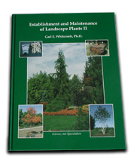 | Establishment and Maintenance of Landscape Plants II. This 3rd Ed. (Published 2006) is in a new 8.5x11" format. Covers drainage, nutrition, and other factors dealing with both the planting and establishment and the long term care of landscape plants. 350 pages, hardback, many photos.  Price: $59.00 plus $12.00 shipping UPS for singles. $4.00 for each additional book.    Beyond Expectations.  Dr. Whitcomb’s autobiography. 190 pages.  Price: $10.00
 | Total Books
 | Total Payment

Oklahoma residents please include state and local sales tax
Business Name:
Contact Person:
UPS Address:
Mailing Address:(if different from UPS)
City, State, Zip:
Phone Number:(with area code)

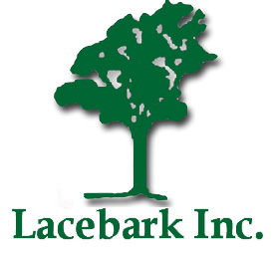
Send Order Form To:
Lacebark, Inc. P.O. Box 2383, Stillwater, OK 74076
Fax 405-377-0131 or e-mail sales@lacebarkinc.com
Phone 405-377-3539 or visit our web site www.lacebarkinc.com

