Spartan
5/6 Combo Gutter Machine

Operation Instructions

Please read before operating for the first time.

Thank you for purchasing a Spartan Gutter Machine.
These guidelines need to be followed the first time you use this machine and whenever you load coil stock into it.
Failure to follow these directions will result in crashing the machine and causing yourself unneeded headaches and extra work to correct. It may also cause damage to the machine, or the aluminum coil stock. Repeated disregard of these instructions may result in expensive repairs and may void the warranty.

Please follow the directions completely. Contact our service department if you are having trouble.
Our contact information is at the back of this booklet.

Thank you,
The Spartan Machine Team

1

Safety First
- Never put your hands or any other part of your body into this machine!
- Wear appropriate clothing when operating this machine.
- Always wear Safety Glasses.
- Always wear cut proof/ resistant Gloves.
- Always wear Kevlar sleeves.
- Always follow OSHA safety regulations.
- Always follow your company safety rules.

2

Step 1.
Loading material.
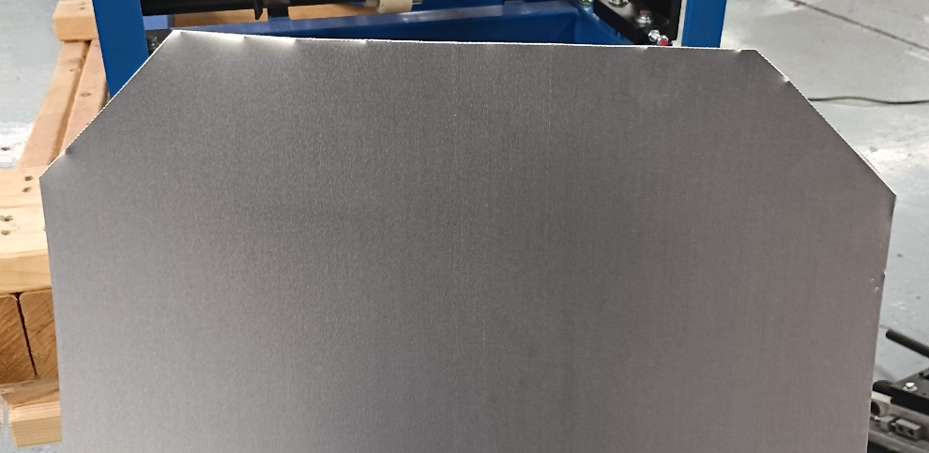
Cut the corners off at approximately a 45⁰ angle to facilitate loading the coil stock into the entrance guide.
This is important to help guide the material into the entrance, to keep it straight and to prevent jams.

3
Step 2.
Positioning.
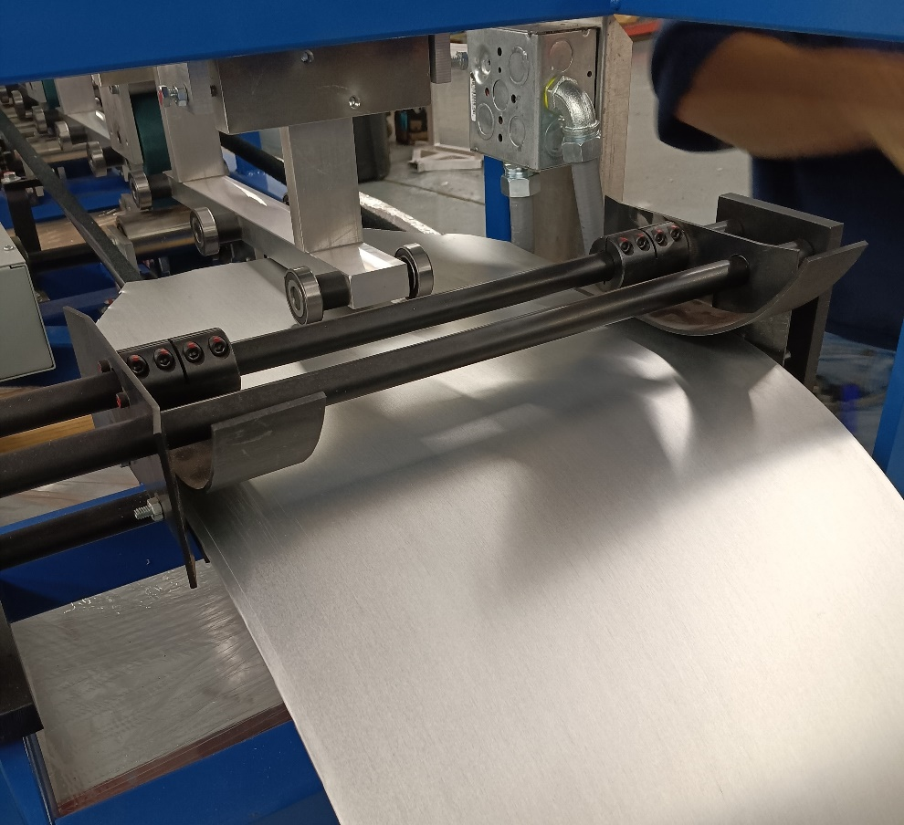
Make sure the aluminum is loaded firmly against the right-side guide rail and that it is in straight. You will not run straight gutter if the material is not perfectly straight in the machine.
If you are using a floor mounted coil cradle it must also be lined up perfectly with the machine or your gutters will not be straight.

4
Step 3.
Finish loading.
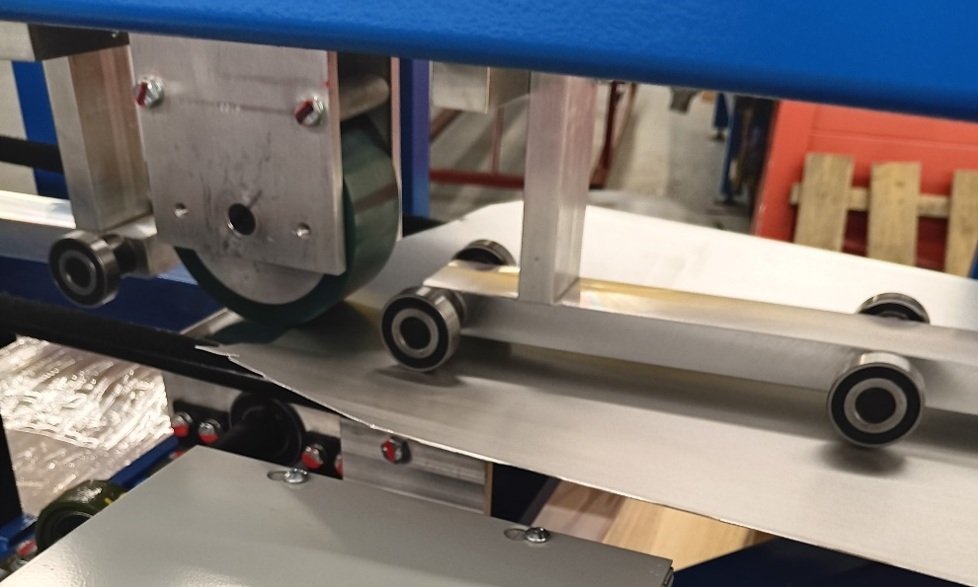
Push the coil stock into the machine while keeping it aligned with the guides until it reaches the first drive roller.
Ensure that the aluminum is firmly in place against the drive roller so that when you start the machine the coil stock will be pulled into the machine.
If the aluminum doesn’t move when you start the machine you may have to help it get started by pushing it in a little from the feed end.

5

Step 4.
Main control panel.
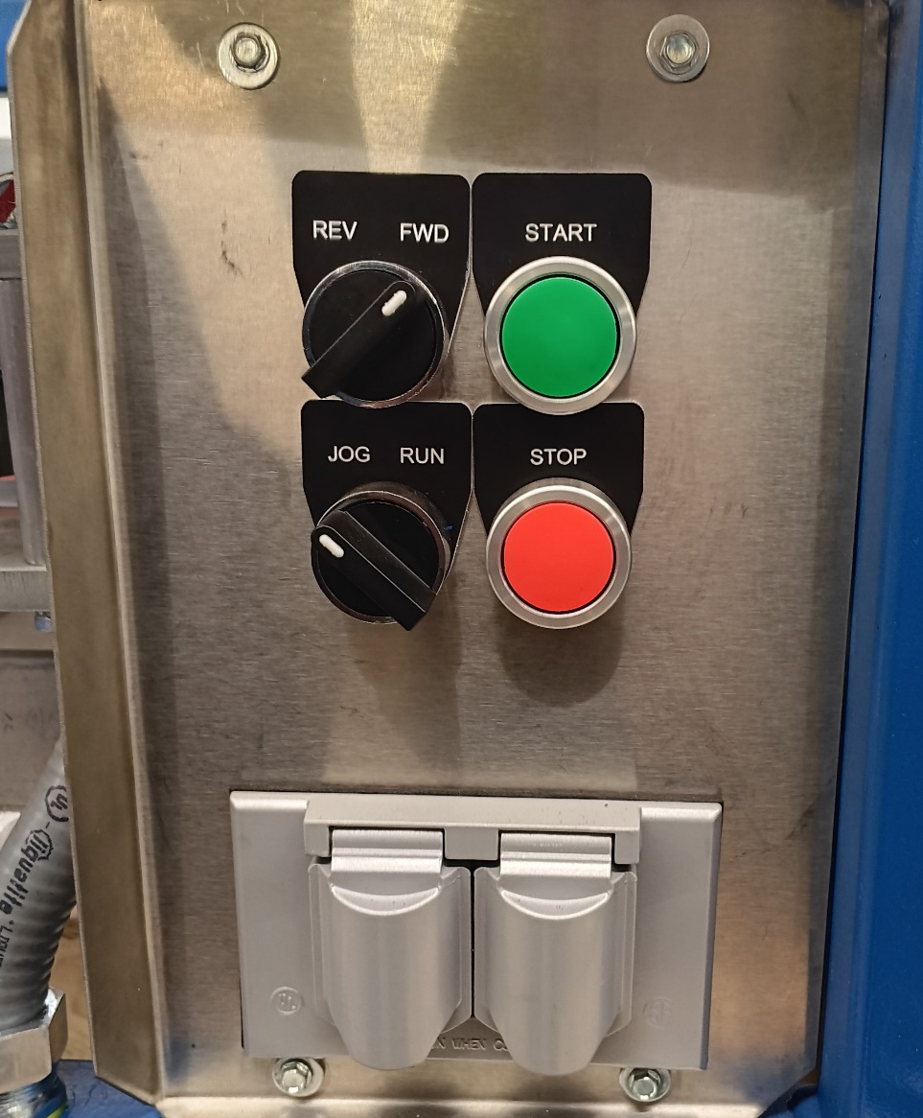
Make sure the direction is set to forward and that the lower switch is set to JOG. DO NOT START IT IN RUN!

6

Important
It is imperative that you use the JOG feature when first loading the machine and continue to use JOG until the end of the gutter exits the guillotine or OSHA guard at the exit end of the machine.
If it is set on run before the gutter exits the machine, the gutter may get stuck against the back of the guillotine or OSHA guard and jam. Due to the power of this machine, a jammed gutter will crush, deform, and get stuck which may result in damage to the machine and its components. At the very least, the components may be moved out of alignment and require being returned to the factory for repair at the owner’s expense.

7
Step 5.
Auxiliary Panel
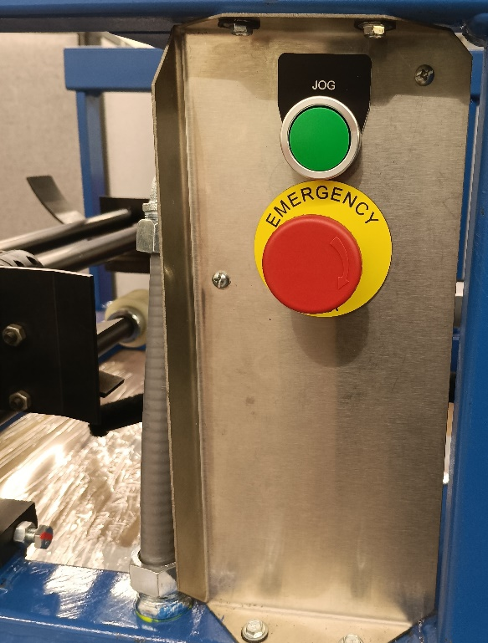
The Auxiliary panel is located at the entrance end of the machine.
The Spartan Gutter Machine may be operated in the JOG mode from either the Main Panel by setting the switch to JOG and pressing the Green START button or by pressing the Green JOG button on the Auxiliary panel at the entrance end of the machine.
8
Step 6
Gutter Exit.
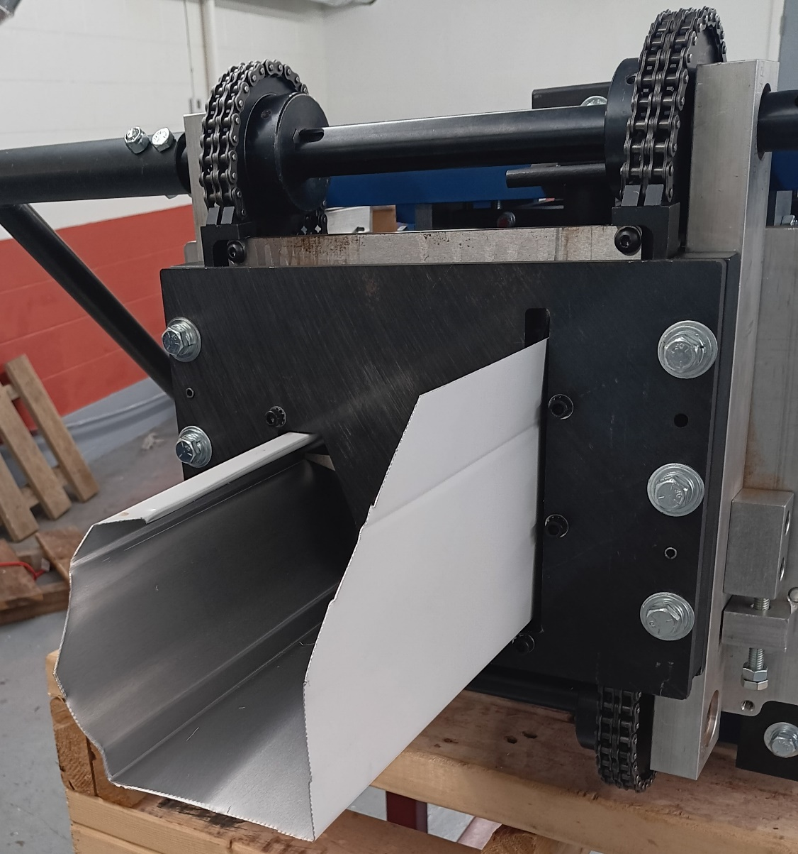
Once the Gutter exits the Guillotine or OSHA Guard the switch on the Main Panel may be changed to the RUN mode and ran normally.
9
If you have any issues with the instructions or the operation of this machine. Please contact your salesman or the factory service department for assistance.

10

Every Spartan 5”/6” Combo Gutter Machine
Comes with a Tool Bag and all of the Tools needed to changeover between 5” & 6” gutters.
The tool bag includes:
1 – 3/8 drive rachet wrench
1 – 3/8 drive 6” extension
1 – 3/8 drive 1/2” socket
1 – 1/2” combination wrench
1 – 5/32” long Allen wrench
1 – 3/16” long Allen wrench

Spartan Machine LLC.
208 W. Main St. New Paris, Ohio 45347
sales@spartanmachinellc.net
All rights reserved 2023 - 2024

