Touch Screen

and

Remote Control Operating Instructions

1. Locate the “Touch Screen” unit in the compartment in the top of the machine.
2. Grasp the black nylon handle and pull the unit up and out of the compartment.

**NOTE: The unit is held in place by a strong magnet!**

1.

1. Place the Touch Screen on the steel plate located in front of compartment.

2.

1. Locate the Handheld Remote Control.

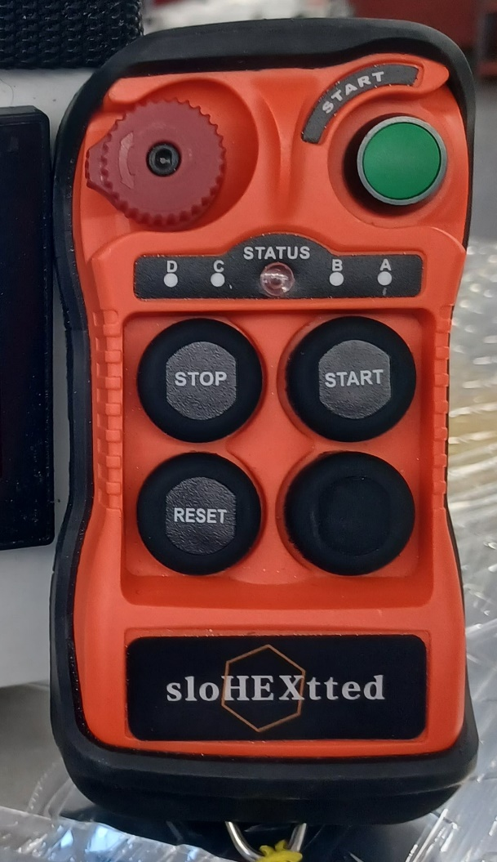

1. Turn the “RED” knob and push the “GREEN” button to turn on the Remote Control. The power indicator on the Touch Screen will now turn green.

3.

1. Use the “REV / FWD” and “JOG / RUN” switches on the touch screen to set those functions.

4.

1. You may now use the “START” and “STOP” buttons on the Remote Control or on the machines Main or Auxilary Panels to operate the gutter machine.

5.

**Operation of the Run Length features**

1. The “RUN LENGTH” meter at the upper right of the Touch Screen will show you how many feet and inches that have been ran since the last time it has reset.
2. To reset the counter, press and hold the yellow “REST RUN LENGTH” button.

6.

The Sparten Gutter Machine is equipped with a feature that allows you to set the number of feet you wish to produce, when that length is reached the machine will automatically stop.

**To set the Run Length**

1. Press the “Feet” buttom at the upper left of the touch screen to bring up the “Feet” screen.

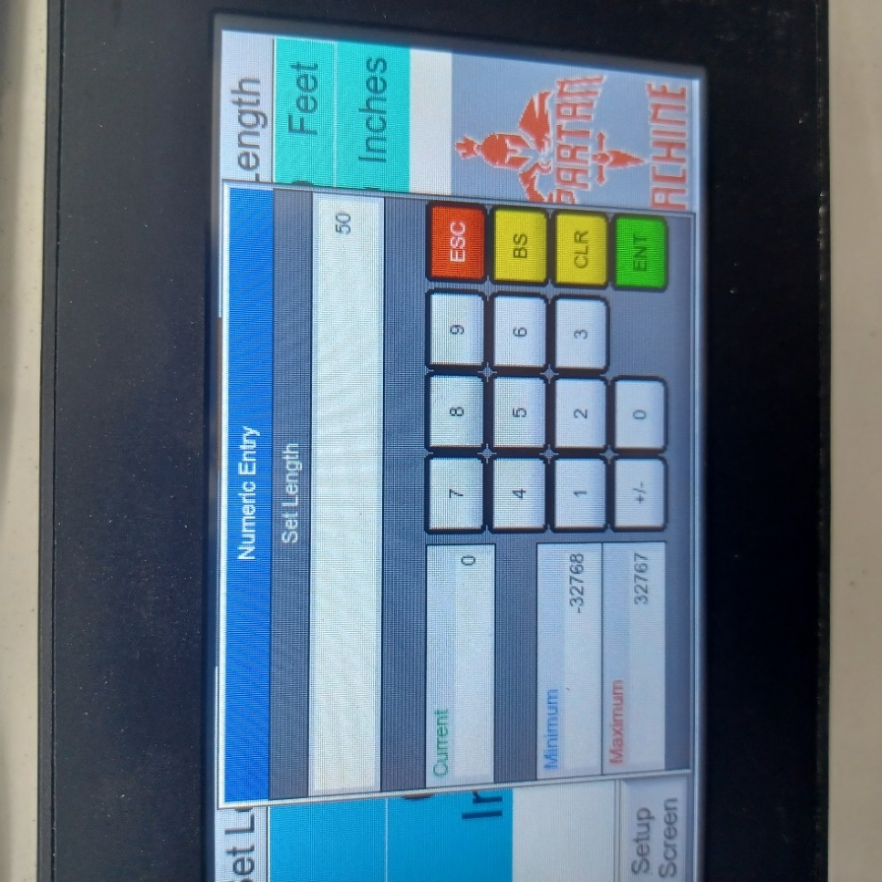

1. If you want to run 50 ft 6 and 1/2 inches of gutter, you should now enter 50 and press the Green “ENT” button.

7.

1. To enter the inches you will press the “Inches” button to bring up the Inches screen.

1. To enter the 6 1/2 inches you will need to enter it in decimal format, such as, 6.50 and then press the Green “ENT” button.
2. Next, press the “RUN” button on either the Remote Control or on the Main Control Panel to begin making gutter.

8.

1. The machine will automatically stop when it the gutter length reaches whatever number of feet and inches you entered.

**If you experience any diffaculty with the operation of the machine please contact your salesman or Spartan Machine customer service.**

Thank you for investing in a Spartan Gutter Machine,

The Spartan Machine Team.

Spartan Machine llc.

208 W. Main St.

New Paris, Ohio 45347

9.