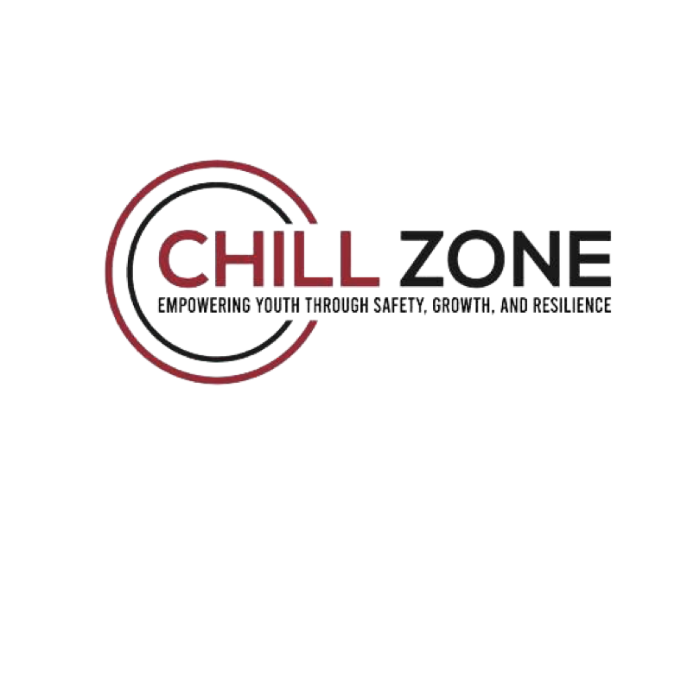

**Permission Slip for Youth Trip to Show Up Film Studio**

Date: ___________________

To Whom It May Concern:
I, the undersigned, give permission for my child, __________________________, to attend a trip organized by The Chill Zone to visit Show Up Film Studio, a Studio facility located in Brooklyn, NY, on November 23,2024. During this trip, our youth will have the opportunity to tour the live studio, learn about the processes involved in film production and recording, and participate in creating their own short film and lunch will be provided.

Details of the Trip:
Departure Time: ___________________
Return Time:___________________
Location: Show Up Film Studio, Brooklyn, NY
Emergency Contact Information:
Name: __________________________
Phone Number: ___________________
I understand that transportation will be provided by The Chill Zone in an RV or Van and all necessary safety precautions will be taken during the trip.

Parent/Guardian Signature:____________________________
Date:___________________
Notary Public Signature: _______________________
Date: ___________________

Notary Seal: _______________________

Thank you for your cooperation! We look forward to an exciting and educational experience for our youth.

