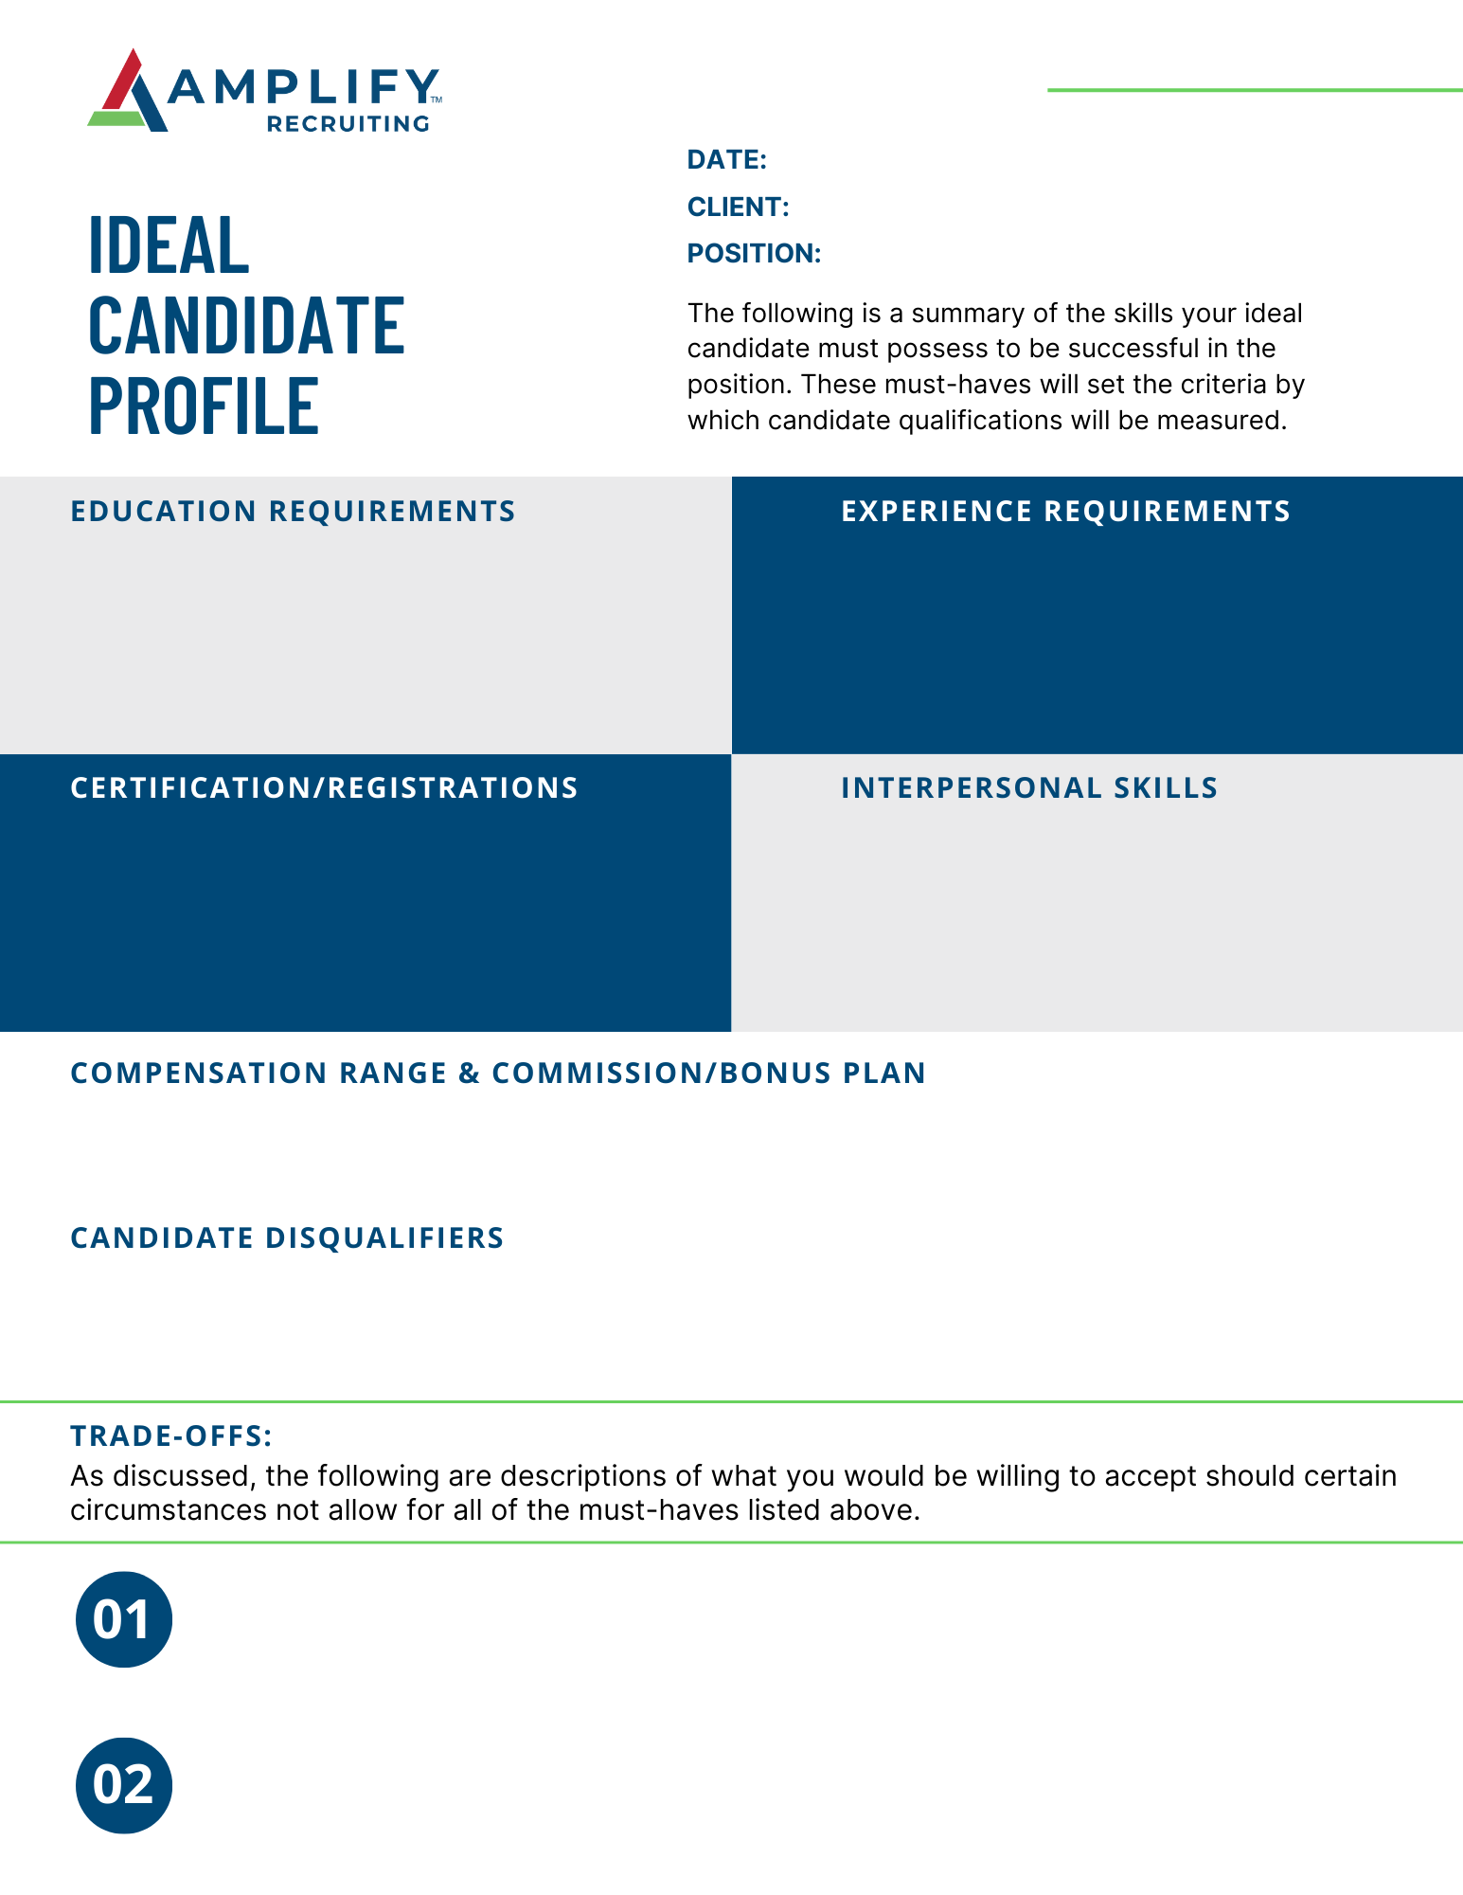

Client name goes here

Position title goes here

Engagement start date goes here

Recruiter name goes here

Description of what you would be willing to accept in certain situations

Description of what you would be willing to accept in certain situations

* Commission/Bonus Details
* Minimum Salary $
* Maximum Salary $
* Disqualifier 1
* Disqualifier 2
* Disqualifier 3
* Disqualifier 4
* Degree Type
* Field of Study
* Number of Years Experience
* Industry Experience
* No More than 3 Requirements
* Skill 1
* Skill 2
* Skill 3
* Certification Type
* Type of Registration