**A PATIENT’S GUIDE -- ARTHROSCOPIC ACL RECONSTRUCTION**

*This is a brief overview of what an Arthroscopic ACL Reconstruction entails. If you have any questions, please write them down and bring them to your next clinic visit so I can answer them for you in detail.*

**WHAT IS AN ACL TEAR?**

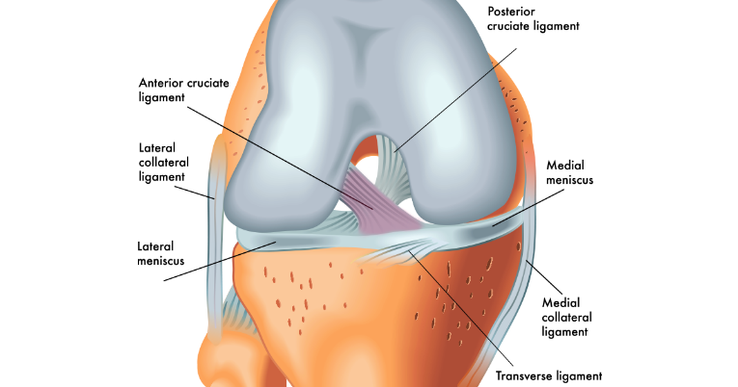The anterior cruciate ligament (ACL) is one of the four knee ligaments, and it is responsible for anterior knee stability. It also has an important role in rotational stability. This makes the ACL crucial for cutting, pivoting, activities found in sports like soccer, football, and skiing.

Injury to the ACL is usually due to trauma and is classically non-contact. The patient will often try to plant, cut, or land from a jump, and the knee will buckle inward, resulting in an audible pop, pain, and significant swelling. An ACL tear is often associated with other injuries including the meniscus, cartilage, and other ligaments.

**HOW IS AN ACL TEAR DIAGNOSED?**

Clinical history is very important, often the mechanism of injury can be the first clue of an ACL injury. The triad of an audible pop, non-contact mechanism, and rapid onset of significant knee swelling are very consistent with ACL injury. Once in the clinic, the physical examination can be used to assess the degree of knee instability as a result of the ACL injury. The orthopedist will test the forward looseness (anterior laxity) of the knee by performing a Lachman test and an Anterior drawer test. Both of these tests have gradings from 1-3, 1 being mild injury, and 3 being severe or complete tear. A positive Lachman test is over 90% specific for ACL injury. The Pivot shift test is a rotational test of the ACL and is often to painful to be done in acute ACL tears, but is a reliable tool in diagnosing chronic ACL tears.

X-Rays are taken in the office to evaluate for associated fractures and to assess the overall knee alignment, but MRI is the gold standard for diagnosing ACL tears. The MRI is a special, non-radiation, study that can very accurately examine the ligaments, cartilage, and meniscus. The typical MRI of an ACL tear will show bone bruising of the lateral knee with loss of the vertical orientation of the ACL fibers on side (sagittal) views. Meniscus tears are often associated with ACL tears and can be identified on MRI as well.

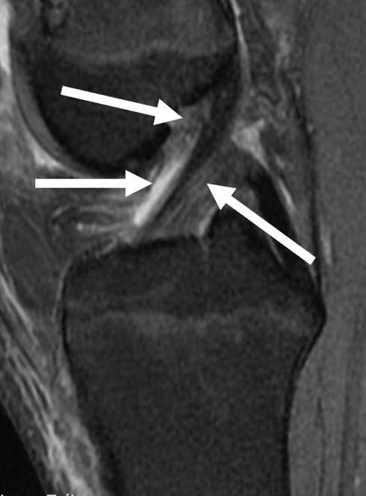

**[Left]- White arrows show normal ACL, [Right]- yellow highlight shows complete tear of ACL**

**DO YOU NEED YOUR ACL FIXED?**

The ACL is not needed in normal walking but is crucial for cutting, pivoting, side-to-side maneuvers. Patients who are older and more sedentary may get by with physical therapy and knee strengthening exercises. For younger, active individuals, who enjoy playing sports; ACL reconstruction is the best treatment option, and provides consistent results, with over 90% of individuals returning to their previous level of sport.

**HOW DO YOU RECONSTRUCT YOUR ACL?**

The majority of ACL tears require reconstruction, with only a small portion being repairable. ACL repair involves reattaching the torn ligament to the bone, while reconstruction entails removing the damaged ACL completely and then replacing it with a tendon (graft). Over a period of 9-12 months, that tendon will then turn into a new ACL. The reconstruction can be performed with either a patient’s own tissue (autograft) or from donor/cadaver tissue (allograft). It is well documented that autograft tissue has better outcomes / survival rates compared to allograft in young patients (<30 years old). In older patients, the results are similar for autograft and allograft reconstruction but is my opinion that autograft tissue is usually of better quality even in older individuals.

ACL reconstruction was classically performed using a patient’s hamstring tendons or the patellar tendon with its attached bone blocks. These grafts are still in wide use today, but quadriceps tendon has become my preferred graft option. I recommend using the quadriceps tendon because it is the largest diameter graft source, its incision is out of the way (not irritated when kneeling), and is unique in that it can be cut to the specific length and width based on each patient’s size. In comparison, hamstring grafts tend to be of smaller diameter and patellar tendon grafts can be too long in length and require an incision directly on the kneeling surface which can be painful in sports like volleyball or surfing.

**Surgical Steps**

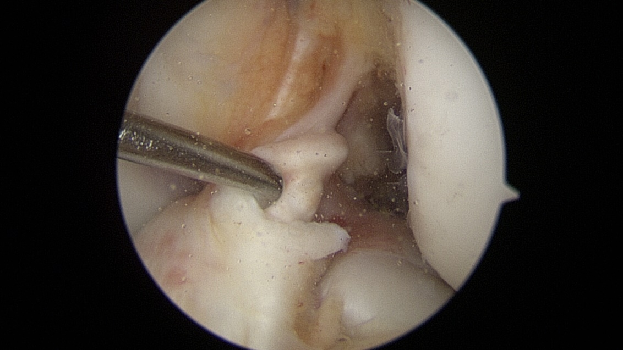Dr. Dunphy’s ACL reconstruction technique is performed using the most modern arthroscopic / minimally invasive methods. The first surgical step is to perform a diagnostic arthroscopy, in which a small camera (arthroscope) and small instruments are used to examine all portions of the knee including the cartilage surfaces, the medial and lateral meniscus, as well as the intra-articular ligaments (ACL and PCL). If injuries to the meniscus or cartilage are identified, these are addressed first using small instruments and repair devices before the ACL is reconstructed.

Complete ACL tear

Next a small incision is made over the upper aspect of the kneecap over the quadriceps tendon. The central portion of the quadriceps tendon is cut to the specific width and length according to the patient size, using a special dual blade scalpel. Then each end of the graft is incorporated into a “tightrope” device which is a high strength looped suture (thread) that will be used to fix the graft to the bone. Each tight rope will have a small metal button (bracket) which will hold the ACL graft in place until it heals. The remainder of the quadriceps tendon is then repaired back together.

Quadriceps Graft with Tightropes

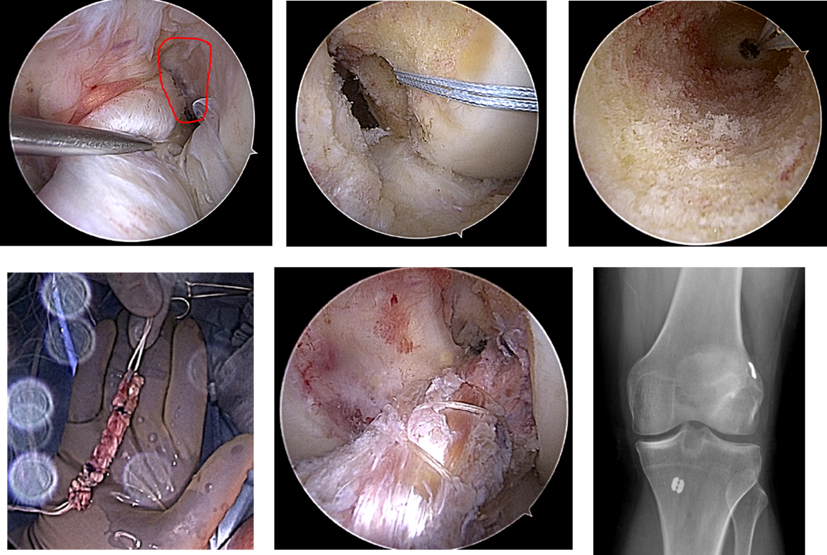Next the remnant ACL is removed and two bone tunnels are created to house the new ACL graft. Dr. Dunphy uses an “all-inside” technique, which is the most accurate and modern way of reconstructing the ACL. A special guide is used to drill a bone tunnel from inside the knee outward, this creates a partial tunnel thus saving bone. Several passing stitches are then inserted to help guide the graft into place.

Bone Tunnels with passing stitch

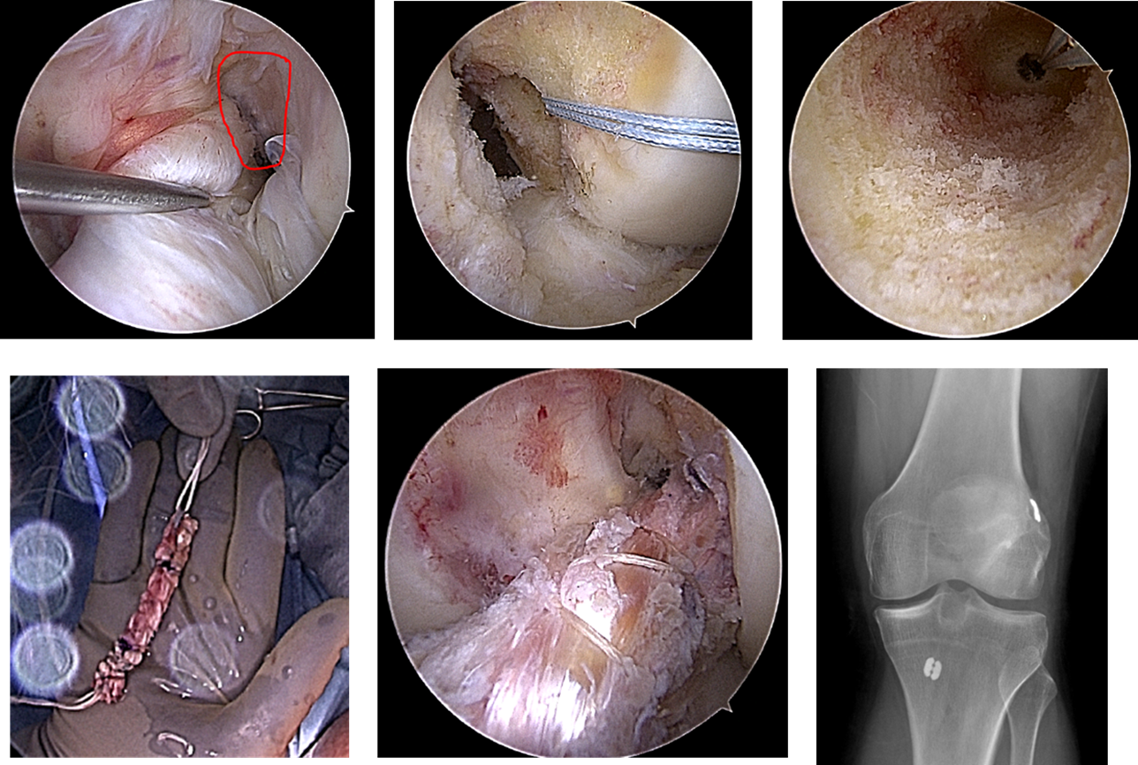

The graft is then positioned into place with the two sets of tightropes and the graft is then secured using small buttons. Once the ACL is fixated, the knee is then checked and confirmed that it is now stable to Lachman, Anterior drawer, and pivot shift tests.

ACL Reconstruction with all-inside technique

The incisions are then closed using dissolvable stitches and steri-strips. A heavy compressive dressing is then applied, followed by the placement of a hinged knee brace. The brace is set to the amount of motion allowed during the first two weeks. Patients are able to bend the knee in the brace right away, but can not place weight on the leg for at least 2 weeks.

ACL Reconstruction with Quadriceps Autograft

**SURGERY TIMELINE**

**Prior to Surgery**

* You may need Physical Therapy, called ACL Prehab, which will help get the knee bending (prior to surgery I like patients to have full straightening (extension) and > 120 degrees of bending (flexion)).
* You may need medical clearance from your medical specialist (primary care doctor, cardiologist, etc.) before surgery.
* Our office will contact you to book your surgical time and location. Typically, outpatient (same day) surgeries are done at the Hoag Orthopedic Institute (HOI) Surgery Center in Newport Beach or Aliso Viejo and in-patient (overnight) procedures are done at the HOI Hospital in Irvine.
* You will receive a confirmation call from the hospital the day prior to surgery informing you at what time you should arrive. They will usually go over last-minute details such as hygiene tips, and let you know which medications to bring. It is normal to arrive several hours ahead of your scheduled time to allow for the check-in process.
* Do not eat or drink anything after midnight the night before surgery. You may take sips of water to swallow pills if required and cleared by your medical team. Your surgery may need to be canceled if you do not adhere to these instructions.

**Day of Surgery**

* Arrive at the hospital or surgery center at your instructed time.
* If possible, arrive with a family member or friend who can assist with your check-in and help you remember any last-minute questions. There will be a place for family and friends to wait while you are in surgery. You will require someone to take you home if you are leaving the same day of surgery.
* Dr. Dunphy will meet with you before you enter the operating room to obtain written consent for the surgery and to answer any questions you may have.
* The anesthesia team will meet with you to discuss their anesthesia plan during surgery and will be able to answer any questions you may have for them. The majority of patients are offered a peripheral nerve block, which will help numb the leg after surgery, reducing the amount of pain medications required.

**After Surgery**

* Most patients having arthroscopic surgery leave the same day. The recovery process will take approximately an hour.
* During this time, your nurse and anesthesia team will help to manage your post-operative pain. It is important to know that you will have some pain, but the medications should help make your pain manageable. If you receive a nerve block, your leg may feel numb or heavy, this is normal, and will typically wear off in 6-8 hrs (up to 24hrs). It is recommended that you take your pain pills prior to the nerve block wearing off.
* You will need someone to take you home.
* One must wear your knee brace at all times. It can be unlocked to do the prescribed home exercises or to sit in the car or toilet. The brace should be locked when up on crutches and while sleeping.
* Keep your bandages dry while bathing. It is best to get a cast cover or a garbage bag and tape this around the top and bottom of the brace when showering.
* No driving until cleared by Dr. Dunphy.
* Do your best to wean off your narcotic pain medications. Over-the-counter medications such as Tylenol and Ibuprofen can be very helpful.
* If you receive an ice machine, please use it as instructed to help reduce swelling. You may also use ice packs or bags. Do not use for longer than directed and always avoid direct skin contact.
* Physical therapy should begin 2-3 days after surgery. The most important aspect after surgery is regaining / maintaining full knee straightening (extension). Remember NO pillows behind the knee, always under the ankle.

**Follow-Up**

* Your first follow-up appointment is usually 10-14 days following surgery.
* At this visit we will discuss your progress and check your incisions. We will also trim a few suture tails at this time.
* Dr. Dunphy will show you the arthroscopic pictures of the surgery, as well as provide you with a copy of your operative report.
* We will then book your next follow-up visit before you leave, which is typically 4-6 weeks later.

**ACL RECONSTRUCTION MILESTONES**

Weeks 0-2: Start physical therapy (Non-weight bearing). Range of motion goal: full extension to 60 degrees of flexion (prioritize extension). Work on quadriceps activation / leg lifts.

Week 6: Range of motion goal: full extension to >120 degrees of flexion. Achieve symmetric prone heel heights (max extension). Brace is removed. Strong quadriceps / leg lift.

Begin stationary bike.

Month 3: Range of motion goal: 0-135 degrees.

Begin jogging.

Month 4: Begin swimming.

Month 6: Begin cross training, jumping, side-to-side agility drills.

Ok to return to golf.

Month 9-12: Return to sport.

*It is a pleasure to take care of you, and I will do my very best to get you back to the activities and the quality of life you enjoy.*

Best,



Taylor Dunphy, MD