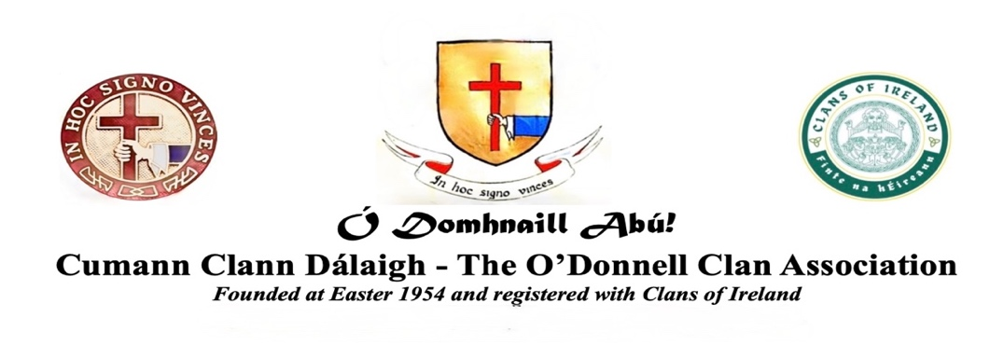
Personal Membership FORM for 2025-2026

Membership number (for office use only): ____
Delete which ever does NOT apply, and underline your choice:
(see Constitution: https://odomhnaill.com/clan-association)

Membership: New Application OR Annual Renewal
Member type: Ordinary (€25; voting) OR Associate (€10; non-voting)
Attend AGM: In person OR online (Zoom)
Indicate: Mr. Mrs. Ms. Other: _____
Your name:
Address:
City: Country:
Email: Phone:
By providing us with your email address, you agree to allow us to communicate with you privately by email

Optional information:
My age: Place of birth: Country of birth:
I volunteer for (highlight choice or delete whichever does not apply):
*Fundraising *Finding corporate sponsors *Institutional partnerships
*Event organisation *Hosting *Tour guide
*Writing articles *Editing and formatting *Drafting publicity/brochures/design
*Newsletter *Annual Journal *Media outreach
*Website *Photography/videography *Musical performance

Membership applications and donations to be paid to:
Bank: AIB - Allied Irish Banks, Main Street, Midleton, County Cork.
Account Holder: O'Donnell Clan Association
IBAN: IE 52 AIBK 93 41 27 50 80 50 58
Swift: AIBK IE 2D
Alternatively online:
Ordinary Membership: - https://buy.stripe.com/3cIeVdfaYcZDbsH2c5fUQ01
Associate Membership: - https://buy.stripe.com/cNi5kD9QE8Jn1S7aIBfUQ03
Please complete and return this form to: emcounihan@gmail.com
With copy to: chancery@odomhnaill.com

In accordance with the ODCA Constitution, the fees are annual, starting from January through the calendar year, however, as we are already half-way through 2025, payment of the above amounts will exceptionally also cover 2026

