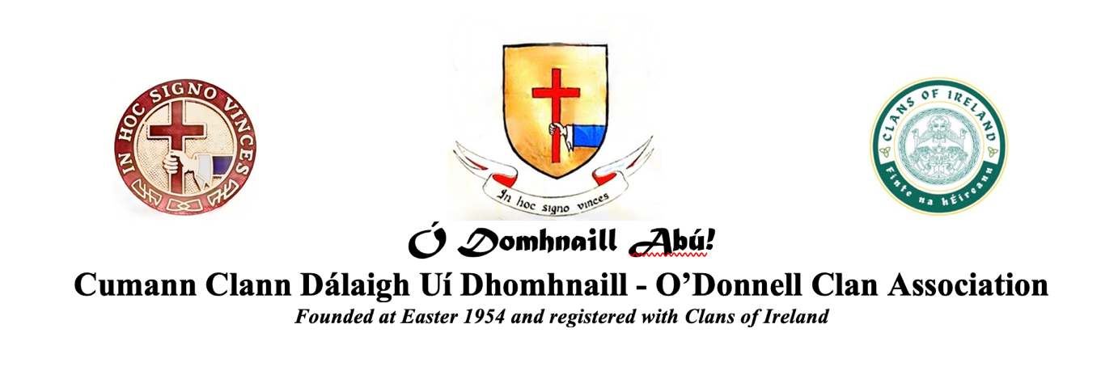
Annual General Meeting, 30 August 2026

Council Nomination Form

Note: Only registered or qualified members of the ODCA may nominate a person to the Council.

Eligibility of election is determined in accordance with the terms of the Clan Constitution article 5.2.

Current council members are: Francis M. O’Donnell (President – 2 year term completed; renewable); other elected members whose 3-year terms continue are: Maria Angeles O’Donnell-Olson (Vice-President); Frank Hannigan; Eibhlin M. O’Connor Counihan; and John McCaffery.

The following members who were co-opted now go forward for election: Hugo O’Donnell y Armada (Spain); Patrick J. O’Donnell (Ireland).

Others may be nominated below:

Nominee's Family Name (please print):______________________ First name: _________________

Nominee’s email address: ________________________County/Country of residence___________
(Please ensure that the nominee is willing to serve as a Member of the Council of the O’Donnell Clan Association (ODCA)

The undersigned registered members of the O’Donnell Clan Association (ODCA) hereby propose the above nominee to go forward for election as a member of the Council of the O’Donnell Clan Association.

Tick or circle Council role proposed (only one): President Other Officer
(Note: Council members once elected will determine other roles between them, e.g. Secretary, Treasurer, etc.)

Proposed by:

Signed: ______________________________ Name (print):________________________________
Email address:_________________________ Mobile phone:_______________________________

Seconded by:
Signed: ______________________________ Name (print)________________________________
Email address:_________________________ Mobile phone:_______________________________

Nominee biographical details (maximum 50 words):
Please provide a brief description of the nominee’s background and on what contribution s/he would want to make, should s/he be elected. Nominees should be able and willing to attend a majority of the Council meetings each year in person or by Zoom online platform.
_________________________________________________________________________________
_________________________________________________________________________________
_________________________________________________________________________________

Closing date for nominations: 31 July 2026 by email to ODCA Registrar/Secretary:
patrickjlodonnell@gmail.com (after which the candidates will be listed for election at the AGM)

Note: data disclosed on this form will only be used for ODCA electoral and listing purposes and will be retained as confidential and not for any third-party use, and in conformity with General Data Protection Regulation (GDPR) – Regulation (EU) 2016/679.

