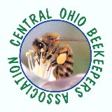
November 15, 2025

Franklin Park Conservatory Apiary Dates for 2026

April 14 and 28, 2026

May 12 and 26, 2026

June 9 and 23, 2026

July 7 and 21, 2026

August 4 and 18, 2026

September 1, 15 and 29, 2026

October 13 and 27, 2026

All events begin at 6:00 p.m. and are weather dependent.

Lead person is Dale Gelter, 614-315-6794, Dale.Gelter@gmail.com.

